Grado en Ingeniería Informática del software

Grupo: Trivial 1A  
Sergio Cueto López de Bustamante  
Ignacio Rodríguez Vázquez  
Yenni Ramos Martínez  
Diego Jaular Ortigueira  
Robert Stefanita Ene  
Alejandro García Torriello  
Isabel Del Álamo Rancaño  
Francisco Gil Gala

Documentación Trivial 1a

Arquitectura del Software



Contenido

Planteamiento del Problema 3

Metodología utilizada 3

Requisitos Funcionales 3

Requisitos No Funcionales 4

Identificación de los Interesados (Stakeholders) 4

Atributos de Calidad 5

Atributos de calidad e Interesados 6

Escenarios de Calidad 7

Vistas 8

Anexo A: Vistas 8

* Controller 9
* Model 38
* View 99
* Despliegue 114
* Diagrama de contexto 124
* Diagrama de paquetes 147

Anexo B: Diagrama BPMN 172

* Diagrama de Procesos de Negocio - Partida de Trivial 172
* Jugar 195

Anexo C: Manual de sistema 213

* Instalación y configuración de play 213
* Ejecución del proyecto 215

Anexo D: Manual de usuario 215

* Ventana de Login 215
* Ventana de registro 216
* Ventana de menú principal 216
* Ventana de estadísticas 217
* Ventana del juego 218

Este documento incluye:

* Una identificación de Stakeholders, atributos y escenarios de calidad para el problema propuesto, junto con la relación que guardan.
* La arquitectura optada que soluciona los requisitos pedidos, explicada y detallada.
* El manual de usuario, indicando lo necesario para que se pueda manejar la aplicación.
* Un manual de sistema, indicando aspectos importantes de configuración y restricciones para el correcto funcionamiento de la misma

# Planteamiento del Problema

Se pide que a partir de la aplicación de escritorio desarrollada anteriormente, se desarrolle una plataforma de juegos Trivial online y multijugador con las siguientes características:

* Los usuarios pueden conectarse a esta plataforma y jugar entre ellos.
* Se podrá crear una partida para jugar.
* Los usuarios se tendrán que registrar para poder jugar.
* Los usuarios podrán ver sus estadísticas.
* Los usuarios podrán ver si hay otros usuarios conectados para poder jugar.
* El sistema deberá responder adecuadamente ante situaciones de pérdida de conexión de los usuarios o que algún usuario decida dejar de jugar.
* Arquitectura escalable y con buenos tiempos de respuesta.
* Separación de lógica e interfaz del juego para poder tener diferentes tipos de visualizaciones.
* Soluciones para que cumpla los principios y estándares Web de diseño responsable.
* Los aspectos visuales se harán mediante el uso de API REST.

# Metodología utilizada

Como se ha visto en clase de Arquitectura del Software el método que ha sido utilizado es el Atribute-Driven-Design (ADD).

El Atribute-Driven-Design (ADD) es un método que se basa en descomponer los procesos en los atributos de calidad que el software deberá cumplir. Se definen los atributos de calidad a partir de los requisitos no funcionales finalizado con el modelado de los escenarios de calidad.

# Requisitos Funcionales

1. Solo un jugador podrá jugar en la partida.
2. Posibilidad de registro como usuario y autenticación ante el sistema mediante nombre de usuario y contraseña.
3. Guardado de estadísticas (porcentaje de preguntas acertadas y falladas clasificadas por categorías y por usuarios) de todas las partidas de los usuarios para fines educativos.
4. Funcionamiento de la aplicación en un futuro en diferentes plataformas y para varias visualizaciones de la misma.
5. Los jugadores si pierden la conexión o pierden el interés en la partida y la dejan sin previo aviso, el sistema deberá saber afrontar estas situaciones de la forma más eficiente posible para que el resto de jugadores puedan continuar jugando.

# Requisitos No Funcionales

* 1. Debe poder correr en paralelo varias instancias de la aplicación a la vez.
  2. Se le debe poder comunicar a la aplicación por consola que formato va a leer.
  3. La visualización se hará mediante API REST.
  4. Uso del framework Play.

# Identificación de los Interesados (Stakeholders)

* Responsables de NoGame: Se trata de los equipos directivos de la empresa, son responsables de los presupuestos y toman las decisiones que comprometen fondos de dicho presupuesto.
* Equipo de desarrollo del proyecto Trivial: Este equipo será el responsable de desarrollar el sistema resultante de la arquitectura.
* Responsables de la información: Este equipo se encargará de introducir la información con las preguntas que utilizarán los distintos juegos, además de comprobar su veracidad y actualizarlas en caso de cambios.
* Usuario cliente: Serán los encargados de jugar con la aplicación.

|  |  |  |
| --- | --- | --- |
| Código | Stakeholders | Intereses |
| ST-01 | Responsables de NoGame | 1. Bajo coste económico de desarrollo. El desarrollo del proyecto debe ser corto y con un coste reducido. 2. Posibilidad de que el juego sea multiplataforma. 3. Posibilidad de crear más juegos con formato preguntas/respuestas, extendiendo el que se está diseñando actualmente. 4. Proyecto rentable, esto es, que permita ser desarrollado por el precio establecido con un grado de rentabilidad que haga atractivo el desarrollo. |
| ST-02 | Equipo de desarrollo del proyecto Trivial | 1. Baja complejidad en los algoritmos de aleatorización de las preguntas. |
| ST-03 | Responsables de la información | 1. Permitir la ampliación de la aplicación con nuevas partes de manera sencilla al proyecto. 2. Máxima facilidad y rapidez a la hora de introducir preguntas, preferiblemente con tratamientos por lotes y no individualmente. 3. Máxima facilidad y rapidez para buscar una determinada pregunta. 4. Máxima facilidad y rapidez para actualizar los datos de una pregunta. 5. Poder mantener la integridad y coherencia en la información. |
| ST-04 | Usuario Cliente | 1. Facilidad de acceso y uso. 2. Confiabilidad en la aplicación: que no provoque averías y que sea segura. 3. Que no solicite aperturas de puertos al ordenador del usuario. 4. Que la conexión de su usuario con el servidor sea estable. |

# Atributos de Calidad

Los diferentes atributos de calidad son de interés para alguno de los Stakeholders. La siguiente tabla muestra la lista de intereses para el proyecto actual:

|  |  |  |
| --- | --- | --- |
| Código | Descripción | Tipo de Atributo |
| AT001 | Posibilidad de cambio de visualización | Modificabilidad |
| AT002 | Posibilidad de cambio de jugador mediante el login. | Modificabilidad |
| AT003 | Las preguntas guardadas en base de datos deberán estar disponibles durante la partida. | Disponibilidad |
| AT004 | El acceso a los usuarios registrados deberá ser accesible en un tiempo óptimo. | Rendimiento |
| AT005 | El acceso a las preguntas almacenadas en la base de datos deberá producirse en un tiempo óptimo y de una manera correcta. | Rendimiento |
| AT006 | Cada usuario podrá ver solamente sus estadísticas. | Confidencialidad |
| AT007 | La interfaz debe ser intuitiva | Usabilidad |
| AT008 | Consistencia de las preguntas en la base de datos | Seguridad |
| AT009 | El acceso a nuestra aplicación se hará por medio de un registro por ello los jugadores no registrados no podrán jugar. | Seguridad |
| AT010 | Aplicación fácilmente depurable. | Testabilidad |
| AT011 | Se pide que este separado claramente la visualización del juego con el resto de la funcionalidad, para que el juego pueda ser utilizado en diferentes plataformas. | Adaptabilidad |
| AT012 | Algunos módulos pueden ser reutilizados en un futuro | Adaptabilidad |
| AT013 | Tiempo de desarrollo de la aplicación que sea corto | Time to market |
| AT014 | Disponibilidad de la aplicación 24x7 | Disponibilidad |
| AT015 | La web tendrá capacidad para ajustarse a cualquier dispositivo tecnológico con acceso a internet | Adaptabilidad |

# Atributos de calidad e Interesados

Los diferentes atributos de calidad son de interés para alguno de los Stakeholders. La siguiente tabla muestra la lista de intereses para el proyecto actual:

|  |  |  |  |  |
| --- | --- | --- | --- | --- |
| Atributos  Vs  Interesados | ST-01 | ST-02 | ST-03 | ST-04 |
| AT001 | x | x |  | x |
| AT002 |  | x |  | x |
| AT003 | x | x | x | x |
| AT004 | x | x |  | x |
| AT005 | x | x |  | x |
| AT006 | x | x |  | x |
| AT007 | x | x |  | x |
| AT008 | x | x | x |  |
| AT009 | x | x |  | x |
| AT010 |  | x |  |  |
| AT011 | x | x |  |  |
| AT012 | x | x |  |  |
| AT013 | x | x |  |  |
| AT014 |  | x |  | x |
| AT015 | x | x |  | x |

# Escenarios de Calidad

Con toda la información anterior se procederá a definir los escenarios de calidad que influencian esta arquitectura.

|  |  |  |  |  |  |  |  |
| --- | --- | --- | --- | --- | --- | --- | --- |
| Escenario | Fuente  de estímulo | Entorno | Artefacto | Respuesta | Medición  de la respuesta |  | Atributos de calidad afectado |
| 1 | Usuario | Explotación | Interfaz | Cambio de vista y usuarios | Tiempo no superior a 5s |  | AT001, AT002 |
| 2 | Responsables de Información | Explotación | Base de Datos | Disponibilidad de preguntas | Tiempo no superior a 2s |  | AT003 |
| 3 | Usuario | Explotación | Aplicación | Inicio de sesión y desarrollo de partidas rápidas | Tiempo no superior a 1-2s |  | AT004, AT005 |
| 4 | Usuario | Explotación | Interfaz | Listado de estadísticas del usuario en sesión | Tiempo no superior a 1s |  | AT006 |
| 5 | Usuario | Explotación | Interfaz | Transiciones y fluidez entre las vistas de la aplicación | Tiempo no superior a 3-4s |  | AT007 |
| 6 | Responsables de Información | Desarrollo | Base de Datos | Consistencia en los datos (preguntas) de la Base de Datos | Tiempo no superior a 1s |  | AT008 |
| 7 | Usuario | Explotación | Aplicación | Registro de los jugadores en el sistema. | Tiempo del registro del usuario (5-10s) |  | AT009 |
| 8 | Desarrolladores | Desarrollo | Aplicación | Módulos de la aplicación depurables. | Tiempo relativamente corto en la localización del bug. |  | AT010 |
| 9 | Desarrolladores | Desarrollo | Aplicación | Módulos de la aplicación reutilizables para distintas plataformas. | Tiempo de respuesta en localizar el módulo a reutilizar. |  | AT011, AT012 |
| 10 | Responsables de NoGame | Desarrollo | Aplicación | Tiempo de desarrollo corto. | Tiempo del desarrollo (un mes) |  | AT013 |
| 11 | Usuario | Explotación | Aplicación | El juego debe estar disponible en todo momento. | Siempre. |  | AT014 |
| 11 | Usuario | Explotación | Interfaz | El juego podrá adaptarse a cualquier dispositivo con acceso a internet | Siempre |  | AT015 |

# Vistas

|  |  |  |  |
| --- | --- | --- | --- |
| Vistas | Stakeholders | Atributos de calidad | Escenarios |
| Logging | ST-02, ST-03 | AT002, AT005, AT003 | 2 |
| Persistencia | ST-01, ST-02,  ST-03 | AT004, AT002, AT005, AT003 | 2, 4 |
| Vista procesado | ST-02, ST-03 | AT001, AT006, AT002, AT005, AT003 | 1, 2, 3 |

# Anexo A: Vistas

Component Diagram

# Controller

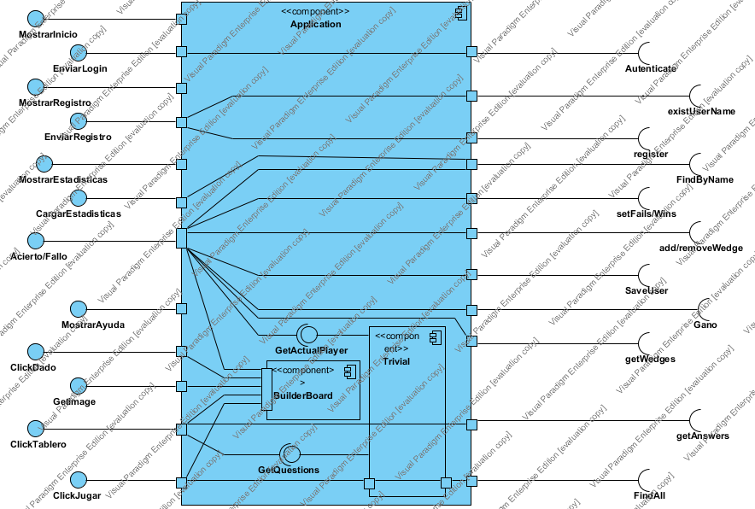

|  |  |
| --- | --- |
| Name | Value |
| Name | Controller |
| Author | Trivial1a |
| Create Date Time | 04-may-2015 15:44:25 |
| Last Modified | 07-may-2015 22:57:35 |
| Teamwork Create Date Time | 0 |
| Show Component Attributes | false |
| Show Component Operations | false |

## Summary

|  |  |
| --- | --- |
| Name | Description |
| Image1.png Application | Aplication es el controlador del juego encargado de comunicarse y comunicar las vistas con el modelo.  también implementa la lógica del juego. |
| Image1.png Trivial | Contiene la lógica del juego |
| Image1.png BuilderBoard | Se en carga de servir y actualizar las imágenes empleadas en la aplicación |

## Details

### Image3.png Application

|  |  |
| --- | --- |
| Name | Value |
| Description | Aplication es el controlador del juego encargado de comunicarse y comunicar las vistas con el modelo.  también implementa la lógica del juego. |
| Active | false |
| Business Key Mutable | true |
| Business Model | false |
| Visibility | public |
| Abstract | false |
| Leaf | false |
| Root | false |
| Quality Score | Fair |
| Quality Reason | |  |  | | --- | --- | | Problem | Suggestion | | Model element at root | Add model element to a container | | Name does not contain glossary terms | Define name as term in glossary | |
| Indirectly Instantiated | true |
| Project Management | |  |  | | --- | --- | | Name | Value | | Author | Trivial1a | | Create Date Time | 05-may-2015 0:54:43 | | Last Modified | 07-may-2015 18:49:21 | |

#### Children

|  |  |
| --- | --- |
| Name | Description |
| Image1.png Trivial | Contiene la lógica del juego |
| Image1.png BuilderBoard | Se en carga de servir y actualizar las imágenes empleadas en la aplicación |

#### Resident Components

|  |  |
| --- | --- |
| Name | Description |
| Image3.png Trivial | Contiene la lógica del juego |
| Image3.png BuilderBoard | Se en carga de servir y actualizar las imágenes empleadas en la aplicación |

### Image5.png MostrarInicio

|  |  |
| --- | --- |
| Name | Value |
| Active | false |
| Business Key Mutable | true |
| Business Model | false |
| Visibility | public |
| Leaf | false |
| Root | false |
| Stereotypes | Interface |
| Quality Score | Fair |
| Quality Reason | |  |  | | --- | --- | | Problem | Suggestion | | Model element at root | Add model element to a container | | Name does not contain glossary terms | Define name as term in glossary | |
| Project Management | |  |  | | --- | --- | | Name | Value | | Author | Trivial1a | | Create Date Time | 05-may-2015 19:22:15 | | Last Modified | 06-may-2015 2:49:59 | |

#### Relationships

|  |  |
| --- | --- |
| Unnamed Realization | |
| From | Image2.png MostrarInicio |
| Visibility | Unspecified |
| Quality Score | Good |
| Project Management | |  |  | | --- | --- | | Name | Value | | Author | Trivial1a | | Create Date Time | 05-may-2015 19:22:15 | | Last Modified | 07-may-2015 18:49:21 | |

### Image5.png EnviarLogin

|  |  |
| --- | --- |
| Name | Value |
| Active | false |
| Business Key Mutable | true |
| Business Model | false |
| Visibility | public |
| Leaf | false |
| Root | false |
| Stereotypes | Interface |
| Quality Score | Fair |
| Quality Reason | |  |  | | --- | --- | | Problem | Suggestion | | Model element at root | Add model element to a container | | Name does not contain glossary terms | Define name as term in glossary | |
| Project Management | |  |  | | --- | --- | | Name | Value | | Author | Trivial1a | | Create Date Time | 06-may-2015 0:47:49 | | Last Modified | 06-may-2015 2:49:59 | |

### Image5.png Autenticate

|  |  |
| --- | --- |
| Name | Value |
| Active | false |
| Business Key Mutable | true |
| Business Model | false |
| Visibility | public |
| Leaf | false |
| Root | false |
| Stereotypes | Interface |
| Quality Score | Fair |
| Quality Reason | |  |  | | --- | --- | | Problem | Suggestion | | Model element at root | Add model element to a container | | Name does not contain glossary terms | Define name as term in glossary | |
| Project Management | |  |  | | --- | --- | | Name | Value | | Author | Trivial1a | | Create Date Time | 06-may-2015 2:26:06 | | Last Modified | 06-may-2015 2:32:20 | |

#### Relationships

|  |  |
| --- | --- |
| Unnamed Realization | |
| From | Image2.png EnviarLogin |
| Visibility | Unspecified |
| Quality Score | Good |
| Project Management | |  |  | | --- | --- | | Name | Value | | Author | Trivial1a | | Create Date Time | 06-may-2015 0:47:49 | | Last Modified | 06-may-2015 2:32:20 | |

#### Relationships

|  |  |
| --- | --- |
| Unnamed Usage | |
| To | Image2.png Autenticate |
| Visibility | Unspecified |
| Quality Score | Good |
| Project Management | |  |  | | --- | --- | | Name | Value | | Author | Trivial1a | | Create Date Time | 06-may-2015 2:26:06 | | Last Modified | 06-may-2015 2:32:20 | |

### Image5.png MostrarRegistro

|  |  |
| --- | --- |
| Name | Value |
| Active | false |
| Business Key Mutable | true |
| Business Model | false |
| Visibility | public |
| Leaf | false |
| Root | false |
| Stereotypes | Interface |
| Quality Score | Fair |
| Quality Reason | |  |  | | --- | --- | | Problem | Suggestion | | Model element at root | Add model element to a container | | Name does not contain glossary terms | Define name as term in glossary | |
| Project Management | |  |  | | --- | --- | | Name | Value | | Author | Trivial1a | | Create Date Time | 05-may-2015 19:26:54 | | Last Modified | 06-may-2015 12:19:00 | |

#### Relationships

|  |  |
| --- | --- |
| Unnamed Realization | |
| From | Image2.png MostrarRegistro |
| Visibility | Unspecified |
| Quality Score | Good |
| Project Management | |  |  | | --- | --- | | Name | Value | | Author | Trivial1a | | Create Date Time | 05-may-2015 19:26:54 | | Last Modified | 07-may-2015 18:49:21 | |

### Image5.png existUserName

|  |  |
| --- | --- |
| Name | Value |
| Active | false |
| Business Key Mutable | true |
| Business Model | false |
| Visibility | public |
| Leaf | false |
| Root | false |
| Stereotypes | Interface |
| Quality Score | Fair |
| Quality Reason | |  |  | | --- | --- | | Problem | Suggestion | | Model element at root | Add model element to a container | | Name does not contain glossary terms | Define name as term in glossary | |
| Project Management | |  |  | | --- | --- | | Name | Value | | Author | Trivial1a | | Create Date Time | 05-may-2015 2:10:40 | | Last Modified | 07-may-2015 18:13:03 | |

#### Relationships

|  |  |
| --- | --- |
| Unnamed Usage | |
| To | Image2.png existUserName |
| Visibility | Unspecified |
| Quality Score | Good |
| Project Management | |  |  | | --- | --- | | Name | Value | | Author | Trivial1a | | Create Date Time | 06-may-2015 1:51:46 | | Last Modified | 06-may-2015 2:11:17 | |

### Image5.png EnviarRegistro

|  |  |
| --- | --- |
| Name | Value |
| Active | false |
| Business Key Mutable | true |
| Business Model | false |
| Visibility | public |
| Leaf | false |
| Root | false |
| Stereotypes | Interface |
| Quality Score | Fair |
| Quality Reason | |  |  | | --- | --- | | Problem | Suggestion | | Model element at root | Add model element to a container | | Name does not contain glossary terms | Define name as term in glossary | |
| Project Management | |  |  | | --- | --- | | Name | Value | | Author | Trivial1a | | Create Date Time | 06-may-2015 0:43:47 | | Last Modified | 06-may-2015 12:19:00 | |

#### Relationships

|  |  |
| --- | --- |
| Unnamed Realization | |
| From | Image2.png EnviarRegistro |
| Visibility | Unspecified |
| Quality Score | Good |
| Project Management | |  |  | | --- | --- | | Name | Value | | Author | Trivial1a | | Create Date Time | 06-may-2015 0:43:47 | | Last Modified | 06-may-2015 2:00:45 | |

### Image5.png register

|  |  |
| --- | --- |
| Name | Value |
| Active | false |
| Business Key Mutable | true |
| Business Model | false |
| Visibility | public |
| Leaf | false |
| Root | false |
| Stereotypes | Interface |
| Quality Score | Fair |
| Quality Reason | |  |  | | --- | --- | | Problem | Suggestion | | Model element at root | Add model element to a container | | Name does not contain glossary terms | Define name as term in glossary | |
| Project Management | |  |  | | --- | --- | | Name | Value | | Author | Trivial1a | | Create Date Time | 05-may-2015 2:12:00 | | Last Modified | 07-may-2015 18:13:03 | |

#### Relationships

|  |  |
| --- | --- |
| Unnamed Usage | |
| To | Image2.png register |
| Visibility | Unspecified |
| Quality Score | Good |
| Project Management | |  |  | | --- | --- | | Name | Value | | Author | Trivial1a | | Create Date Time | 06-may-2015 1:51:08 | | Last Modified | 06-may-2015 2:00:45 | |

### Image5.png MostrarEstadisticas

|  |  |
| --- | --- |
| Name | Value |
| Active | false |
| Business Key Mutable | true |
| Business Model | false |
| Visibility | public |
| Leaf | false |
| Root | false |
| Stereotypes | Interface |
| Quality Score | Fair |
| Quality Reason | |  |  | | --- | --- | | Problem | Suggestion | | Model element at root | Add model element to a container | | Name does not contain glossary terms | Define name as term in glossary | |
| Project Management | |  |  | | --- | --- | | Name | Value | | Author | Trivial1a | | Create Date Time | 05-may-2015 19:27:29 | | Last Modified | 06-may-2015 12:19:00 | |

### Image5.png FindByName

|  |  |
| --- | --- |
| Name | Value |
| Active | false |
| Business Key Mutable | true |
| Business Model | false |
| Visibility | public |
| Leaf | false |
| Root | false |
| Stereotypes | Interface |
| Quality Score | Fair |
| Quality Reason | |  |  | | --- | --- | | Problem | Suggestion | | Model element at root | Add model element to a container | | Name does not contain glossary terms | Define name as term in glossary | |
| Project Management | |  |  | | --- | --- | | Name | Value | | Author | Trivial1a | | Create Date Time | 07-may-2015 18:29:17 | | Last Modified | 07-may-2015 18:39:20 | |

#### Relationships

|  |  |
| --- | --- |
| Unnamed Realization | |
| From | Image2.png MostrarEstadisticas |
| Visibility | Unspecified |
| Quality Score | Good |
| Project Management | |  |  | | --- | --- | | Name | Value | | Author | Trivial1a | | Create Date Time | 05-may-2015 19:27:29 | | Last Modified | 06-may-2015 1:50:14 | |

#### Relationships

|  |  |
| --- | --- |
| Unnamed Usage | |
| To | Image2.png FindByName |
| Visibility | Unspecified |
| Quality Score | Good |
| Project Management | |  |  | | --- | --- | | Name | Value | | Author | Trivial1a | | Create Date Time | 07-may-2015 18:31:17 | | Last Modified | 07-may-2015 18:39:20 | |

### Image5.png CargarEstadisticas

|  |  |
| --- | --- |
| Name | Value |
| Active | false |
| Business Key Mutable | true |
| Business Model | false |
| Visibility | public |
| Leaf | false |
| Root | false |
| Stereotypes | Interface |
| Quality Score | Fair |
| Quality Reason | |  |  | | --- | --- | | Problem | Suggestion | | Model element at root | Add model element to a container | | Name does not contain glossary terms | Define name as term in glossary | |
| Project Management | |  |  | | --- | --- | | Name | Value | | Author | Trivial1a | | Create Date Time | 07-may-2015 18:25:52 | | Last Modified | 07-may-2015 18:49:21 | |

### Image5.png setFails/Wins

|  |  |
| --- | --- |
| Name | Value |
| Active | false |
| Business Key Mutable | true |
| Business Model | false |
| Visibility | public |
| Leaf | false |
| Root | false |
| Stereotypes | Interface |
| Quality Score | Fair |
| Quality Reason | |  |  | | --- | --- | | Problem | Suggestion | | Model element at root | Add model element to a container | | Name does not contain glossary terms | Define name as term in glossary | |
| Project Management | |  |  | | --- | --- | | Name | Value | | Author | Trivial1a | | Create Date Time | 05-may-2015 17:03:59 | | Last Modified | 06-may-2015 1:50:14 | |

#### Relationships

|  |  |
| --- | --- |
| Unnamed Usage | |
| To | Image2.png setFails/Wins |
| Visibility | Unspecified |
| Quality Score | Good |
| Project Management | |  |  | | --- | --- | | Name | Value | | Author | Trivial1a | | Create Date Time | 06-may-2015 1:46:47 | | Last Modified | 06-may-2015 19:40:33 | |

#### Relationships

|  |  |
| --- | --- |
| Unnamed Realization | |
| From | Image2.png CargarEstadisticas |
| Visibility | Unspecified |
| Quality Score | Good |
| Project Management | |  |  | | --- | --- | | Name | Value | | Author | Trivial1a | | Create Date Time | 07-may-2015 18:25:52 | | Last Modified | 07-may-2015 18:39:20 | |

### Image5.png add/removeWedge

|  |  |
| --- | --- |
| Name | Value |
| Active | false |
| Business Key Mutable | true |
| Business Model | false |
| Visibility | public |
| Leaf | false |
| Root | false |
| Stereotypes | Interface |
| Quality Score | Fair |
| Quality Reason | |  |  | | --- | --- | | Problem | Suggestion | | Model element at root | Add model element to a container | | Name does not contain glossary terms | Define name as term in glossary | |
| Project Management | |  |  | | --- | --- | | Name | Value | | Author | Trivial1a | | Create Date Time | 05-may-2015 17:05:30 | | Last Modified | 06-may-2015 1:50:14 | |

#### Relationships

|  |  |
| --- | --- |
| Unnamed Usage | |
| From | Image4.png N/A |
| Visibility | Unspecified |
| Quality Score | Good |
| Project Management | |  |  | | --- | --- | | Name | Value | | Author | Trivial1a | | Create Date Time | 06-may-2015 1:41:07 | | Last Modified | 06-may-2015 19:54:21 | |

|  |  |
| --- | --- |
| Name | Value |
| Service | true |
| Behavior | false |
| Conjugated | false |
| Derived | false |
| Is ID | false |
| Derived Union | false |
| Aggregation | Unspecified |
| Multiplicity | Unspecified |
| Read Only | false |
| Static | false |
| Leaf | false |
| Visibility | public |
| Project Management | |  |  | | --- | --- | | Name | Value | | Author | Trivial1a | | Create Date Time | 06-may-2015 19:38:15 | | Last Modified | 07-may-2015 18:45:15 | |

#### Relationships

|  |  |
| --- | --- |
| Unnamed Usage | |
| To | Image2.png GetActualPlayer |
| Visibility | Unspecified |
| Quality Score | Good |
| Project Management | |  |  | | --- | --- | | Name | Value | | Author | Trivial1a | | Create Date Time | 06-may-2015 19:50:43 | | Last Modified | 06-may-2015 22:52:45 | |
| Unnamed Realization | |
| From | Image2.png Acierto/Fallo |
| Visibility | Unspecified |
| Quality Score | Good |
| Project Management | |  |  | | --- | --- | | Name | Value | | Author | Trivial1a | | Create Date Time | 06-may-2015 19:35:33 | | Last Modified | 06-may-2015 19:40:33 | |

#### Relationships

|  |  |
| --- | --- |
| Unnamed Usage | |
| To | Image2.png add/removeWedge |
| Visibility | Unspecified |
| Quality Score | Good |
| Project Management | |  |  | | --- | --- | | Name | Value | | Author | Trivial1a | | Create Date Time | 06-may-2015 1:41:07 | | Last Modified | 06-may-2015 19:54:21 | |

### Image5.png Acierto/Fallo

|  |  |
| --- | --- |
| Name | Value |
| Active | false |
| Business Key Mutable | true |
| Business Model | false |
| Visibility | public |
| Leaf | false |
| Root | false |
| Stereotypes | Interface |
| Quality Score | Fair |
| Quality Reason | |  |  | | --- | --- | | Problem | Suggestion | | Model element at root | Add model element to a container | | Name does not contain glossary terms | Define name as term in glossary | |
| Project Management | |  |  | | --- | --- | | Name | Value | | Author | Trivial1a | | Create Date Time | 06-may-2015 19:35:33 | | Last Modified | 07-may-2015 18:52:32 | |

### Image5.png SaveUser

|  |  |
| --- | --- |
| Name | Value |
| Active | false |
| Business Key Mutable | true |
| Business Model | false |
| Visibility | public |
| Leaf | false |
| Root | false |
| Stereotypes | Interface |
| Quality Score | Fair |
| Quality Reason | |  |  | | --- | --- | | Problem | Suggestion | | Model element at root | Add model element to a container | | Name does not contain glossary terms | Define name as term in glossary | |
| Project Management | |  |  | | --- | --- | | Name | Value | | Author | Trivial1a | | Create Date Time | 07-may-2015 18:08:40 | | Last Modified | 07-may-2015 18:28:16 | |

#### Relationships

|  |  |
| --- | --- |
| Unnamed Usage | |
| To | Image2.png SaveUser |
| Visibility | Unspecified |
| Quality Score | Good |
| Project Management | |  |  | | --- | --- | | Name | Value | | Author | Trivial1a | | Create Date Time | 07-may-2015 18:16:30 | | Last Modified | 07-may-2015 18:28:16 | |

### Image5.png MostrarAyuda

|  |  |
| --- | --- |
| Name | Value |
| Active | false |
| Business Key Mutable | true |
| Business Model | false |
| Visibility | public |
| Leaf | false |
| Root | false |
| Stereotypes | Interface |
| Quality Score | Fair |
| Quality Reason | |  |  | | --- | --- | | Problem | Suggestion | | Model element at root | Add model element to a container | | Name does not contain glossary terms | Define name as term in glossary | |
| Project Management | |  |  | | --- | --- | | Name | Value | | Author | Trivial1a | | Create Date Time | 05-may-2015 19:31:05 | | Last Modified | 06-may-2015 12:40:49 | |

### Image5.png Gano

|  |  |
| --- | --- |
| Name | Value |
| Active | false |
| Business Key Mutable | true |
| Business Model | false |
| Visibility | public |
| Leaf | false |
| Root | false |
| Stereotypes | Interface |
| Quality Score | Fair |
| Quality Reason | |  |  | | --- | --- | | Problem | Suggestion | | Model element at root | Add model element to a container | | Name does not contain glossary terms | Define name as term in glossary | |
| Project Management | |  |  | | --- | --- | | Name | Value | | Author | Trivial1a | | Create Date Time | 06-may-2015 23:47:12 | | Last Modified | 07-may-2015 18:13:03 | |

#### Relationships

|  |  |
| --- | --- |
| Unnamed Realization | |
| From | Image2.png MostrarAyuda |
| Visibility | Unspecified |
| Quality Score | Good |
| Project Management | |  |  | | --- | --- | | Name | Value | | Author | Trivial1a | | Create Date Time | 05-may-2015 19:31:05 | | Last Modified | 07-may-2015 18:49:21 | |

#### Relationships

|  |  |
| --- | --- |
| Unnamed Usage | |
| To | Image2.png Gano |
| Visibility | Unspecified |
| Quality Score | Good |
| Project Management | |  |  | | --- | --- | | Name | Value | | Author | Trivial1a | | Create Date Time | 06-may-2015 23:51:47 | | Last Modified | 07-may-2015 0:04:03 | |

### Image5.png GetActualPlayer

|  |  |
| --- | --- |
| Name | Value |
| Active | false |
| Business Key Mutable | true |
| Business Model | false |
| Visibility | public |
| Leaf | false |
| Root | false |
| Stereotypes | Interface |
| Quality Score | Fair |
| Quality Reason | |  |  | | --- | --- | | Problem | Suggestion | | Name does not contain glossary terms | Define name as term in glossary | |
| Project Management | |  |  | | --- | --- | | Name | Value | | Author | Trivial1a | | Create Date Time | 06-may-2015 19:50:29 | | Last Modified | 06-may-2015 22:52:45 | |

#### Relationships

|  |  |
| --- | --- |
| Unnamed Realization | |
| To | Image1.png Trivial |
| Visibility | Unspecified |
| Quality Score | Good |
| Project Management | |  |  | | --- | --- | | Name | Value | | Author | Trivial1a | | Create Date Time | 06-may-2015 19:50:29 | | Last Modified | 06-may-2015 22:52:45 | |

### Image3.png Trivial

|  |  |
| --- | --- |
| Name | Value |
| Description | Contiene la lógica del juego |
| Active | false |
| Business Key Mutable | true |
| Business Model | false |
| Visibility | public |
| Abstract | false |
| Leaf | false |
| Root | false |
| Quality Score | Fair |
| Quality Reason | |  |  | | --- | --- | | Problem | Suggestion | | Name does not contain glossary terms | Define name as term in glossary | |
| Indirectly Instantiated | true |
| Project Management | |  |  | | --- | --- | | Name | Value | | Author | Trivial1a | | Create Date Time | 05-may-2015 19:36:49 | | Last Modified | 06-may-2015 23:53:32 | |

#### Relationships

|  |  |
| --- | --- |
| Unnamed Realization | |
| From | Image2.png GetQuestions |
| Visibility | Unspecified |
| Quality Score | Good |
| Project Management | |  |  | | --- | --- | | Name | Value | | Author | Trivial1a | | Create Date Time | 05-may-2015 19:50:22 | | Last Modified | 06-may-2015 1:23:02 | |

|  |  |
| --- | --- |
| Unnamed Realization | |
| From | Image2.png GetActualPlayer |
| Visibility | Unspecified |
| Quality Score | Good |
| Project Management | |  |  | | --- | --- | | Name | Value | | Author | Trivial1a | | Create Date Time | 06-may-2015 19:50:29 | | Last Modified | 06-may-2015 22:52:45 | |

### Image5.png getWedges

|  |  |
| --- | --- |
| Name | Value |
| Active | false |
| Business Key Mutable | true |
| Business Model | false |
| Visibility | public |
| Leaf | false |
| Root | false |
| Stereotypes | Interface |
| Quality Score | Fair |
| Quality Reason | |  |  | | --- | --- | | Problem | Suggestion | | Model element at root | Add model element to a container | | Name does not contain glossary terms | Define name as term in glossary | |
| Project Management | |  |  | | --- | --- | | Name | Value | | Author | Trivial1a | | Create Date Time | 05-may-2015 17:07:23 | | Last Modified | 06-may-2015 1:39:13 | |

#### Relationships

|  |  |
| --- | --- |
| Unnamed Usage | |
| To | Image2.png getWedges |
| Visibility | Unspecified |
| Quality Score | Good |
| Project Management | |  |  | | --- | --- | | Name | Value | | Author | Trivial1a | | Create Date Time | 06-may-2015 1:39:06 | | Last Modified | 07-may-2015 0:08:05 | |

### Image5.png ClickDado

|  |  |
| --- | --- |
| Name | Value |
| Active | false |
| Business Key Mutable | true |
| Business Model | false |
| Visibility | public |
| Leaf | false |
| Root | false |
| Stereotypes | Interface |
| Quality Score | Fair |
| Quality Reason | |  |  | | --- | --- | | Problem | Suggestion | | Model element at root | Add model element to a container | | Name does not contain glossary terms | Define name as term in glossary | |
| Project Management | |  |  | | --- | --- | | Name | Value | | Author | Trivial1a | | Create Date Time | 05-may-2015 19:27:53 | | Last Modified | 06-may-2015 12:40:49 | |

#### Relationships

|  |  |
| --- | --- |
| Unnamed Realization | |
| From | Image2.png ClickDado |
| Visibility | Unspecified |
| Quality Score | Good |
| Project Management | |  |  | | --- | --- | | Name | Value | | Author | Trivial1a | | Create Date Time | 05-may-2015 19:27:53 | | Last Modified | 06-may-2015 2:49:59 | |

### Image3.png BuilderBoard

|  |  |
| --- | --- |
| Name | Value |
| Description | Se en carga de servir y actualizar las imágenes empleadas en la aplicación |
| Active | false |
| Business Key Mutable | true |
| Business Model | false |
| Visibility | public |
| Abstract | false |
| Leaf | false |
| Root | false |
| Quality Score | Fair |
| Quality Reason | |  |  | | --- | --- | | Problem | Suggestion | | Name does not contain glossary terms | Define name as term in glossary | |
| Indirectly Instantiated | true |
| Project Management | |  |  | | --- | --- | | Name | Value | | Author | Trivial1a | | Create Date Time | 06-may-2015 0:53:14 | | Last Modified | 07-may-2015 18:45:15 | |

### Image5.png GetImage

|  |  |
| --- | --- |
| Name | Value |
| Active | false |
| Business Key Mutable | true |
| Business Model | false |
| Visibility | public |
| Leaf | false |
| Root | false |
| Stereotypes | Interface |
| Quality Score | Fair |
| Quality Reason | |  |  | | --- | --- | | Problem | Suggestion | | Model element at root | Add model element to a container | | Name does not contain glossary terms | Define name as term in glossary | |
| Project Management | |  |  | | --- | --- | | Name | Value | | Author | Trivial1a | | Create Date Time | 05-may-2015 19:29:43 | | Last Modified | 06-may-2015 12:40:49 | |

#### Relationships

|  |  |
| --- | --- |
| Unnamed Realization | |
| From | Image2.png GetImage |
| Visibility | Unspecified |
| Quality Score | Good |
| Project Management | |  |  | | --- | --- | | Name | Value | | Author | Trivial1a | | Create Date Time | 05-may-2015 19:29:43 | | Last Modified | 06-may-2015 1:39:13 | |

### Image5.png getAnswers

|  |  |
| --- | --- |
| Name | Value |
| Active | false |
| Business Key Mutable | true |
| Business Model | false |
| Visibility | public |
| Leaf | false |
| Root | false |
| Stereotypes | Interface |
| Quality Score | Fair |
| Quality Reason | |  |  | | --- | --- | | Problem | Suggestion | | Model element at root | Add model element to a container | | Name does not contain glossary terms | Define name as term in glossary | |
| Project Management | |  |  | | --- | --- | | Name | Value | | Author | Trivial1a | | Create Date Time | 05-may-2015 18:03:38 | | Last Modified | 06-may-2015 1:18:28 | |

#### Relationships

|  |  |
| --- | --- |
| Unnamed Usage | |
| To | Image2.png getAnswers |
| Visibility | Unspecified |
| Quality Score | Good |
| Project Management | |  |  | | --- | --- | | Name | Value | | Author | Trivial1a | | Create Date Time | 05-may-2015 19:51:49 | | Last Modified | 06-may-2015 1:18:28 | |

### Image5.png ClickTablero

|  |  |
| --- | --- |
| Name | Value |
| Active | false |
| Business Key Mutable | true |
| Business Model | false |
| Visibility | public |
| Leaf | false |
| Root | false |
| Stereotypes | Interface |
| Quality Score | Fair |
| Quality Reason | |  |  | | --- | --- | | Problem | Suggestion | | Model element at root | Add model element to a container | | Name does not contain glossary terms | Define name as term in glossary | |
| Project Management | |  |  | | --- | --- | | Name | Value | | Author | Trivial1a | | Create Date Time | 05-may-2015 19:30:31 | | Last Modified | 06-may-2015 12:40:49 | |

#### Relationships

|  |  |
| --- | --- |
| Unnamed Usage | |
| To | Image2.png GetQuestions |
| Visibility | Unspecified |
| Quality Score | Good |
| Project Management | |  |  | | --- | --- | | Name | Value | | Author | Trivial1a | | Create Date Time | 05-may-2015 19:50:26 | | Last Modified | 06-may-2015 1:23:02 | |
| Unnamed Realization | |
| From | Image2.png ClickTablero |
| Visibility | Unspecified |
| Quality Score | Good |
| Project Management | |  |  | | --- | --- | | Name | Value | | Author | Trivial1a | | Create Date Time | 05-may-2015 19:30:31 | | Last Modified | 05-may-2015 19:34:07 | |

### Image5.png GetQuestions

|  |  |
| --- | --- |
| Name | Value |
| Active | false |
| Business Key Mutable | true |
| Business Model | false |
| Visibility | public |
| Leaf | false |
| Root | false |
| Stereotypes | Interface |
| Quality Score | Fair |
| Quality Reason | |  |  | | --- | --- | | Problem | Suggestion | | Name does not contain glossary terms | Define name as term in glossary | |
| Project Management | |  |  | | --- | --- | | Name | Value | | Author | Trivial1a | | Create Date Time | 05-may-2015 19:50:22 | | Last Modified | 06-may-2015 1:23:02 | |

#### Relationships

|  |  |
| --- | --- |
| Unnamed Realization | |
| To | Image1.png Trivial |
| Visibility | Unspecified |
| Quality Score | Good |
| Project Management | |  |  | | --- | --- | | Name | Value | | Author | Trivial1a | | Create Date Time | 05-may-2015 19:50:22 | | Last Modified | 06-may-2015 1:23:02 | |
| Unnamed Usage | |
| From | Image4.png N/A |
| Visibility | Unspecified |
| Quality Score | Good |
| Project Management | |  |  | | --- | --- | | Name | Value | | Author | Trivial1a | | Create Date Time | 05-may-2015 19:50:26 | | Last Modified | 06-may-2015 1:23:02 | |

### Image5.png ClickJugar

|  |  |
| --- | --- |
| Name | Value |
| Active | false |
| Business Key Mutable | true |
| Business Model | false |
| Visibility | public |
| Leaf | false |
| Root | false |
| Stereotypes | Interface |
| Quality Score | Fair |
| Quality Reason | |  |  | | --- | --- | | Problem | Suggestion | | Model element at root | Add model element to a container | | Name does not contain glossary terms | Define name as term in glossary | |
| Project Management | |  |  | | --- | --- | | Name | Value | | Author | Trivial1a | | Create Date Time | 05-may-2015 19:28:56 | | Last Modified | 06-may-2015 12:40:49 | |

#### Relationships

|  |  |
| --- | --- |
| Unnamed Realization | |
| To | Image4.png N/A |
| Visibility | Unspecified |
| Quality Score | Good |
| Project Management | |  |  | | --- | --- | | Name | Value | | Author | Trivial1a | | Create Date Time | 05-may-2015 19:28:56 | | Last Modified | 05-may-2015 19:45:52 | |

### Image5.png FindAll

|  |  |
| --- | --- |
| Name | Value |
| Active | false |
| Business Key Mutable | true |
| Business Model | false |
| Visibility | public |
| Leaf | false |
| Root | false |
| Stereotypes | Interface |
| Quality Score | Fair |
| Quality Reason | |  |  | | --- | --- | | Problem | Suggestion | | Model element at root | Add model element to a container | | Name does not contain glossary terms | Define name as term in glossary | |
| Project Management | |  |  | | --- | --- | | Name | Value | | Author | Trivial1a | | Create Date Time | 05-may-2015 19:45:20 | | Last Modified | 06-may-2015 1:18:28 | |

#### Relationships

|  |  |
| --- | --- |
| Unnamed Usage | |
| To | Image2.png FindAll |
| Visibility | Unspecified |
| Quality Score | Good |
| Project Management | |  |  | | --- | --- | | Name | Value | | Author | Trivial1a | | Create Date Time | 06-may-2015 1:07:32 | | Last Modified | 06-may-2015 1:18:28 | |

|  |  |
| --- | --- |
| Name | Value |
| Service | true |
| Behavior | false |
| Conjugated | false |
| Derived | false |
| Is ID | false |
| Derived Union | false |
| Aggregation | Unspecified |
| Multiplicity | Unspecified |
| Read Only | false |
| Static | false |
| Leaf | false |
| Visibility | public |
| Project Management | |  |  | | --- | --- | | Name | Value | | Author | Trivial1a | | Create Date Time | 05-may-2015 19:44:28 | | Last Modified | 06-may-2015 2:49:59 | |

#### Relationships

|  |  |
| --- | --- |
| Unnamed Realization | |
| From | Image2.png ClickJugar |
| Visibility | Unspecified |
| Quality Score | Good |
| Project Management | |  |  | | --- | --- | | Name | Value | | Author | Trivial1a | | Create Date Time | 05-may-2015 19:28:56 | | Last Modified | 05-may-2015 19:45:52 | |

|  |  |
| --- | --- |
| Name | Value |
| Service | true |

Component Diagram

# Model

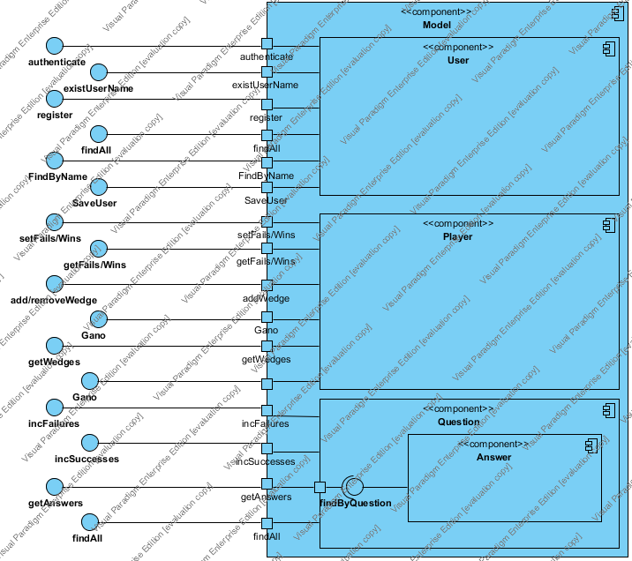

|  |  |
| --- | --- |
| Name | Value |
| Name | Model |
| Author | Trivial1a |
| Create Date Time | 04-may-2015 23:29:27 |
| Last Modified | 07-may-2015 22:57:35 |
| Teamwork Create Date Time | 0 |
| Show Component Attributes | false |
| Show Component Operations | false |

## Summary

|  |  |
| --- | --- |
| Name | Description |
| Image1.png Model | Modelo interno de datos de la aplicación. |
| Image2.png authenticate |  |
| Image1.png User | Representa a los usuarios de la base de datos.  son los que se registran y logean. |
| Image1.png Player | son los jugadores de una partida. son los que emplea el controlador para la dinámica del juego |
| Image1.png Question | preguntas que almacenan todas sus respuestas |
| Image1.png Answer | son las respuestas de las pregunas |

## Details

### Image3.png Model

|  |  |
| --- | --- |
| Name | Value |
| Description | Modelo interno de datos de la aplicación. |
| Active | false |
| Business Key Mutable | true |
| Business Model | false |
| Visibility | public |
| Abstract | false |
| Leaf | false |
| Root | false |
| Quality Score | Ignore |
| Indirectly Instantiated | true |
| Project Management | |  |  | | --- | --- | | Name | Value | | Author | Trivial1a | | Create Date Time | 05-may-2015 0:49:32 | | Last Modified | 07-may-2015 18:39:20 | |

#### Children

|  |  |
| --- | --- |
| Name | Description |
| Image1.png User | Representa a los usuarios de la base de datos.  son los que se registran y logean. |
| Image1.png Player | son los jugadores de una partida. son los que emplea el controlador para la dinámica del juego |
| Image1.png Question | preguntas que almacenan todas sus respuestas |

#### Resident Components

|  |  |
| --- | --- |
| Name | Description |
| Image3.png User | Representa a los usuarios de la base de datos.  son los que se registran y logean. |
| Image3.png Player | son los jugadores de una partida. son los que emplea el controlador para la dinámica del juego |
| Image3.png Question | preguntas que almacenan todas sus respuestas |

### Image5.png authenticate

|  |  |
| --- | --- |
| Name | Value |
| Active | false |
| Business Key Mutable | true |
| Business Model | false |
| Visibility | public |
| Leaf | false |
| Root | false |
| Stereotypes | Interface |
| Quality Score | Fair |
| Quality Reason | |  |  | | --- | --- | | Problem | Suggestion | | Model element at root | Add model element to a container | | Name does not contain glossary terms | Define name as term in glossary | |
| Project Management | |  |  | | --- | --- | | Name | Value | | Author | Trivial1a | | Create Date Time | 05-may-2015 2:08:07 | | Last Modified | 05-may-2015 2:13:56 | |

#### Relationships

|  |  |
| --- | --- |
| Unnamed Realization | |
| To | Image4.png authenticate |
| Visibility | Unspecified |
| Quality Score | Good |
| Project Management | |  |  | | --- | --- | | Name | Value | | Author | Trivial1a | | Create Date Time | 05-may-2015 2:08:07 | | Last Modified | 05-may-2015 2:13:56 | |

### Image3.png User

|  |  |
| --- | --- |
| Name | Value |
| Description | Representa a los usuarios de la base de datos.  son los que se registran y logean. |
| Active | false |
| Business Key Mutable | true |
| Business Model | false |
| Visibility | public |
| Abstract | false |
| Leaf | false |
| Root | false |
| Quality Score | Fair |
| Quality Reason | |  |  | | --- | --- | | Problem | Suggestion | | Name does not contain glossary terms | Define name as term in glossary | |
| Indirectly Instantiated | true |
| Project Management | |  |  | | --- | --- | | Name | Value | | Author | Trivial1a | | Create Date Time | 05-may-2015 1:36:13 | | Last Modified | 07-may-2015 18:39:20 | |

#### Relationships

|  |  |
| --- | --- |
| Unnamed Association | |
| To | |  |  | | --- | --- | | Name | Value | | End Model Element | Image6.png authenticate | | Provide Property Getter Method | false | | Provide Property Setter Method | false | | Multiplicity | Unspecified | | Visibility | Unspecified | | Aggregation Kind | None | | Navigable | Navigable | | Derived | false | | Derived Union | false | | Read Only | false | | Static | false | | Leaf | false | | Type | Image6.png authenticate | | Project Management | |  |  | | --- | --- | | Name | Value | | Author | Trivial1a | | Create Date Time | 05-may-2015 17:31:20 | | |
| Abstract | false |
| Leaf | false |
| Visibility | Unspecified |
| Quality Score | Good |
| Derived | false |
| Project Management | |  |  | | --- | --- | | Name | Value | | Author | Trivial1a | | Create Date Time | 05-may-2015 17:31:20 | | Last Modified | 05-may-2015 17:38:24 | |

|  |  |
| --- | --- |
| Unnamed Association | |
| To | |  |  | | --- | --- | | Name | Value | | End Model Element | Image6.png existUserName | | Provide Property Getter Method | false | | Provide Property Setter Method | false | | Multiplicity | Unspecified | | Visibility | Unspecified | | Aggregation Kind | None | | Navigable | Navigable | | Derived | false | | Derived Union | false | | Read Only | false | | Static | false | | Leaf | false | | Type | Image6.png existUserName | | Project Management | |  |  | | --- | --- | | Name | Value | | Author | Trivial1a | | Create Date Time | 05-may-2015 17:31:43 | | |
| Abstract | false |
| Leaf | false |
| Visibility | Unspecified |
| Quality Score | Good |
| Derived | false |
| Project Management | |  |  | | --- | --- | | Name | Value | | Author | Trivial1a | | Create Date Time | 05-may-2015 17:31:43 | | Last Modified | 05-may-2015 17:38:24 | |

|  |  |
| --- | --- |
| Unnamed Association | |
| To | |  |  | | --- | --- | | Name | Value | | End Model Element | Image6.png register | | Provide Property Getter Method | false | | Provide Property Setter Method | false | | Multiplicity | Unspecified | | Visibility | Unspecified | | Aggregation Kind | None | | Navigable | Navigable | | Derived | false | | Derived Union | false | | Read Only | false | | Static | false | | Leaf | false | | Type | Image6.png register | | Project Management | |  |  | | --- | --- | | Name | Value | | Author | Trivial1a | | Create Date Time | 05-may-2015 17:31:48 | | |
| Abstract | false |
| Leaf | false |
| Visibility | Unspecified |
| Quality Score | Good |
| Derived | false |
| Project Management | |  |  | | --- | --- | | Name | Value | | Author | Trivial1a | | Create Date Time | 05-may-2015 17:31:48 | | Last Modified | 05-may-2015 17:38:24 | |

|  |  |
| --- | --- |
| Unnamed Association | |
| To | |  |  | | --- | --- | | Name | Value | | End Model Element | Image6.png findAll | | Provide Property Getter Method | false | | Provide Property Setter Method | false | | Multiplicity | Unspecified | | Visibility | Unspecified | | Aggregation Kind | None | | Navigable | Navigable | | Derived | false | | Derived Union | false | | Read Only | false | | Static | false | | Leaf | false | | Type | Image6.png findAll | | Project Management | |  |  | | --- | --- | | Name | Value | | Author | Trivial1a | | Create Date Time | 05-may-2015 17:31:54 | | |
| Abstract | false |
| Leaf | false |
| Visibility | Unspecified |
| Quality Score | Good |
| Derived | false |
| Project Management | |  |  | | --- | --- | | Name | Value | | Author | Trivial1a | | Create Date Time | 05-may-2015 17:31:54 | | Last Modified | 05-may-2015 17:38:24 | |

|  |  |
| --- | --- |
| Unnamed Association | |
| To | |  |  | | --- | --- | | Name | Value | | End Model Element | Image6.png SaveUser | | Provide Property Getter Method | false | | Provide Property Setter Method | false | | Multiplicity | Unspecified | | Visibility | Unspecified | | Aggregation Kind | None | | Navigable | Navigable | | Derived | false | | Derived Union | false | | Read Only | false | | Static | false | | Leaf | false | | Type | Image6.png SaveUser | | Project Management | |  |  | | --- | --- | | Name | Value | | Author | Trivial1a | | Create Date Time | 07-may-2015 18:09:28 | | |
| Abstract | false |
| Leaf | false |
| Visibility | Unspecified |
| Quality Score | Good |
| Derived | false |
| Project Management | |  |  | | --- | --- | | Name | Value | | Author | Trivial1a | | Create Date Time | 07-may-2015 18:09:28 | | Last Modified | 07-may-2015 18:28:16 | |

|  |  |
| --- | --- |
| Unnamed Association | |
| To | |  |  | | --- | --- | | Name | Value | | End Model Element | Image6.png FindByName | | Provide Property Getter Method | false | | Provide Property Setter Method | false | | Multiplicity | Unspecified | | Visibility | Unspecified | | Aggregation Kind | None | | Navigable | Navigable | | Derived | false | | Derived Union | false | | Read Only | false | | Static | false | | Leaf | false | | Type | Image6.png FindByName | | Project Management | |  |  | | --- | --- | | Name | Value | | Author | Trivial1a | | Create Date Time | 07-may-2015 18:29:44 | | |
| Abstract | false |
| Leaf | false |
| Visibility | Unspecified |
| Quality Score | Good |
| Derived | false |
| Project Management | |  |  | | --- | --- | | Name | Value | | Author | Trivial1a | | Create Date Time | 07-may-2015 18:29:44 | | Last Modified | 07-may-2015 18:39:20 | |

### Image6.png authenticate

|  |  |
| --- | --- |
| Name | Value |
| Service | true |
| Behavior | false |
| Conjugated | false |
| Derived | false |
| Is ID | false |
| Derived Union | false |
| Aggregation | Unspecified |
| Multiplicity | Unspecified |
| Read Only | false |
| Static | false |
| Leaf | false |
| Visibility | public |
| Project Management | |  |  | | --- | --- | | Name | Value | | Author | Trivial1a | | Create Date Time | 05-may-2015 2:07:58 | | Last Modified | 05-may-2015 17:38:24 | |

#### Relationships

|  |  |
| --- | --- |
| Unnamed Realization | |
| From | Image2.png authenticate |
| Visibility | Unspecified |
| Quality Score | Good |
| Project Management | |  |  | | --- | --- | | Name | Value | | Author | Trivial1a | | Create Date Time | 05-may-2015 2:08:07 | | Last Modified | 05-may-2015 2:13:56 | |

|  |  |
| --- | --- |
| Unnamed Association | |
| From | |  |  | | --- | --- | | Name | Value | | End Model Element | Image3.png User | | Provide Property Getter Method | false | | Provide Property Setter Method | false | | Multiplicity | Unspecified | | Visibility | Unspecified | | Aggregation Kind | None | | Navigable | Navigable | | Derived | false | | Derived Union | false | | Read Only | false | | Static | false | | Leaf | false | | Type | Image3.png User | | Project Management | |  |  | | --- | --- | | Name | Value | | Author | Trivial1a | | Create Date Time | 05-may-2015 17:31:20 | | |
| Abstract | false |
| Leaf | false |
| Visibility | Unspecified |
| Quality Score | Good |
| Derived | false |
| Project Management | |  |  | | --- | --- | | Name | Value | | Author | Trivial1a | | Create Date Time | 05-may-2015 17:31:20 | | Last Modified | 05-may-2015 17:38:24 | |

### Image5.png existUserName

|  |  |
| --- | --- |
| Name | Value |
| Active | false |
| Business Key Mutable | true |
| Business Model | false |
| Visibility | public |
| Leaf | false |
| Root | false |
| Stereotypes | Interface |
| Quality Score | Fair |
| Quality Reason | |  |  | | --- | --- | | Problem | Suggestion | | Model element at root | Add model element to a container | | Name does not contain glossary terms | Define name as term in glossary | |
| Project Management | |  |  | | --- | --- | | Name | Value | | Author | Trivial1a | | Create Date Time | 05-may-2015 2:10:40 | | Last Modified | 07-may-2015 18:13:03 | |

#### Relationships

|  |  |
| --- | --- |
| Unnamed Realization | |
| To | Image4.png existUserName |
| Visibility | Unspecified |
| Quality Score | Good |
| Project Management | |  |  | | --- | --- | | Name | Value | | Author | Trivial1a | | Create Date Time | 05-may-2015 2:10:40 | | Last Modified | 05-may-2015 2:24:27 | |

### Image6.png existUserName

|  |  |
| --- | --- |
| Name | Value |
| Service | true |
| Behavior | false |
| Conjugated | false |
| Derived | false |
| Is ID | false |
| Derived Union | false |
| Aggregation | Unspecified |
| Multiplicity | Unspecified |
| Read Only | false |
| Static | false |
| Leaf | false |
| Visibility | public |
| Project Management | |  |  | | --- | --- | | Name | Value | | Author | Trivial1a | | Create Date Time | 05-may-2015 2:10:28 | | Last Modified | 05-may-2015 17:38:24 | |

#### Relationships

|  |  |
| --- | --- |
| Unnamed Realization | |
| From | Image2.png existUserName |
| Visibility | Unspecified |
| Quality Score | Good |
| Project Management | |  |  | | --- | --- | | Name | Value | | Author | Trivial1a | | Create Date Time | 05-may-2015 2:10:40 | | Last Modified | 05-may-2015 2:24:27 | |

|  |  |
| --- | --- |
| Unnamed Association | |
| From | |  |  | | --- | --- | | Name | Value | | End Model Element | Image3.png User | | Provide Property Getter Method | false | | Provide Property Setter Method | false | | Multiplicity | Unspecified | | Visibility | Unspecified | | Aggregation Kind | None | | Navigable | Navigable | | Derived | false | | Derived Union | false | | Read Only | false | | Static | false | | Leaf | false | | Type | Image3.png User | | Project Management | |  |  | | --- | --- | | Name | Value | | Author | Trivial1a | | Create Date Time | 05-may-2015 17:31:43 | | |
| Abstract | false |
| Leaf | false |
| Visibility | Unspecified |
| Quality Score | Good |
| Derived | false |
| Project Management | |  |  | | --- | --- | | Name | Value | | Author | Trivial1a | | Create Date Time | 05-may-2015 17:31:43 | | Last Modified | 05-may-2015 17:38:24 | |

### Image5.png register

|  |  |
| --- | --- |
| Name | Value |
| Active | false |
| Business Key Mutable | true |
| Business Model | false |
| Visibility | public |
| Leaf | false |
| Root | false |
| Stereotypes | Interface |
| Quality Score | Fair |
| Quality Reason | |  |  | | --- | --- | | Problem | Suggestion | | Model element at root | Add model element to a container | | Name does not contain glossary terms | Define name as term in glossary | |
| Project Management | |  |  | | --- | --- | | Name | Value | | Author | Trivial1a | | Create Date Time | 05-may-2015 2:12:00 | | Last Modified | 07-may-2015 18:13:03 | |

#### Relationships

|  |  |
| --- | --- |
| Unnamed Realization | |
| To | Image4.png register |
| Visibility | Unspecified |
| Quality Score | Good |
| Project Management | |  |  | | --- | --- | | Name | Value | | Author | Trivial1a | | Create Date Time | 05-may-2015 2:12:00 | | Last Modified | 05-may-2015 2:24:27 | |

### Image6.png register

|  |  |
| --- | --- |
| Name | Value |
| Service | true |
| Behavior | false |
| Conjugated | false |
| Derived | false |
| Is ID | false |
| Derived Union | false |
| Aggregation | Unspecified |
| Multiplicity | Unspecified |
| Read Only | false |
| Static | false |
| Leaf | false |
| Visibility | public |
| Project Management | |  |  | | --- | --- | | Name | Value | | Author | Trivial1a | | Create Date Time | 05-may-2015 2:11:53 | | Last Modified | 05-may-2015 17:38:24 | |

#### Relationships

|  |  |
| --- | --- |
| Unnamed Realization | |
| From | Image2.png register |
| Visibility | Unspecified |
| Quality Score | Good |
| Project Management | |  |  | | --- | --- | | Name | Value | | Author | Trivial1a | | Create Date Time | 05-may-2015 2:12:00 | | Last Modified | 05-may-2015 2:24:27 | |

|  |  |
| --- | --- |
| Unnamed Association | |
| From | |  |  | | --- | --- | | Name | Value | | End Model Element | Image3.png User | | Provide Property Getter Method | false | | Provide Property Setter Method | false | | Multiplicity | Unspecified | | Visibility | Unspecified | | Aggregation Kind | None | | Navigable | Navigable | | Derived | false | | Derived Union | false | | Read Only | false | | Static | false | | Leaf | false | | Type | Image3.png User | | Project Management | |  |  | | --- | --- | | Name | Value | | Author | Trivial1a | | Create Date Time | 05-may-2015 17:31:48 | | |
| Abstract | false |
| Leaf | false |
| Visibility | Unspecified |
| Quality Score | Good |
| Derived | false |
| Project Management | |  |  | | --- | --- | | Name | Value | | Author | Trivial1a | | Create Date Time | 05-may-2015 17:31:48 | | Last Modified | 05-may-2015 17:38:24 | |

### Image6.png findAll

|  |  |
| --- | --- |
| Name | Value |
| Service | true |
| Behavior | false |
| Conjugated | false |
| Derived | false |
| Is ID | false |
| Derived Union | false |
| Aggregation | Unspecified |
| Multiplicity | Unspecified |
| Read Only | false |
| Static | false |
| Leaf | false |
| Visibility | public |
| Project Management | |  |  | | --- | --- | | Name | Value | | Author | Trivial1a | | Create Date Time | 05-may-2015 2:17:39 | | Last Modified | 05-may-2015 17:38:24 | |

#### Relationships

|  |  |
| --- | --- |
| Unnamed Realization | |
| From | Image2.png findAll |
| Visibility | Unspecified |
| Quality Score | Good |
| Project Management | |  |  | | --- | --- | | Name | Value | | Author | Trivial1a | | Create Date Time | 05-may-2015 2:17:52 | | Last Modified | 05-may-2015 2:24:27 | |

|  |  |
| --- | --- |
| Unnamed Association | |
| From | |  |  | | --- | --- | | Name | Value | | End Model Element | Image3.png User | | Provide Property Getter Method | false | | Provide Property Setter Method | false | | Multiplicity | Unspecified | | Visibility | Unspecified | | Aggregation Kind | None | | Navigable | Navigable | | Derived | false | | Derived Union | false | | Read Only | false | | Static | false | | Leaf | false | | Type | Image3.png User | | Project Management | |  |  | | --- | --- | | Name | Value | | Author | Trivial1a | | Create Date Time | 05-may-2015 17:31:54 | | |
| Abstract | false |
| Leaf | false |
| Visibility | Unspecified |
| Quality Score | Good |
| Derived | false |
| Project Management | |  |  | | --- | --- | | Name | Value | | Author | Trivial1a | | Create Date Time | 05-may-2015 17:31:54 | | Last Modified | 05-may-2015 17:38:24 | |

### Image5.png FindByName

|  |  |
| --- | --- |
| Name | Value |
| Active | false |
| Business Key Mutable | true |
| Business Model | false |
| Visibility | public |
| Leaf | false |
| Root | false |
| Stereotypes | Interface |
| Quality Score | Fair |
| Quality Reason | |  |  | | --- | --- | | Problem | Suggestion | | Model element at root | Add model element to a container | | Name does not contain glossary terms | Define name as term in glossary | |
| Project Management | |  |  | | --- | --- | | Name | Value | | Author | Trivial1a | | Create Date Time | 07-may-2015 18:29:17 | | Last Modified | 07-may-2015 18:39:20 | |

#### Relationships

|  |  |
| --- | --- |
| Unnamed Realization | |
| To | Image4.png FindByName |
| Visibility | Unspecified |
| Quality Score | Good |
| Project Management | |  |  | | --- | --- | | Name | Value | | Author | Trivial1a | | Create Date Time | 07-may-2015 18:29:17 | | Last Modified | 07-may-2015 18:39:20 | |

### Image6.png FindByName

|  |  |
| --- | --- |
| Name | Value |
| Service | true |
| Behavior | false |
| Conjugated | false |
| Derived | false |
| Is ID | false |
| Derived Union | false |
| Aggregation | Unspecified |
| Multiplicity | Unspecified |
| Read Only | false |
| Static | false |
| Leaf | false |
| Visibility | public |
| Project Management | |  |  | | --- | --- | | Name | Value | | Author | Trivial1a | | Create Date Time | 07-may-2015 18:29:07 | | Last Modified | 07-may-2015 18:39:20 | |

#### Relationships

|  |  |
| --- | --- |
| Unnamed Realization | |
| From | Image2.png FindByName |
| Visibility | Unspecified |
| Quality Score | Good |
| Project Management | |  |  | | --- | --- | | Name | Value | | Author | Trivial1a | | Create Date Time | 07-may-2015 18:29:17 | | Last Modified | 07-may-2015 18:39:20 | |

|  |  |
| --- | --- |
| Unnamed Association | |
| From | |  |  | | --- | --- | | Name | Value | | End Model Element | Image3.png User | | Provide Property Getter Method | false | | Provide Property Setter Method | false | | Multiplicity | Unspecified | | Visibility | Unspecified | | Aggregation Kind | None | | Navigable | Navigable | | Derived | false | | Derived Union | false | | Read Only | false | | Static | false | | Leaf | false | | Type | Image3.png User | | Project Management | |  |  | | --- | --- | | Name | Value | | Author | Trivial1a | | Create Date Time | 07-may-2015 18:29:44 | | |
| Abstract | false |
| Leaf | false |
| Visibility | Unspecified |
| Quality Score | Good |
| Derived | false |
| Project Management | |  |  | | --- | --- | | Name | Value | | Author | Trivial1a | | Create Date Time | 07-may-2015 18:29:44 | | Last Modified | 07-may-2015 18:39:20 | |

### Image5.png SaveUser

|  |  |
| --- | --- |
| Name | Value |
| Active | false |
| Business Key Mutable | true |
| Business Model | false |
| Visibility | public |
| Leaf | false |
| Root | false |
| Stereotypes | Interface |
| Quality Score | Fair |
| Quality Reason | |  |  | | --- | --- | | Problem | Suggestion | | Model element at root | Add model element to a container | | Name does not contain glossary terms | Define name as term in glossary | |
| Project Management | |  |  | | --- | --- | | Name | Value | | Author | Trivial1a | | Create Date Time | 07-may-2015 18:08:40 | | Last Modified | 07-may-2015 18:28:16 | |

#### Relationships

|  |  |
| --- | --- |
| Unnamed Realization | |
| To | Image4.png SaveUser |
| Visibility | Unspecified |
| Quality Score | Good |
| Project Management | |  |  | | --- | --- | | Name | Value | | Author | Trivial1a | | Create Date Time | 07-may-2015 18:08:40 | | Last Modified | 07-may-2015 18:28:16 | |

### Image6.png SaveUser

|  |  |
| --- | --- |
| Name | Value |
| Service | true |
| Behavior | false |
| Conjugated | false |
| Derived | false |
| Is ID | false |
| Derived Union | false |
| Aggregation | Unspecified |
| Multiplicity | Unspecified |
| Read Only | false |
| Static | false |
| Leaf | false |
| Visibility | public |
| Project Management | |  |  | | --- | --- | | Name | Value | | Author | Trivial1a | | Create Date Time | 07-may-2015 18:08:20 | | Last Modified | 07-may-2015 18:13:03 | |

#### Relationships

|  |  |
| --- | --- |
| Unnamed Realization | |
| From | Image2.png SaveUser |
| Visibility | Unspecified |
| Quality Score | Good |
| Project Management | |  |  | | --- | --- | | Name | Value | | Author | Trivial1a | | Create Date Time | 07-may-2015 18:08:40 | | Last Modified | 07-may-2015 18:28:16 | |

|  |  |
| --- | --- |
| Unnamed Association | |
| From | |  |  | | --- | --- | | Name | Value | | End Model Element | Image3.png User | | Provide Property Getter Method | false | | Provide Property Setter Method | false | | Multiplicity | Unspecified | | Visibility | Unspecified | | Aggregation Kind | None | | Navigable | Navigable | | Derived | false | | Derived Union | false | | Read Only | false | | Static | false | | Leaf | false | | Type | Image3.png User | | Project Management | |  |  | | --- | --- | | Name | Value | | Author | Trivial1a | | Create Date Time | 07-may-2015 18:09:28 | | |
| Abstract | false |
| Leaf | false |
| Visibility | Unspecified |
| Quality Score | Good |
| Derived | false |
| Project Management | |  |  | | --- | --- | | Name | Value | | Author | Trivial1a | | Create Date Time | 07-may-2015 18:09:28 | | Last Modified | 07-may-2015 18:28:16 | |

### Image5.png setFails/Wins

|  |  |
| --- | --- |
| Name | Value |
| Active | false |
| Business Key Mutable | true |
| Business Model | false |
| Visibility | public |
| Leaf | false |
| Root | false |
| Stereotypes | Interface |
| Quality Score | Fair |
| Quality Reason | |  |  | | --- | --- | | Problem | Suggestion | | Model element at root | Add model element to a container | | Name does not contain glossary terms | Define name as term in glossary | |
| Project Management | |  |  | | --- | --- | | Name | Value | | Author | Trivial1a | | Create Date Time | 05-may-2015 17:03:59 | | Last Modified | 06-may-2015 1:50:14 | |

#### Relationships

|  |  |
| --- | --- |
| Unnamed Realization | |
| To | Image4.png setFails/Wins |
| Visibility | Unspecified |
| Quality Score | Good |
| Project Management | |  |  | | --- | --- | | Name | Value | | Author | Trivial1a | | Create Date Time | 05-may-2015 17:04:00 | | Last Modified | 05-may-2015 17:38:24 | |

### Image3.png Player

|  |  |
| --- | --- |
| Name | Value |
| Description | son los jugadores de una partida. son los que emplea el controlador para la dinámica del juego |
| Active | false |
| Business Key Mutable | true |
| Business Model | false |
| Visibility | public |
| Abstract | false |
| Leaf | false |
| Root | false |
| Quality Score | Fair |
| Quality Reason | |  |  | | --- | --- | | Problem | Suggestion | | Name does not contain glossary terms | Define name as term in glossary | |
| Indirectly Instantiated | true |
| Project Management | |  |  | | --- | --- | | Name | Value | | Author | Trivial1a | | Create Date Time | 05-may-2015 1:36:22 | | Last Modified | 07-may-2015 18:28:16 | |

#### Relationships

|  |  |
| --- | --- |
| Unnamed Association | |
| To | |  |  | | --- | --- | | Name | Value | | End Model Element | Image6.png getWedges | | Provide Property Getter Method | false | | Provide Property Setter Method | false | | Multiplicity | Unspecified | | Visibility | Unspecified | | Aggregation Kind | None | | Navigable | Navigable | | Derived | false | | Derived Union | false | | Read Only | false | | Static | false | | Leaf | false | | Type | Image6.png getWedges | | Project Management | |  |  | | --- | --- | | Name | Value | | Author | Trivial1a | | Create Date Time | 05-may-2015 17:33:47 | | |
| Abstract | false |
| Leaf | false |
| Visibility | Unspecified |
| Quality Score | Good |
| Derived | false |
| Project Management | |  |  | | --- | --- | | Name | Value | | Author | Trivial1a | | Create Date Time | 05-may-2015 17:33:47 | | Last Modified | 05-may-2015 17:38:24 | |

|  |  |
| --- | --- |
| Unnamed Association | |
| To | |  |  | | --- | --- | | Name | Value | | End Model Element | Image6.png addWedge | | Provide Property Getter Method | false | | Provide Property Setter Method | false | | Multiplicity | Unspecified | | Visibility | Unspecified | | Aggregation Kind | None | | Navigable | Navigable | | Derived | false | | Derived Union | false | | Read Only | false | | Static | false | | Leaf | false | | Type | Image6.png addWedge | | Project Management | |  |  | | --- | --- | | Name | Value | | Author | Trivial1a | | Create Date Time | 05-may-2015 17:34:01 | | |
| Abstract | false |
| Leaf | false |
| Visibility | Unspecified |
| Quality Score | Good |
| Derived | false |
| Project Management | |  |  | | --- | --- | | Name | Value | | Author | Trivial1a | | Create Date Time | 05-may-2015 17:34:01 | | Last Modified | 05-may-2015 17:38:24 | |

|  |  |
| --- | --- |
| Unnamed Association | |
| To | |  |  | | --- | --- | | Name | Value | | End Model Element | Image6.png getFails/Wins | | Provide Property Getter Method | false | | Provide Property Setter Method | false | | Multiplicity | Unspecified | | Visibility | Unspecified | | Aggregation Kind | None | | Navigable | Navigable | | Derived | false | | Derived Union | false | | Read Only | false | | Static | false | | Leaf | false | | Type | Image6.png getFails/Wins | | Project Management | |  |  | | --- | --- | | Name | Value | | Author | Trivial1a | | Create Date Time | 05-may-2015 17:34:10 | | |
| Abstract | false |
| Leaf | false |
| Visibility | Unspecified |
| Quality Score | Good |
| Derived | false |
| Project Management | |  |  | | --- | --- | | Name | Value | | Author | Trivial1a | | Create Date Time | 05-may-2015 17:34:10 | | Last Modified | 05-may-2015 17:38:24 | |

|  |  |
| --- | --- |
| Unnamed Association | |
| To | |  |  | | --- | --- | | Name | Value | | End Model Element | Image6.png setFails/Wins | | Provide Property Getter Method | false | | Provide Property Setter Method | false | | Multiplicity | Unspecified | | Visibility | Unspecified | | Aggregation Kind | None | | Navigable | Navigable | | Derived | false | | Derived Union | false | | Read Only | false | | Static | false | | Leaf | false | | Type | Image6.png setFails/Wins | | Project Management | |  |  | | --- | --- | | Name | Value | | Author | Trivial1a | | Create Date Time | 05-may-2015 17:34:15 | | |
| Abstract | false |
| Leaf | false |
| Visibility | Unspecified |
| Quality Score | Good |
| Derived | false |
| Project Management | |  |  | | --- | --- | | Name | Value | | Author | Trivial1a | | Create Date Time | 05-may-2015 17:34:15 | | Last Modified | 05-may-2015 17:38:24 | |

|  |  |
| --- | --- |
| Unnamed Association | |
| To | |  |  | | --- | --- | | Name | Value | | End Model Element | Image6.png N/A | | Provide Property Getter Method | false | | Provide Property Setter Method | false | | Multiplicity | Unspecified | | Visibility | Unspecified | | Aggregation Kind | None | | Navigable | Navigable | | Derived | false | | Derived Union | false | | Read Only | false | | Static | false | | Leaf | false | | Type | Image6.png N/A | | Project Management | |  |  | | --- | --- | | Name | Value | | Author | Trivial1a | | Create Date Time | 06-may-2015 23:46:42 | | |
| Abstract | false |
| Leaf | false |
| Visibility | Unspecified |
| Quality Score | Good |
| Derived | false |
| Project Management | |  |  | | --- | --- | | Name | Value | | Author | Trivial1a | | Create Date Time | 06-may-2015 23:46:42 | | Last Modified | 06-may-2015 23:53:32 | |

|  |  |
| --- | --- |
| Unnamed Association | |
| To | |  |  | | --- | --- | | Name | Value | | End Model Element | Image6.png Gano | | Provide Property Getter Method | false | | Provide Property Setter Method | false | | Multiplicity | Unspecified | | Visibility | Unspecified | | Aggregation Kind | None | | Navigable | Navigable | | Derived | false | | Derived Union | false | | Read Only | false | | Static | false | | Leaf | false | | Type | Image6.png Gano | | Project Management | |  |  | | --- | --- | | Name | Value | | Author | Trivial1a | | Create Date Time | 07-may-2015 18:27:36 | | |
| Abstract | false |
| Leaf | false |
| Visibility | Unspecified |
| Quality Score | Good |
| Derived | false |
| Project Management | |  |  | | --- | --- | | Name | Value | | Author | Trivial1a | | Create Date Time | 07-may-2015 18:27:36 | | Last Modified | 07-may-2015 18:39:20 | |

### Image6.png setFails/Wins

|  |  |
| --- | --- |
| Name | Value |
| Service | true |
| Behavior | false |
| Conjugated | false |
| Derived | false |
| Is ID | false |
| Derived Union | false |
| Aggregation | Unspecified |
| Multiplicity | Unspecified |
| Read Only | false |
| Static | false |
| Leaf | false |
| Visibility | public |
| Project Management | |  |  | | --- | --- | | Name | Value | | Author | Trivial1a | | Create Date Time | 05-may-2015 17:32:03 | | Last Modified | 06-may-2015 0:24:58 | |

#### Relationships

|  |  |
| --- | --- |
| Unnamed Realization | |
| From | Image2.png setFails/Wins |
| Visibility | Unspecified |
| Quality Score | Good |
| Project Management | |  |  | | --- | --- | | Name | Value | | Author | Trivial1a | | Create Date Time | 05-may-2015 17:04:00 | | Last Modified | 05-may-2015 17:38:24 | |

|  |  |
| --- | --- |
| Unnamed Association | |
| From | |  |  | | --- | --- | | Name | Value | | End Model Element | Image3.png Player | | Provide Property Getter Method | false | | Provide Property Setter Method | false | | Multiplicity | Unspecified | | Visibility | Unspecified | | Aggregation Kind | None | | Navigable | Navigable | | Derived | false | | Derived Union | false | | Read Only | false | | Static | false | | Leaf | false | | Type | Image3.png Player | | Project Management | |  |  | | --- | --- | | Name | Value | | Author | Trivial1a | | Create Date Time | 05-may-2015 17:34:15 | | |
| Abstract | false |
| Leaf | false |
| Visibility | Unspecified |
| Quality Score | Good |
| Derived | false |
| Project Management | |  |  | | --- | --- | | Name | Value | | Author | Trivial1a | | Create Date Time | 05-may-2015 17:34:15 | | Last Modified | 05-may-2015 17:38:24 | |

### Image5.png getFails/Wins

|  |  |
| --- | --- |
| Name | Value |
| Active | false |
| Business Key Mutable | true |
| Business Model | false |
| Visibility | public |
| Leaf | false |
| Root | false |
| Stereotypes | Interface |
| Quality Score | Fair |
| Quality Reason | |  |  | | --- | --- | | Problem | Suggestion | | Model element at root | Add model element to a container | | Name does not contain glossary terms | Define name as term in glossary | |
| Project Management | |  |  | | --- | --- | | Name | Value | | Author | Trivial1a | | Create Date Time | 05-may-2015 17:04:14 | | Last Modified | 07-may-2015 18:39:20 | |

#### Relationships

|  |  |
| --- | --- |
| Unnamed Realization | |
| To | Image4.png getFails/Wins |
| Visibility | Unspecified |
| Quality Score | Good |
| Project Management | |  |  | | --- | --- | | Name | Value | | Author | Trivial1a | | Create Date Time | 05-may-2015 17:04:14 | | Last Modified | 05-may-2015 17:38:24 | |

### Image6.png getFails/Wins

|  |  |
| --- | --- |
| Name | Value |
| Service | true |
| Behavior | false |
| Conjugated | false |
| Derived | false |
| Is ID | false |
| Derived Union | false |
| Aggregation | Unspecified |
| Multiplicity | Unspecified |
| Read Only | false |
| Static | false |
| Leaf | false |
| Visibility | public |
| Project Management | |  |  | | --- | --- | | Name | Value | | Author | Trivial1a | | Create Date Time | 05-may-2015 17:32:21 | | Last Modified | 06-may-2015 0:24:58 | |

#### Relationships

|  |  |
| --- | --- |
| Unnamed Realization | |
| From | Image2.png getFails/Wins |
| Visibility | Unspecified |
| Quality Score | Good |
| Project Management | |  |  | | --- | --- | | Name | Value | | Author | Trivial1a | | Create Date Time | 05-may-2015 17:04:14 | | Last Modified | 05-may-2015 17:38:24 | |

|  |  |
| --- | --- |
| Unnamed Association | |
| From | |  |  | | --- | --- | | Name | Value | | End Model Element | Image3.png Player | | Provide Property Getter Method | false | | Provide Property Setter Method | false | | Multiplicity | Unspecified | | Visibility | Unspecified | | Aggregation Kind | None | | Navigable | Navigable | | Derived | false | | Derived Union | false | | Read Only | false | | Static | false | | Leaf | false | | Type | Image3.png Player | | Project Management | |  |  | | --- | --- | | Name | Value | | Author | Trivial1a | | Create Date Time | 05-may-2015 17:34:10 | | |
| Abstract | false |
| Leaf | false |
| Visibility | Unspecified |
| Quality Score | Good |
| Derived | false |
| Project Management | |  |  | | --- | --- | | Name | Value | | Author | Trivial1a | | Create Date Time | 05-may-2015 17:34:10 | | Last Modified | 05-may-2015 17:38:24 | |

### Image5.png add/removeWedge

|  |  |
| --- | --- |
| Name | Value |
| Active | false |
| Business Key Mutable | true |
| Business Model | false |
| Visibility | public |
| Leaf | false |
| Root | false |
| Stereotypes | Interface |
| Quality Score | Fair |
| Quality Reason | |  |  | | --- | --- | | Problem | Suggestion | | Model element at root | Add model element to a container | | Name does not contain glossary terms | Define name as term in glossary | |
| Project Management | |  |  | | --- | --- | | Name | Value | | Author | Trivial1a | | Create Date Time | 05-may-2015 17:05:30 | | Last Modified | 06-may-2015 1:50:14 | |

#### Relationships

|  |  |
| --- | --- |
| Unnamed Realization | |
| To | Image4.png addWedge |
| Visibility | Unspecified |
| Quality Score | Good |
| Project Management | |  |  | | --- | --- | | Name | Value | | Author | Trivial1a | | Create Date Time | 05-may-2015 17:05:30 | | Last Modified | 05-may-2015 17:38:24 | |

### Image6.png addWedge

|  |  |
| --- | --- |
| Name | Value |
| Service | true |
| Behavior | false |
| Conjugated | false |
| Derived | false |
| Is ID | false |
| Derived Union | false |
| Aggregation | Unspecified |
| Multiplicity | Unspecified |
| Read Only | false |
| Static | false |
| Leaf | false |
| Visibility | public |
| Project Management | |  |  | | --- | --- | | Name | Value | | Author | Trivial1a | | Create Date Time | 05-may-2015 17:32:38 | | Last Modified | 06-may-2015 0:24:58 | |

#### Relationships

|  |  |
| --- | --- |
| Unnamed Realization | |
| From | Image2.png add/removeWedge |
| Visibility | Unspecified |
| Quality Score | Good |
| Project Management | |  |  | | --- | --- | | Name | Value | | Author | Trivial1a | | Create Date Time | 05-may-2015 17:05:30 | | Last Modified | 05-may-2015 17:38:24 | |

|  |  |
| --- | --- |
| Unnamed Association | |
| From | |  |  | | --- | --- | | Name | Value | | End Model Element | Image3.png Player | | Provide Property Getter Method | false | | Provide Property Setter Method | false | | Multiplicity | Unspecified | | Visibility | Unspecified | | Aggregation Kind | None | | Navigable | Navigable | | Derived | false | | Derived Union | false | | Read Only | false | | Static | false | | Leaf | false | | Type | Image3.png Player | | Project Management | |  |  | | --- | --- | | Name | Value | | Author | Trivial1a | | Create Date Time | 05-may-2015 17:34:01 | | |
| Abstract | false |
| Leaf | false |
| Visibility | Unspecified |
| Quality Score | Good |
| Derived | false |
| Project Management | |  |  | | --- | --- | | Name | Value | | Author | Trivial1a | | Create Date Time | 05-may-2015 17:34:01 | | Last Modified | 05-may-2015 17:38:24 | |

### Image5.png Gano

|  |  |
| --- | --- |
| Name | Value |
| Active | false |
| Business Key Mutable | true |
| Business Model | false |
| Visibility | public |
| Leaf | false |
| Root | false |
| Stereotypes | Interface |
| Quality Score | Fair |
| Quality Reason | |  |  | | --- | --- | | Problem | Suggestion | | Model element at root | Add model element to a container | | Name does not contain glossary terms | Define name as term in glossary | |
| Project Management | |  |  | | --- | --- | | Name | Value | | Author | Trivial1a | | Create Date Time | 06-may-2015 23:47:12 | | Last Modified | 07-may-2015 18:13:03 | |

#### Relationships

|  |  |
| --- | --- |
| Unnamed Realization | |
| To | Image4.png Gano |
| Visibility | Unspecified |
| Quality Score | Good |
| Project Management | |  |  | | --- | --- | | Name | Value | | Author | Trivial1a | | Create Date Time | 07-may-2015 18:12:54 | | Last Modified | 07-may-2015 18:28:16 | |

### Image6.png Gano

|  |  |
| --- | --- |
| Name | Value |
| Service | true |
| Behavior | false |
| Conjugated | false |
| Derived | false |
| Is ID | false |
| Derived Union | false |
| Aggregation | Unspecified |
| Multiplicity | Unspecified |
| Read Only | false |
| Static | false |
| Leaf | false |
| Visibility | public |
| Project Management | |  |  | | --- | --- | | Name | Value | | Author | Trivial1a | | Create Date Time | 07-may-2015 18:10:59 | | Last Modified | 07-may-2015 18:28:16 | |

#### Relationships

|  |  |
| --- | --- |
| Unnamed Realization | |
| From | Image2.png Gano |
| Visibility | Unspecified |
| Quality Score | Good |
| Project Management | |  |  | | --- | --- | | Name | Value | | Author | Trivial1a | | Create Date Time | 07-may-2015 18:12:54 | | Last Modified | 07-may-2015 18:28:16 | |

|  |  |
| --- | --- |
| Unnamed Association | |
| From | |  |  | | --- | --- | | Name | Value | | End Model Element | Image3.png Player | | Provide Property Getter Method | false | | Provide Property Setter Method | false | | Multiplicity | Unspecified | | Visibility | Unspecified | | Aggregation Kind | None | | Navigable | Navigable | | Derived | false | | Derived Union | false | | Read Only | false | | Static | false | | Leaf | false | | Type | Image3.png Player | | Project Management | |  |  | | --- | --- | | Name | Value | | Author | Trivial1a | | Create Date Time | 07-may-2015 18:27:36 | | |
| Abstract | false |
| Leaf | false |
| Visibility | Unspecified |
| Quality Score | Good |
| Derived | false |
| Project Management | |  |  | | --- | --- | | Name | Value | | Author | Trivial1a | | Create Date Time | 07-may-2015 18:27:36 | | Last Modified | 07-may-2015 18:39:20 | |

### Image5.png getWedges

|  |  |
| --- | --- |
| Name | Value |
| Active | false |
| Business Key Mutable | true |
| Business Model | false |
| Visibility | public |
| Leaf | false |
| Root | false |
| Stereotypes | Interface |
| Quality Score | Fair |
| Quality Reason | |  |  | | --- | --- | | Problem | Suggestion | | Model element at root | Add model element to a container | | Name does not contain glossary terms | Define name as term in glossary | |
| Project Management | |  |  | | --- | --- | | Name | Value | | Author | Trivial1a | | Create Date Time | 05-may-2015 17:07:23 | | Last Modified | 06-may-2015 1:39:13 | |

#### Relationships

|  |  |
| --- | --- |
| Unnamed Realization | |
| To | Image4.png getWedges |
| Visibility | Unspecified |
| Quality Score | Good |
| Project Management | |  |  | | --- | --- | | Name | Value | | Author | Trivial1a | | Create Date Time | 05-may-2015 17:07:24 | | Last Modified | 05-may-2015 17:38:24 | |

### Image6.png getWedges

|  |  |
| --- | --- |
| Name | Value |
| Service | true |
| Behavior | false |
| Conjugated | false |
| Derived | false |
| Is ID | false |
| Derived Union | false |
| Aggregation | Unspecified |
| Multiplicity | Unspecified |
| Read Only | false |
| Static | false |
| Leaf | false |
| Visibility | public |
| Project Management | |  |  | | --- | --- | | Name | Value | | Author | Trivial1a | | Create Date Time | 05-may-2015 17:32:59 | | Last Modified | 06-may-2015 0:24:58 | |

#### Relationships

|  |  |
| --- | --- |
| Unnamed Realization | |
| From | Image2.png getWedges |
| Visibility | Unspecified |
| Quality Score | Good |
| Project Management | |  |  | | --- | --- | | Name | Value | | Author | Trivial1a | | Create Date Time | 05-may-2015 17:07:24 | | Last Modified | 05-may-2015 17:38:24 | |

|  |  |
| --- | --- |
| Unnamed Association | |
| From | |  |  | | --- | --- | | Name | Value | | End Model Element | Image3.png Player | | Provide Property Getter Method | false | | Provide Property Setter Method | false | | Multiplicity | Unspecified | | Visibility | Unspecified | | Aggregation Kind | None | | Navigable | Navigable | | Derived | false | | Derived Union | false | | Read Only | false | | Static | false | | Leaf | false | | Type | Image3.png Player | | Project Management | |  |  | | --- | --- | | Name | Value | | Author | Trivial1a | | Create Date Time | 05-may-2015 17:33:47 | | |
| Abstract | false |
| Leaf | false |
| Visibility | Unspecified |
| Quality Score | Good |
| Derived | false |
| Project Management | |  |  | | --- | --- | | Name | Value | | Author | Trivial1a | | Create Date Time | 05-may-2015 17:33:47 | | Last Modified | 05-may-2015 17:38:24 | |

#### Relationships

|  |  |
| --- | --- |
| Unnamed Association | |
| From | |  |  | | --- | --- | | Name | Value | | End Model Element | Image3.png Player | | Provide Property Getter Method | false | | Provide Property Setter Method | false | | Multiplicity | Unspecified | | Visibility | Unspecified | | Aggregation Kind | None | | Navigable | Navigable | | Derived | false | | Derived Union | false | | Read Only | false | | Static | false | | Leaf | false | | Type | Image3.png Player | | Project Management | |  |  | | --- | --- | | Name | Value | | Author | Trivial1a | | Create Date Time | 06-may-2015 23:46:42 | | |
| Abstract | false |
| Leaf | false |
| Visibility | Unspecified |
| Quality Score | Good |
| Derived | false |
| Project Management | |  |  | | --- | --- | | Name | Value | | Author | Trivial1a | | Create Date Time | 06-may-2015 23:46:42 | | Last Modified | 06-may-2015 23:53:32 | |

|  |  |
| --- | --- |
| Unnamed Realization | |
| From | Image2.png Gano |
| Visibility | Unspecified |
| Quality Score | Good |
| Project Management | |  |  | | --- | --- | | Name | Value | | Author | Trivial1a | | Create Date Time | 06-may-2015 23:47:12 | | Last Modified | 06-may-2015 23:53:32 | |

### Image5.png incFailures

|  |  |
| --- | --- |
| Name | Value |
| Active | false |
| Business Key Mutable | true |
| Business Model | false |
| Visibility | public |
| Leaf | false |
| Root | false |
| Stereotypes | Interface |
| Quality Score | Fair |
| Quality Reason | |  |  | | --- | --- | | Problem | Suggestion | | Model element at root | Add model element to a container | | Name does not contain glossary terms | Define name as term in glossary | |
| Project Management | |  |  | | --- | --- | | Name | Value | | Author | Trivial1a | | Create Date Time | 05-may-2015 3:00:42 | | Last Modified | 06-may-2015 1:39:13 | |

#### Relationships

|  |  |
| --- | --- |
| Unnamed Realization | |
| To | Image4.png incFailures |
| Visibility | Unspecified |
| Quality Score | Good |
| Project Management | |  |  | | --- | --- | | Name | Value | | Author | Trivial1a | | Create Date Time | 05-may-2015 3:00:42 | | Last Modified | 05-may-2015 17:03:11 | |

### Image3.png Question

|  |  |
| --- | --- |
| Name | Value |
| Description | preguntas que almacenan todas sus respuestas |
| Active | false |
| Business Key Mutable | true |
| Business Model | false |
| Visibility | public |
| Abstract | false |
| Leaf | false |
| Root | false |
| Quality Score | Fair |
| Quality Reason | |  |  | | --- | --- | | Problem | Suggestion | | Name does not contain glossary terms | Define name as term in glossary | |
| Indirectly Instantiated | true |
| Project Management | |  |  | | --- | --- | | Name | Value | | Author | Trivial1a | | Create Date Time | 05-may-2015 1:38:16 | | Last Modified | 06-may-2015 19:20:01 | |

#### Children

|  |  |
| --- | --- |
| Name | Description |
| Image1.png Answer | son las respuestas de las pregunas |

#### Relationships

|  |  |
| --- | --- |
| Unnamed Association | |
| To | |  |  | | --- | --- | | Name | Value | | End Model Element | Image6.png incSuccesses | | Provide Property Getter Method | false | | Provide Property Setter Method | false | | Multiplicity | Unspecified | | Visibility | Unspecified | | Aggregation Kind | None | | Navigable | Navigable | | Derived | false | | Derived Union | false | | Read Only | false | | Static | false | | Leaf | false | | Type | Image6.png incSuccesses | | Project Management | |  |  | | --- | --- | | Name | Value | | Author | Trivial1a | | Create Date Time | 05-may-2015 17:02:23 | | |
| Abstract | false |
| Leaf | false |
| Visibility | Unspecified |
| Quality Score | Good |
| Derived | false |
| Project Management | |  |  | | --- | --- | | Name | Value | | Author | Trivial1a | | Create Date Time | 05-may-2015 17:02:23 | | Last Modified | 05-may-2015 17:13:42 | |

|  |  |
| --- | --- |
| Unnamed Association | |
| To | |  |  | | --- | --- | | Name | Value | | End Model Element | Image6.png incFailures | | Provide Property Getter Method | false | | Provide Property Setter Method | false | | Multiplicity | Unspecified | | Visibility | Unspecified | | Aggregation Kind | None | | Navigable | Navigable | | Derived | false | | Derived Union | false | | Read Only | false | | Static | false | | Leaf | false | | Type | Image6.png incFailures | | Project Management | |  |  | | --- | --- | | Name | Value | | Author | Trivial1a | | Create Date Time | 05-may-2015 17:02:50 | | |
| Abstract | false |
| Leaf | false |
| Visibility | Unspecified |
| Quality Score | Good |
| Derived | false |
| Project Management | |  |  | | --- | --- | | Name | Value | | Author | Trivial1a | | Create Date Time | 05-may-2015 17:02:50 | | Last Modified | 05-may-2015 17:13:42 | |

|  |  |
| --- | --- |
| Unnamed Association | |
| To | |  |  | | --- | --- | | Name | Value | | End Model Element | Image6.png findAll | | Provide Property Getter Method | false | | Provide Property Setter Method | false | | Multiplicity | Unspecified | | Visibility | Unspecified | | Aggregation Kind | None | | Navigable | Navigable | | Derived | false | | Derived Union | false | | Read Only | false | | Static | false | | Leaf | false | | Type | Image6.png findAll | | Project Management | |  |  | | --- | --- | | Name | Value | | Author | Trivial1a | | Create Date Time | 05-may-2015 18:05:19 | | |
| Abstract | false |
| Leaf | false |
| Visibility | Unspecified |
| Quality Score | Good |
| Derived | false |
| Project Management | |  |  | | --- | --- | | Name | Value | | Author | Trivial1a | | Create Date Time | 05-may-2015 18:05:19 | | Last Modified | 05-may-2015 18:20:00 | |

#### Resident Components

|  |  |
| --- | --- |
| Name | Description |
| Image3.png Answer | son las respuestas de las pregunas |

### Image6.png incFailures

|  |  |
| --- | --- |
| Name | Value |
| Service | true |
| Behavior | false |
| Conjugated | false |
| Derived | false |
| Is ID | false |
| Derived Union | false |
| Aggregation | Unspecified |
| Multiplicity | Unspecified |
| Read Only | false |
| Static | false |
| Leaf | false |
| Visibility | public |
| Project Management | |  |  | | --- | --- | | Name | Value | | Author | Trivial1a | | Create Date Time | 05-may-2015 2:58:04 | | Last Modified | 05-may-2015 17:03:11 | |

#### Relationships

|  |  |
| --- | --- |
| Unnamed Realization | |
| From | Image2.png incFailures |
| Visibility | Unspecified |
| Quality Score | Good |
| Project Management | |  |  | | --- | --- | | Name | Value | | Author | Trivial1a | | Create Date Time | 05-may-2015 3:00:42 | | Last Modified | 05-may-2015 17:03:11 | |

|  |  |
| --- | --- |
| Unnamed Association | |
| From | |  |  | | --- | --- | | Name | Value | | End Model Element | Image3.png Question | | Provide Property Getter Method | false | | Provide Property Setter Method | false | | Multiplicity | Unspecified | | Visibility | Unspecified | | Aggregation Kind | None | | Navigable | Navigable | | Derived | false | | Derived Union | false | | Read Only | false | | Static | false | | Leaf | false | | Type | Image3.png Question | | Project Management | |  |  | | --- | --- | | Name | Value | | Author | Trivial1a | | Create Date Time | 05-may-2015 17:02:50 | | |
| Abstract | false |
| Leaf | false |
| Visibility | Unspecified |
| Quality Score | Good |
| Derived | false |
| Project Management | |  |  | | --- | --- | | Name | Value | | Author | Trivial1a | | Create Date Time | 05-may-2015 17:02:50 | | Last Modified | 05-may-2015 17:13:42 | |

### Image5.png incSuccesses

|  |  |
| --- | --- |
| Name | Value |
| Active | false |
| Business Key Mutable | true |
| Business Model | false |
| Visibility | public |
| Leaf | false |
| Root | false |
| Stereotypes | Interface |
| Quality Score | Fair |
| Quality Reason | |  |  | | --- | --- | | Problem | Suggestion | | Model element at root | Add model element to a container | | Name does not contain glossary terms | Define name as term in glossary | |
| Project Management | |  |  | | --- | --- | | Name | Value | | Author | Trivial1a | | Create Date Time | 05-may-2015 3:00:49 | | Last Modified | 07-may-2015 0:18:30 | |

#### Relationships

|  |  |
| --- | --- |
| Unnamed Realization | |
| To | Image4.png incSuccesses |
| Visibility | Unspecified |
| Quality Score | Good |
| Project Management | |  |  | | --- | --- | | Name | Value | | Author | Trivial1a | | Create Date Time | 05-may-2015 3:00:49 | | Last Modified | 05-may-2015 17:03:11 | |

### Image3.png Answer

|  |  |
| --- | --- |
| Name | Value |
| Description | son las respuestas de las pregunas |
| Active | false |
| Business Key Mutable | true |
| Business Model | false |
| Visibility | public |
| Abstract | false |
| Leaf | false |
| Root | false |
| Quality Score | Fair |
| Quality Reason | |  |  | | --- | --- | | Problem | Suggestion | | Name does not contain glossary terms | Define name as term in glossary | |
| Indirectly Instantiated | true |
| Project Management | |  |  | | --- | --- | | Name | Value | | Author | Trivial1a | | Create Date Time | 05-may-2015 17:43:21 | | Last Modified | 06-may-2015 19:20:01 | |

#### Relationships

|  |  |
| --- | --- |
| Unnamed Realization | |
| From | Image2.png findByQuestion |
| Visibility | Unspecified |
| Quality Score | Good |
| Project Management | |  |  | | --- | --- | | Name | Value | | Author | Trivial1a | | Create Date Time | 05-may-2015 17:47:53 | | Last Modified | 05-may-2015 17:59:27 | |

### Image6.png incSuccesses

|  |  |
| --- | --- |
| Name | Value |
| Service | true |
| Behavior | false |
| Conjugated | false |
| Derived | false |
| Is ID | false |
| Derived Union | false |
| Aggregation | Unspecified |
| Multiplicity | Unspecified |
| Read Only | false |
| Static | false |
| Leaf | false |
| Visibility | public |
| Project Management | |  |  | | --- | --- | | Name | Value | | Author | Trivial1a | | Create Date Time | 05-may-2015 2:58:09 | | Last Modified | 05-may-2015 17:03:11 | |

#### Relationships

|  |  |
| --- | --- |
| Unnamed Realization | |
| From | Image2.png incSuccesses |
| Visibility | Unspecified |
| Quality Score | Good |
| Project Management | |  |  | | --- | --- | | Name | Value | | Author | Trivial1a | | Create Date Time | 05-may-2015 3:00:49 | | Last Modified | 05-may-2015 17:03:11 | |

|  |  |
| --- | --- |
| Unnamed Association | |
| From | |  |  | | --- | --- | | Name | Value | | End Model Element | Image3.png Question | | Provide Property Getter Method | false | | Provide Property Setter Method | false | | Multiplicity | Unspecified | | Visibility | Unspecified | | Aggregation Kind | None | | Navigable | Navigable | | Derived | false | | Derived Union | false | | Read Only | false | | Static | false | | Leaf | false | | Type | Image3.png Question | | Project Management | |  |  | | --- | --- | | Name | Value | | Author | Trivial1a | | Create Date Time | 05-may-2015 17:02:23 | | |
| Abstract | false |
| Leaf | false |
| Visibility | Unspecified |
| Quality Score | Good |
| Derived | false |
| Project Management | |  |  | | --- | --- | | Name | Value | | Author | Trivial1a | | Create Date Time | 05-may-2015 17:02:23 | | Last Modified | 05-may-2015 17:13:42 | |

### Image5.png getAnswers

|  |  |
| --- | --- |
| Name | Value |
| Active | false |
| Business Key Mutable | true |
| Business Model | false |
| Visibility | public |
| Leaf | false |
| Root | false |
| Stereotypes | Interface |
| Quality Score | Fair |
| Quality Reason | |  |  | | --- | --- | | Problem | Suggestion | | Model element at root | Add model element to a container | | Name does not contain glossary terms | Define name as term in glossary | |
| Project Management | |  |  | | --- | --- | | Name | Value | | Author | Trivial1a | | Create Date Time | 05-may-2015 18:03:38 | | Last Modified | 06-may-2015 1:18:28 | |

#### Relationships

|  |  |
| --- | --- |
| Unnamed Realization | |
| To | Image4.png getAnswers |
| Visibility | Unspecified |
| Quality Score | Good |
| Project Management | |  |  | | --- | --- | | Name | Value | | Author | Trivial1a | | Create Date Time | 05-may-2015 18:03:38 | | Last Modified | 05-may-2015 18:20:00 | |

### Image6.png getAnswers

|  |  |
| --- | --- |
| Name | Value |
| Service | true |
| Behavior | false |
| Conjugated | false |
| Derived | false |
| Is ID | false |
| Derived Union | false |
| Aggregation | Unspecified |
| Multiplicity | Unspecified |
| Read Only | false |
| Static | false |
| Leaf | false |
| Visibility | public |
| Project Management | |  |  | | --- | --- | | Name | Value | | Author | Trivial1a | | Create Date Time | 05-may-2015 18:03:03 | | Last Modified | 05-may-2015 18:06:13 | |

#### Relationships

|  |  |
| --- | --- |
| Unnamed Realization | |
| From | Image2.png getAnswers |
| Visibility | Unspecified |
| Quality Score | Good |
| Project Management | |  |  | | --- | --- | | Name | Value | | Author | Trivial1a | | Create Date Time | 05-may-2015 18:03:38 | | Last Modified | 05-may-2015 18:20:00 | |

|  |  |
| --- | --- |
| Unnamed Association | |
| From | |  |  | | --- | --- | | Name | Value | | End Model Element | Image6.png N/A | | Provide Property Getter Method | false | | Provide Property Setter Method | false | | Multiplicity | Unspecified | | Visibility | Unspecified | | Aggregation Kind | None | | Navigable | Navigable | | Derived | false | | Derived Union | false | | Read Only | false | | Static | false | | Leaf | false | | Type | Image6.png N/A | | Project Management | |  |  | | --- | --- | | Name | Value | | Author | Trivial1a | | Create Date Time | 05-may-2015 18:05:12 | | |
| Abstract | false |
| Leaf | false |
| Visibility | Unspecified |
| Quality Score | Good |
| Derived | false |
| Project Management | |  |  | | --- | --- | | Name | Value | | Author | Trivial1a | | Create Date Time | 05-may-2015 18:05:12 | | Last Modified | 05-may-2015 18:20:00 | |

### Image5.png findByQuestion

|  |  |
| --- | --- |
| Name | Value |
| Active | false |
| Business Key Mutable | true |
| Business Model | false |
| Visibility | public |
| Leaf | false |
| Root | false |
| Stereotypes | Interface |
| Quality Score | Fair |
| Quality Reason | |  |  | | --- | --- | | Problem | Suggestion | | Name does not contain glossary terms | Define name as term in glossary | |
| Project Management | |  |  | | --- | --- | | Name | Value | | Author | Trivial1a | | Create Date Time | 05-may-2015 17:47:53 | | Last Modified | 05-may-2015 18:06:13 | |

#### Relationships

|  |  |
| --- | --- |
| Unnamed Realization | |
| To | Image1.png Answer |
| Visibility | Unspecified |
| Quality Score | Good |
| Project Management | |  |  | | --- | --- | | Name | Value | | Author | Trivial1a | | Create Date Time | 05-may-2015 17:47:53 | | Last Modified | 05-may-2015 17:59:27 | |
| Unnamed Usage | |
| From | Image4.png N/A |
| Visibility | Unspecified |
| Quality Score | Good |
| Project Management | |  |  | | --- | --- | | Name | Value | | Author | Trivial1a | | Create Date Time | 05-may-2015 18:06:00 | | Last Modified | 05-may-2015 18:20:00 | |

#### Relationships

|  |  |
| --- | --- |
| Unnamed Association | |
| To | |  |  | | --- | --- | | Name | Value | | End Model Element | Image6.png getAnswers | | Provide Property Getter Method | false | | Provide Property Setter Method | false | | Multiplicity | Unspecified | | Visibility | Unspecified | | Aggregation Kind | None | | Navigable | Navigable | | Derived | false | | Derived Union | false | | Read Only | false | | Static | false | | Leaf | false | | Type | Image6.png getAnswers | | Project Management | |  |  | | --- | --- | | Name | Value | | Author | Trivial1a | | Create Date Time | 05-may-2015 18:05:12 | | |
| Abstract | false |
| Leaf | false |
| Visibility | Unspecified |
| Quality Score | Good |
| Derived | false |
| Project Management | |  |  | | --- | --- | | Name | Value | | Author | Trivial1a | | Create Date Time | 05-may-2015 18:05:12 | | Last Modified | 05-may-2015 18:20:00 | |

|  |  |
| --- | --- |
| Unnamed Usage | |
| To | Image2.png findByQuestion |
| Visibility | Unspecified |
| Quality Score | Good |
| Project Management | |  |  | | --- | --- | | Name | Value | | Author | Trivial1a | | Create Date Time | 05-may-2015 18:06:00 | | Last Modified | 05-may-2015 18:20:00 | |

### Image5.png findAll

|  |  |
| --- | --- |
| Name | Value |
| Active | false |
| Business Key Mutable | true |
| Business Model | false |
| Visibility | public |
| Leaf | false |
| Root | false |
| Stereotypes | Interface |
| Quality Score | Fair |
| Quality Reason | |  |  | | --- | --- | | Problem | Suggestion | | Model element at root | Add model element to a container | | Name does not contain glossary terms | Define name as term in glossary | |
| Project Management | |  |  | | --- | --- | | Name | Value | | Author | Trivial1a | | Create Date Time | 05-may-2015 2:17:52 | | Last Modified | 05-may-2015 19:55:03 | |

#### Relationships

|  |  |
| --- | --- |
| Unnamed Realization | |
| To | Image4.png findAll |
| Visibility | Unspecified |
| Quality Score | Good |
| Project Management | |  |  | | --- | --- | | Name | Value | | Author | Trivial1a | | Create Date Time | 05-may-2015 3:00:54 | | Last Modified | 05-may-2015 19:55:03 | |

### Image6.png findAll

|  |  |
| --- | --- |
| Name | Value |
| Service | true |
| Behavior | false |
| Conjugated | false |
| Derived | false |
| Is ID | false |
| Derived Union | false |
| Aggregation | Unspecified |
| Multiplicity | Unspecified |
| Read Only | false |
| Static | false |
| Leaf | false |
| Visibility | public |
| Project Management | |  |  | | --- | --- | | Name | Value | | Author | Trivial1a | | Create Date Time | 05-may-2015 2:59:28 | | Last Modified | 05-may-2015 18:06:13 | |

#### Relationships

|  |  |
| --- | --- |
| Unnamed Association | |
| From | |  |  | | --- | --- | | Name | Value | | End Model Element | Image3.png Question | | Provide Property Getter Method | false | | Provide Property Setter Method | false | | Multiplicity | Unspecified | | Visibility | Unspecified | | Aggregation Kind | None | | Navigable | Navigable | | Derived | false | | Derived Union | false | | Read Only | false | | Static | false | | Leaf | false | | Type | Image3.png Question | | Project Management | |  |  | | --- | --- | | Name | Value | | Author | Trivial1a | | Create Date Time | 05-may-2015 18:05:19 | | |
| Abstract | false |
| Leaf | false |
| Visibility | Unspecified |
| Quality Score | Good |
| Derived | false |
| Project Management | |  |  | | --- | --- | | Name | Value | | Author | Trivial1a | | Create Date Time | 05-may-2015 18:05:19 | | Last Modified | 05-may-2015 18:20:00 | |

|  |  |
| --- | --- |
| Unnamed Realization | |
| From | Image2.png findAll |
| Visibility | Unspecified |
| Quality Score | Good |
| Project Management | |  |  | | --- | --- | | Name | Value | | Author | Trivial1a | | Create Date Time | 05-may-2015 3:00:54 | | Last Modified | 05-may-2015 19:55:03 | |

Component Diagram

# View

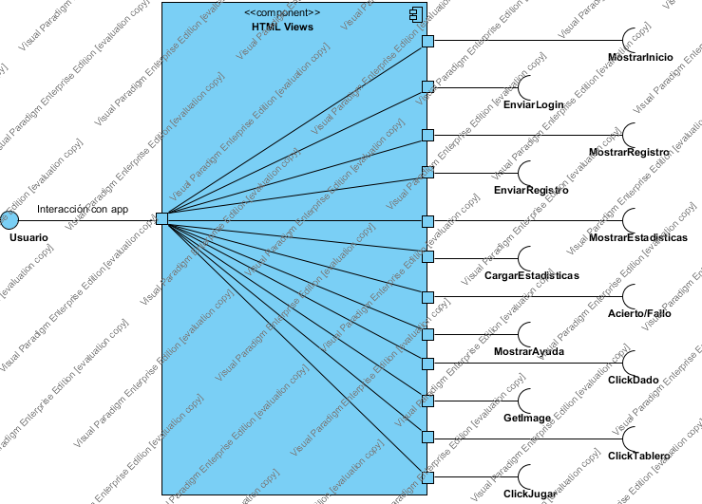

|  |  |
| --- | --- |
| Name | Value |
| Name | View |
| Author | Trivial1a |
| Create Date Time | 05-may-2015 0:49:08 |
| Last Modified | 07-may-2015 22:57:35 |
| Teamwork Create Date Time | 0 |
| Show Component Attributes | false |
| Show Component Operations | false |

## Summary

|  |  |
| --- | --- |
| Name | Description |
| Image1.png HTML Views | El usuario interactúa con las diferentes vistas HTML  servidas por el navegador web.  Y estas realizan peticiones al controlador. |

## Details

### Image3.png HTML Views

|  |  |
| --- | --- |
| Name | Value |
| Description | El usuario interactúa con las diferentes vistas HTML  servidas por el navegador web.  Y estas realizan peticiones al controlador. |
| Active | false |
| Business Key Mutable | true |
| Business Model | false |
| Visibility | public |
| Abstract | false |
| Leaf | false |
| Root | false |
| Quality Score | Ignore |
| Indirectly Instantiated | true |
| Project Management | |  |  | | --- | --- | | Name | Value | | Author | Trivial1a | | Create Date Time | 05-may-2015 0:54:50 | | Last Modified | 07-may-2015 18:52:32 | |

### Image5.png MostrarInicio

|  |  |
| --- | --- |
| Name | Value |
| Active | false |
| Business Key Mutable | true |
| Business Model | false |
| Visibility | public |
| Leaf | false |
| Root | false |
| Stereotypes | Interface |
| Quality Score | Fair |
| Quality Reason | |  |  | | --- | --- | | Problem | Suggestion | | Model element at root | Add model element to a container | | Name does not contain glossary terms | Define name as term in glossary | |
| Project Management | |  |  | | --- | --- | | Name | Value | | Author | Trivial1a | | Create Date Time | 05-may-2015 19:22:15 | | Last Modified | 06-may-2015 2:49:59 | |

#### Relationships

|  |  |
| --- | --- |
| Unnamed Usage | |
| From | Image4.png N/A |
| Visibility | Unspecified |
| Quality Score | Good |
| Project Management | |  |  | | --- | --- | | Name | Value | | Author | Trivial1a | | Create Date Time | 06-may-2015 2:41:54 | | Last Modified | 06-may-2015 12:19:00 | |

#### Relationships

|  |  |
| --- | --- |
| Unnamed Usage | |
| To | Image2.png MostrarInicio |
| Visibility | Unspecified |
| Quality Score | Good |
| Project Management | |  |  | | --- | --- | | Name | Value | | Author | Trivial1a | | Create Date Time | 06-may-2015 2:41:54 | | Last Modified | 06-may-2015 12:19:00 | |

### Image5.png EnviarLogin

|  |  |
| --- | --- |
| Name | Value |
| Active | false |
| Business Key Mutable | true |
| Business Model | false |
| Visibility | public |
| Leaf | false |
| Root | false |
| Stereotypes | Interface |
| Quality Score | Fair |
| Quality Reason | |  |  | | --- | --- | | Problem | Suggestion | | Model element at root | Add model element to a container | | Name does not contain glossary terms | Define name as term in glossary | |
| Project Management | |  |  | | --- | --- | | Name | Value | | Author | Trivial1a | | Create Date Time | 06-may-2015 0:47:49 | | Last Modified | 06-may-2015 2:49:59 | |

#### Relationships

|  |  |
| --- | --- |
| Unnamed Usage | |
| From | Image4.png N/A |
| Visibility | Unspecified |
| Quality Score | Good |
| Project Management | |  |  | | --- | --- | | Name | Value | | Author | Trivial1a | | Create Date Time | 06-may-2015 0:09:54 | | Last Modified | 06-may-2015 12:19:00 | |

#### Relationships

|  |  |
| --- | --- |
| Unnamed Usage | |
| To | Image2.png EnviarLogin |
| Visibility | Unspecified |
| Quality Score | Good |
| Project Management | |  |  | | --- | --- | | Name | Value | | Author | Trivial1a | | Create Date Time | 06-may-2015 0:09:54 | | Last Modified | 06-may-2015 12:19:00 | |

### Image5.png MostrarRegistro

|  |  |
| --- | --- |
| Name | Value |
| Active | false |
| Business Key Mutable | true |
| Business Model | false |
| Visibility | public |
| Leaf | false |
| Root | false |
| Stereotypes | Interface |
| Quality Score | Fair |
| Quality Reason | |  |  | | --- | --- | | Problem | Suggestion | | Model element at root | Add model element to a container | | Name does not contain glossary terms | Define name as term in glossary | |
| Project Management | |  |  | | --- | --- | | Name | Value | | Author | Trivial1a | | Create Date Time | 05-may-2015 19:26:54 | | Last Modified | 06-may-2015 12:19:00 | |

#### Relationships

|  |  |
| --- | --- |
| Unnamed Usage | |
| From | Image4.png N/A |
| Visibility | Unspecified |
| Quality Score | Good |
| Project Management | |  |  | | --- | --- | | Name | Value | | Author | Trivial1a | | Create Date Time | 06-may-2015 2:41:50 | | Last Modified | 06-may-2015 12:19:00 | |

#### Relationships

|  |  |
| --- | --- |
| Unnamed Usage | |
| To | Image2.png MostrarRegistro |
| Visibility | Unspecified |
| Quality Score | Good |
| Project Management | |  |  | | --- | --- | | Name | Value | | Author | Trivial1a | | Create Date Time | 06-may-2015 2:41:50 | | Last Modified | 06-may-2015 12:19:00 | |

### Image5.png EnviarRegistro

|  |  |
| --- | --- |
| Name | Value |
| Active | false |
| Business Key Mutable | true |
| Business Model | false |
| Visibility | public |
| Leaf | false |
| Root | false |
| Stereotypes | Interface |
| Quality Score | Fair |
| Quality Reason | |  |  | | --- | --- | | Problem | Suggestion | | Model element at root | Add model element to a container | | Name does not contain glossary terms | Define name as term in glossary | |
| Project Management | |  |  | | --- | --- | | Name | Value | | Author | Trivial1a | | Create Date Time | 06-may-2015 0:43:47 | | Last Modified | 06-may-2015 12:19:00 | |

#### Relationships

|  |  |
| --- | --- |
| Unnamed Usage | |
| To | Image2.png EnviarRegistro |
| Visibility | Unspecified |
| Quality Score | Good |
| Project Management | |  |  | | --- | --- | | Name | Value | | Author | Trivial1a | | Create Date Time | 06-may-2015 0:09:57 | | Last Modified | 06-may-2015 12:19:00 | |

### Image5.png Usuario

|  |  |
| --- | --- |
| Name | Value |
| Active | false |
| Business Key Mutable | true |
| Business Model | false |
| Visibility | public |
| Leaf | false |
| Root | false |
| Stereotypes | Interface |
| Quality Score | Fair |
| Quality Reason | |  |  | | --- | --- | | Problem | Suggestion | | Model element at root | Add model element to a container | | Name does not contain glossary terms | Define name as term in glossary | |
| Project Management | |  |  | | --- | --- | | Name | Value | | Author | Trivial1a | | Create Date Time | 06-may-2015 12:09:29 | | Last Modified | 06-may-2015 12:19:00 | |

### Image5.png MostrarEstadisticas

|  |  |
| --- | --- |
| Name | Value |
| Active | false |
| Business Key Mutable | true |
| Business Model | false |
| Visibility | public |
| Leaf | false |
| Root | false |
| Stereotypes | Interface |
| Quality Score | Fair |
| Quality Reason | |  |  | | --- | --- | | Problem | Suggestion | | Model element at root | Add model element to a container | | Name does not contain glossary terms | Define name as term in glossary | |
| Project Management | |  |  | | --- | --- | | Name | Value | | Author | Trivial1a | | Create Date Time | 05-may-2015 19:27:29 | | Last Modified | 06-may-2015 12:19:00 | |

#### Relationships

|  |  |
| --- | --- |
| Unnamed Usage | |
| From | Image4.png N/A |
| Visibility | Unspecified |
| Quality Score | Good |
| Project Management | |  |  | | --- | --- | | Name | Value | | Author | Trivial1a | | Create Date Time | 06-may-2015 2:42:07 | | Last Modified | 06-may-2015 12:19:00 | |

#### Relationships

|  |  |
| --- | --- |
| Interacción con app : Realization | |
| From | Image2.png Usuario |
| Visibility | Unspecified |
| Quality Score | Fair |
| Quality Reason | |  |  | | --- | --- | | Problem | Suggestion | | Name does not contain glossary terms | Define name as term in glossary | |
| Project Management | |  |  | | --- | --- | | Name | Value | | Author | Trivial1a | | Create Date Time | 06-may-2015 12:09:33 | | Last Modified | 06-may-2015 12:19:00 | |

#### Relationships

|  |  |
| --- | --- |
| Unnamed Usage | |
| To | Image2.png MostrarEstadisticas |
| Visibility | Unspecified |
| Quality Score | Good |
| Project Management | |  |  | | --- | --- | | Name | Value | | Author | Trivial1a | | Create Date Time | 06-may-2015 2:42:07 | | Last Modified | 06-may-2015 12:19:00 | |

### Image5.png CargarEstadisticas

|  |  |
| --- | --- |
| Name | Value |
| Active | false |
| Business Key Mutable | true |
| Business Model | false |
| Visibility | public |
| Leaf | false |
| Root | false |
| Stereotypes | Interface |
| Quality Score | Fair |
| Quality Reason | |  |  | | --- | --- | | Problem | Suggestion | | Model element at root | Add model element to a container | | Name does not contain glossary terms | Define name as term in glossary | |
| Project Management | |  |  | | --- | --- | | Name | Value | | Author | Trivial1a | | Create Date Time | 07-may-2015 18:25:52 | | Last Modified | 07-may-2015 18:49:21 | |

#### Relationships

|  |  |
| --- | --- |
| Unnamed Usage | |
| To | Image2.png CargarEstadisticas |
| Visibility | Unspecified |
| Quality Score | Good |
| Project Management | |  |  | | --- | --- | | Name | Value | | Author | Trivial1a | | Create Date Time | 07-may-2015 18:48:56 | | Last Modified | 07-may-2015 22:43:15 | |

### Image5.png Acierto/Fallo

|  |  |
| --- | --- |
| Name | Value |
| Active | false |
| Business Key Mutable | true |
| Business Model | false |
| Visibility | public |
| Leaf | false |
| Root | false |
| Stereotypes | Interface |
| Quality Score | Fair |
| Quality Reason | |  |  | | --- | --- | | Problem | Suggestion | | Model element at root | Add model element to a container | | Name does not contain glossary terms | Define name as term in glossary | |
| Project Management | |  |  | | --- | --- | | Name | Value | | Author | Trivial1a | | Create Date Time | 06-may-2015 19:35:33 | | Last Modified | 07-may-2015 18:52:32 | |

#### Relationships

|  |  |
| --- | --- |
| Unnamed Usage | |
| To | Image2.png Acierto/Fallo |
| Visibility | Unspecified |
| Quality Score | Good |
| Project Management | |  |  | | --- | --- | | Name | Value | | Author | Trivial1a | | Create Date Time | 07-may-2015 18:52:19 | | Last Modified | 07-may-2015 22:43:15 | |

### Image5.png MostrarAyuda

|  |  |
| --- | --- |
| Name | Value |
| Active | false |
| Business Key Mutable | true |
| Business Model | false |
| Visibility | public |
| Leaf | false |
| Root | false |
| Stereotypes | Interface |
| Quality Score | Fair |
| Quality Reason | |  |  | | --- | --- | | Problem | Suggestion | | Model element at root | Add model element to a container | | Name does not contain glossary terms | Define name as term in glossary | |
| Project Management | |  |  | | --- | --- | | Name | Value | | Author | Trivial1a | | Create Date Time | 05-may-2015 19:31:05 | | Last Modified | 06-may-2015 12:40:49 | |

|  |  |
| --- | --- |
| Unnamed Usage | |
| To | Image2.png MostrarAyuda |
| Visibility | Unspecified |
| Quality Score | Good |
| Project Management | |  |  | | --- | --- | | Name | Value | | Author | Trivial1a | | Create Date Time | 06-may-2015 12:34:35 | | Last Modified | 06-may-2015 12:40:49 | |

### Image5.png ClickDado

|  |  |
| --- | --- |
| Name | Value |
| Active | false |
| Business Key Mutable | true |
| Business Model | false |
| Visibility | public |
| Leaf | false |
| Root | false |
| Stereotypes | Interface |
| Quality Score | Fair |
| Quality Reason | |  |  | | --- | --- | | Problem | Suggestion | | Model element at root | Add model element to a container | | Name does not contain glossary terms | Define name as term in glossary | |
| Project Management | |  |  | | --- | --- | | Name | Value | | Author | Trivial1a | | Create Date Time | 05-may-2015 19:27:53 | | Last Modified | 06-may-2015 12:40:49 | |

#### Relationships

|  |  |
| --- | --- |
| Unnamed Usage | |
| To | Image2.png ClickDado |
| Visibility | Unspecified |
| Quality Score | Good |
| Project Management | |  |  | | --- | --- | | Name | Value | | Author | Trivial1a | | Create Date Time | 06-may-2015 12:36:24 | | Last Modified | 06-may-2015 12:40:49 | |

### Image5.png GetImage

|  |  |
| --- | --- |
| Name | Value |
| Active | false |
| Business Key Mutable | true |
| Business Model | false |
| Visibility | public |
| Leaf | false |
| Root | false |
| Stereotypes | Interface |
| Quality Score | Fair |
| Quality Reason | |  |  | | --- | --- | | Problem | Suggestion | | Model element at root | Add model element to a container | | Name does not contain glossary terms | Define name as term in glossary | |
| Project Management | |  |  | | --- | --- | | Name | Value | | Author | Trivial1a | | Create Date Time | 05-may-2015 19:29:43 | | Last Modified | 06-may-2015 12:40:49 | |

#### Relationships

|  |  |
| --- | --- |
| Unnamed Usage | |
| To | Image2.png GetImage |
| Visibility | Unspecified |
| Quality Score | Good |
| Project Management | |  |  | | --- | --- | | Name | Value | | Author | Trivial1a | | Create Date Time | 06-may-2015 12:37:03 | | Last Modified | 06-may-2015 12:40:49 | |

### Image5.png ClickTablero

|  |  |
| --- | --- |
| Name | Value |
| Active | false |
| Business Key Mutable | true |
| Business Model | false |
| Visibility | public |
| Leaf | false |
| Root | false |
| Stereotypes | Interface |
| Quality Score | Fair |
| Quality Reason | |  |  | | --- | --- | | Problem | Suggestion | | Model element at root | Add model element to a container | | Name does not contain glossary terms | Define name as term in glossary | |
| Project Management | |  |  | | --- | --- | | Name | Value | | Author | Trivial1a | | Create Date Time | 05-may-2015 19:30:31 | | Last Modified | 06-may-2015 12:40:49 | |

#### Relationships

|  |  |
| --- | --- |
| Unnamed Usage | |
| To | Image2.png ClickTablero |
| Visibility | Unspecified |
| Quality Score | Good |
| Project Management | |  |  | | --- | --- | | Name | Value | | Author | Trivial1a | | Create Date Time | 06-may-2015 12:38:43 | | Last Modified | 06-may-2015 16:20:50 | |

### Image5.png ClickJugar

|  |  |
| --- | --- |
| Name | Value |
| Active | false |
| Business Key Mutable | true |
| Business Model | false |
| Visibility | public |
| Leaf | false |
| Root | false |
| Stereotypes | Interface |
| Quality Score | Fair |
| Quality Reason | |  |  | | --- | --- | | Problem | Suggestion | | Model element at root | Add model element to a container | | Name does not contain glossary terms | Define name as term in glossary | |
| Project Management | |  |  | | --- | --- | | Name | Value | | Author | Trivial1a | | Create Date Time | 05-may-2015 19:28:56 | | Last Modified | 06-may-2015 12:40:49 | |

#### Relationships

|  |  |
| --- | --- |
| Unnamed Usage | |
| To | Image2.png ClickJugar |
| Visibility | Unspecified |
| Quality Score | Good |
| Project Management | |  |  | | --- | --- | | Name | Value | | Author | Trivial1a | | Create Date Time | 06-may-2015 12:39:58 | | Last Modified | 06-may-2015 16:20:50 | |

Deployment Diagram

# Despliegue

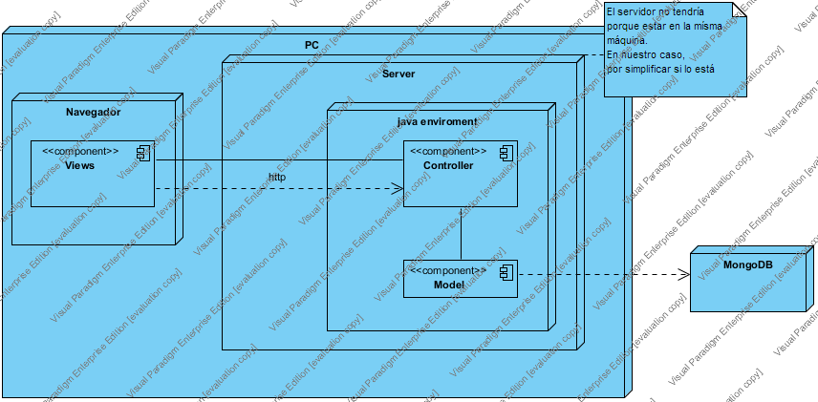

|  |  |
| --- | --- |
| Name | Value |
| Name | Despliegue |
| Author | Trivial1a |
| Create Date Time | 04-may-2015 15:47:56 |
| Last Modified | 07-may-2015 18:06:10 |
| Teamwork Create Date Time | 0 |
| Show Component Attributes | false |
| Show Component Operations | false |

## Summary

|  |  |
| --- | --- |
| Name | Description |
| Image10.png PC | Ordenador en el que se accede a la aplicación a través del navegador y en este caso también se ejecuta el server. |
| Image10.png Server | server scala (activator) |
| Image10.png Navegador | navegador web que soporte canvas |
| Image10.png java enviroment |  |
| Image1.png Views | son las diferentes vistas del juego |
| Image1.png Controller | se encarga de comunicar la vista con el modelo y contiene la lógica del juego. |
| Image10.png MongoDB | Base de datos empleada para la persistencia.  se trata de una base de datos online |
| Image1.png Model | representación interna de los datos y persistencia. |
| Image11.png N/A | El servidor no tendría  porque estar en la mísma  máquina.  En nuestro caso,  por simplificar si lo está |

## Details

### Image12.png PC

|  |  |
| --- | --- |
| Name | Value |
| Description | Ordenador en el que se accede a la aplicación a través del navegador y en este caso también se ejecuta el server. |
| Active | false |
| Business Key Mutable | true |
| Business Model | false |
| Visibility | public |
| Abstract | false |
| Leaf | false |
| Root | false |
| Quality Score | Ignore |
| Project Management | |  |  | | --- | --- | | Name | Value | | Author | Trivial1a | | Create Date Time | 05-may-2015 1:00:20 | | Last Modified | 07-may-2015 9:43:33 | |

#### Nested Nodes

|  |  |
| --- | --- |
| Name | Description |
| Image12.png Server | server scala (activator) |
| Image12.png Navegador | navegador web que soporte canvas |

### Image12.png Server

|  |  |
| --- | --- |
| Name | Value |
| Description | server scala (activator) |
| Active | false |
| Business Key Mutable | true |
| Business Model | false |
| Visibility | public |
| Abstract | false |
| Leaf | false |
| Root | false |
| Quality Score | Fair |
| Quality Reason | |  |  | | --- | --- | | Problem | Suggestion | | Name does not contain glossary terms | Define name as term in glossary | |
| Project Management | |  |  | | --- | --- | | Name | Value | | Author | Trivial1a | | Create Date Time | 05-may-2015 0:57:52 | | Last Modified | 07-may-2015 9:43:33 | |

#### Nested Nodes

|  |  |
| --- | --- |
| Name | Description |
| Image12.png Navegador |  |
| Image12.png java enviroment |  |

#### Relationships

|  |  |
| --- | --- |
| Unnamed Anchor | |
| To | Image11.png N/A |
| Quality Score | Good |
| Project Management | |  |  | | --- | --- | | Name | Value | | Author | Trivial1a | | Create Date Time | 05-may-2015 18:22:53 | | Last Modified | 05-may-2015 18:30:31 | |

### Image12.png Navegador

|  |  |
| --- | --- |
| Name | Value |
| Description | navegador web que soporte canvas |
| Active | false |
| Business Key Mutable | true |
| Business Model | false |
| Visibility | public |
| Abstract | false |
| Leaf | false |
| Root | false |
| Quality Score | Ignore |
| Project Management | |  |  | | --- | --- | | Name | Value | | Author | Trivial1a | | Create Date Time | 05-may-2015 18:15:27 | | Last Modified | 07-may-2015 9:47:11 | |

#### Resident Components

|  |  |
| --- | --- |
| Name | Description |
| Image3.png Views | son las diferentes vistas del juego |

### Image12.png java enviroment

|  |  |
| --- | --- |
| Name | Value |
| Active | false |
| Business Key Mutable | true |
| Business Model | false |
| Visibility | public |
| Abstract | false |
| Leaf | false |
| Root | false |
| Quality Score | Ignore |
| Project Management | |  |  | | --- | --- | | Name | Value | | Author | Trivial1a | | Create Date Time | 05-may-2015 1:01:40 | | Last Modified | 06-may-2015 0:18:23 | |

#### Nested Nodes

|  |  |
| --- | --- |
| Name | Description |
| Image12.png controller |  |

#### Resident Components

|  |  |
| --- | --- |
| Name | Description |
| Image3.png Model | representación interna de los datos y persistencia. |
| Image3.png Controller | se encarga de comunicar la vista con el modelo y contiene la lógica del juego. |

### Image3.png Views

|  |  |
| --- | --- |
| Name | Value |
| Description | son las diferentes vistas del juego |
| Active | false |
| Business Key Mutable | true |
| Business Model | false |
| Visibility | public |
| Abstract | false |
| Leaf | false |
| Root | false |
| Quality Score | Fair |
| Quality Reason | |  |  | | --- | --- | | Problem | Suggestion | | Name does not contain glossary terms | Define name as term in glossary | |
| Indirectly Instantiated | true |
| Project Management | |  |  | | --- | --- | | Name | Value | | Author | Trivial1a | | Create Date Time | 05-may-2015 18:16:14 | | Last Modified | 07-may-2015 9:43:33 | |

#### Relationships

|  |  |
| --- | --- |
| http : Dependency | |
| To | Image1.png Controller |
| Visibility | Unspecified |
| Quality Score | Fair |
| Quality Reason | |  |  | | --- | --- | | Problem | Suggestion | | Name does not contain glossary terms | Define name as term in glossary | |
| Project Management | |  |  | | --- | --- | | Name | Value | | Author | Trivial1a | | Create Date Time | 05-may-2015 18:22:20 | | Last Modified | 06-may-2015 0:18:23 | |
| Unnamed Generic Connector | |
| From | Image1.png Controller |
| Quality Score | Good |
| Project Management | |  |  | | --- | --- | | Name | Value | | Author | Trivial1a | | Create Date Time | 05-may-2015 18:18:59 | | Last Modified | 06-may-2015 0:18:23 | |

### Image3.png Controller

|  |  |
| --- | --- |
| Name | Value |
| Description | se encarga de comunicar la vista con el modelo y contiene la lógica del juego. |
| Active | false |
| Business Key Mutable | true |
| Business Model | false |
| Visibility | public |
| Abstract | false |
| Leaf | false |
| Root | false |
| Quality Score | Fair |
| Quality Reason | |  |  | | --- | --- | | Problem | Suggestion | | Name does not contain glossary terms | Define name as term in glossary | |
| Indirectly Instantiated | true |
| Project Management | |  |  | | --- | --- | | Name | Value | | Author | Trivial1a | | Create Date Time | 05-may-2015 18:14:21 | | Last Modified | 07-may-2015 9:43:33 | |

#### Relationships

|  |  |
| --- | --- |
| Unnamed Generic Connector | |
| To | Image1.png Views |
| Quality Score | Good |
| Project Management | |  |  | | --- | --- | | Name | Value | | Author | Trivial1a | | Create Date Time | 05-may-2015 18:18:59 | | Last Modified | 06-may-2015 0:18:23 | |
| Unnamed Generic Connector | |
| From | Image1.png Model |
| Quality Score | Good |
| Project Management | |  |  | | --- | --- | | Name | Value | | Author | Trivial1a | | Create Date Time | 05-may-2015 18:18:37 | | Last Modified | 05-may-2015 18:30:31 | |

|  |  |
| --- | --- |
| http : Dependency | |
| From | Image1.png Views |
| Visibility | Unspecified |
| Quality Score | Fair |
| Quality Reason | |  |  | | --- | --- | | Problem | Suggestion | | Name does not contain glossary terms | Define name as term in glossary | |
| Project Management | |  |  | | --- | --- | | Name | Value | | Author | Trivial1a | | Create Date Time | 05-may-2015 18:22:20 | | Last Modified | 06-may-2015 0:18:23 | |

### Image12.png MongoDB

|  |  |
| --- | --- |
| Name | Value |
| Description | Base de datos empleada para la persistencia.  se trata de una base de datos online |
| Active | false |
| Business Key Mutable | true |
| Business Model | false |
| Visibility | public |
| Abstract | false |
| Leaf | false |
| Root | false |
| Quality Score | Fair |
| Quality Reason | |  |  | | --- | --- | | Problem | Suggestion | | Model element at root | Add model element to a container | | Name does not contain glossary terms | Define name as term in glossary | |
| Project Management | |  |  | | --- | --- | | Name | Value | | Author | Trivial1a | | Create Date Time | 05-may-2015 0:57:58 | | Last Modified | 06-may-2015 19:30:02 | |

#### Relationships

|  |  |
| --- | --- |
| Unnamed Dependency | |
| From | Image1.png Model |
| Visibility | Unspecified |
| Quality Score | Good |
| Project Management | |  |  | | --- | --- | | Name | Value | | Author | Trivial1a | | Create Date Time | 05-may-2015 18:19:45 | | Last Modified | 05-may-2015 18:30:31 | |

### Image3.png Model

|  |  |
| --- | --- |
| Name | Value |
| Description | representación interna de los datos y persistencia. |
| Active | false |
| Business Key Mutable | true |
| Business Model | false |
| Visibility | public |
| Abstract | false |
| Leaf | false |
| Root | false |
| Quality Score | Fair |
| Quality Reason | |  |  | | --- | --- | | Problem | Suggestion | | Name does not contain glossary terms | Define name as term in glossary | |
| Indirectly Instantiated | true |
| Project Management | |  |  | | --- | --- | | Name | Value | | Author | Trivial1a | | Create Date Time | 05-may-2015 18:14:13 | | Last Modified | 07-may-2015 9:47:11 | |

#### Relationships

|  |  |
| --- | --- |
| Unnamed Generic Connector | |
| To | Image1.png Controller |
| Quality Score | Good |
| Project Management | |  |  | | --- | --- | | Name | Value | | Author | Trivial1a | | Create Date Time | 05-may-2015 18:18:37 | | Last Modified | 05-may-2015 18:30:31 | |

|  |  |
| --- | --- |
| Unnamed Dependency | |
| To | Image10.png MongoDB |
| Visibility | Unspecified |
| Quality Score | Good |
| Project Management | |  |  | | --- | --- | | Name | Value | | Author | Trivial1a | | Create Date Time | 05-may-2015 18:19:45 | | Last Modified | 05-may-2015 18:30:31 | |

### Image13.png N/A

|  |  |
| --- | --- |
| Name | Value |
| Description | El servidor no tendría  porque estar en la mísma  máquina.  En nuestro caso,  por simplificar si lo está |
| Quality Score | Fair |
| Quality Reason | |  |  | | --- | --- | | Problem | Suggestion | | Model element at root | Add model element to a container | |
| Project Management | |  |  | | --- | --- | | Name | Value | | Author | Trivial1a | | Create Date Time | 05-may-2015 18:22:52 | | Last Modified | 05-may-2015 18:30:31 | |

#### Relationships

|  |  |
| --- | --- |
| Unnamed Anchor | |
| From | Image10.png Server |
| Quality Score | Good |
| Project Management | |  |  | | --- | --- | | Name | Value | | Author | Trivial1a | | Create Date Time | 05-may-2015 18:22:53 | | Last Modified | 05-may-2015 18:30:31 | |

Package Diagram

# Diagrama de contexto

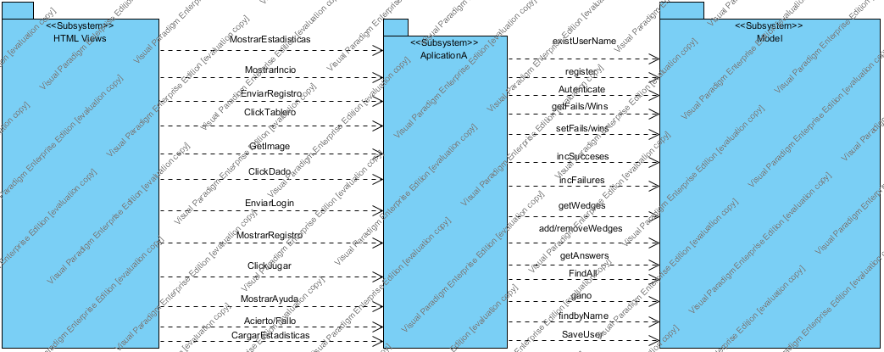

|  |  |
| --- | --- |
| Name | Value |
| Name | Diagrama de contexto |
| Author | Trivial1a |
| Create Date Time | 06-may-2015 23:47:22 |
| Last Modified | 07-may-2015 22:57:35 |
| Teamwork Create Date Time | 0 |

## Summary

|  |  |
| --- | --- |
| Name | Description |
| Image15.png HTML Views | Las vistas realizan peticiones al controlador, ya que será el que las conecte con el modelo. El usuario interactuará a través de las vistas en los navegadores web. |
| Image15.png Model | Esto es el modelo de datos que contiene los datos relacionados a la aplicación. Aquí se encontrarán usuarios registrados o logueados, los jugadores activos en una partida y las preguntas con sus respuestas. |
| Image15.png AplicationA | Aplication contiene la lógica del juego y es el controlador, es decir, se encarga de conectar las vistas con el modelo. Contendrá la lógica propia del juego y lo correspondiente a las imágenes y actualización de las mismas en la partida. |

## Details

### Image16.png HTML Views

|  |  |
| --- | --- |
| Name | Value |
| Description | Las vistas realizan peticiones al controlador, ya que será el que las conecte con el modelo. El usuario interactuará a través de las vistas en los navegadores web. |
| Abstract | false |
| Leaf | false |
| Root | false |
| Stereotypes | Subsystem |
| Quality Score | Fair |
| Quality Reason | |  |  | | --- | --- | | Problem | Suggestion | | Name does not contain glossary terms | Define name as term in glossary | |
| Visibility | public |
| Project Management | |  |  | | --- | --- | | Name | Value | | Author | Trivial1a | | Create Date Time | 06-may-2015 23:16:29 | | Last Modified | 07-may-2015 22:51:07 | |

#### Relationships

|  |  |
| --- | --- |
| MostrarIncio : Dependency | |
| To | Image15.png AplicationA |
| Visibility | Unspecified |
| Quality Score | Fair |
| Quality Reason | |  |  | | --- | --- | | Problem | Suggestion | | Name does not contain glossary terms | Define name as term in glossary | |
| Project Management | |  |  | | --- | --- | | Name | Value | | Author | Trivial1a | | Create Date Time | 06-may-2015 23:33:59 | | Last Modified | 07-may-2015 17:51:39 | |

|  |  |
| --- | --- |
| EnviarLogin : Dependency | |
| To | Image15.png AplicationA |
| Visibility | Unspecified |
| Quality Score | Fair |
| Quality Reason | |  |  | | --- | --- | | Problem | Suggestion | | Name does not contain glossary terms | Define name as term in glossary | |
| Project Management | |  |  | | --- | --- | | Name | Value | | Author | Trivial1a | | Create Date Time | 06-may-2015 23:34:32 | | Last Modified | 07-may-2015 17:51:39 | |

|  |  |
| --- | --- |
| MostrarRegistro : Dependency | |
| To | Image15.png AplicationA |
| Visibility | Unspecified |
| Quality Score | Fair |
| Quality Reason | |  |  | | --- | --- | | Problem | Suggestion | | Name does not contain glossary terms | Define name as term in glossary | |
| Project Management | |  |  | | --- | --- | | Name | Value | | Author | Trivial1a | | Create Date Time | 06-may-2015 23:35:07 | | Last Modified | 07-may-2015 17:51:39 | |

|  |  |
| --- | --- |
| EnviarRegistro : Dependency | |
| To | Image15.png AplicationA |
| Description | Envia el registro de un usuario al controlador. |
| Visibility | Unspecified |
| Quality Score | Fair |
| Quality Reason | |  |  | | --- | --- | | Problem | Suggestion | | Name does not contain glossary terms | Define name as term in glossary | |
| Project Management | |  |  | | --- | --- | | Name | Value | | Author | Trivial1a | | Create Date Time | 06-may-2015 23:35:26 | | Last Modified | 07-may-2015 22:55:07 | |

|  |  |
| --- | --- |
| MostrarEstadisticas : Dependency | |
| To | Image15.png AplicationA |
| Description | Muestra las estadísticas del usuario. |
| Visibility | Unspecified |
| Quality Score | Fair |
| Quality Reason | |  |  | | --- | --- | | Problem | Suggestion | | Name does not contain glossary terms | Define name as term in glossary | |
| Project Management | |  |  | | --- | --- | | Name | Value | | Author | Trivial1a | | Create Date Time | 06-may-2015 23:35:53 | | Last Modified | 07-may-2015 22:57:18 | |

|  |  |
| --- | --- |
| MostrarAyuda : Dependency | |
| To | Image15.png AplicationA |
| Visibility | Unspecified |
| Quality Score | Fair |
| Quality Reason | |  |  | | --- | --- | | Problem | Suggestion | | Name does not contain glossary terms | Define name as term in glossary | |
| Project Management | |  |  | | --- | --- | | Name | Value | | Author | Trivial1a | | Create Date Time | 06-may-2015 23:36:50 | | Last Modified | 07-may-2015 17:51:39 | |

|  |  |
| --- | --- |
| ClickDado : Dependency | |
| To | Image15.png AplicationA |
| Description | Hace que saques un número para poder mover la ficha. |
| Visibility | Unspecified |
| Quality Score | Fair |
| Quality Reason | |  |  | | --- | --- | | Problem | Suggestion | | Name does not contain glossary terms | Define name as term in glossary | |
| Project Management | |  |  | | --- | --- | | Name | Value | | Author | Trivial1a | | Create Date Time | 06-may-2015 23:37:04 | | Last Modified | 07-may-2015 22:57:18 | |

|  |  |
| --- | --- |
| GetImage : Dependency | |
| To | Image15.png AplicationA |
| Visibility | Unspecified |
| Quality Score | Fair |
| Quality Reason | |  |  | | --- | --- | | Problem | Suggestion | | Name does not contain glossary terms | Define name as term in glossary | |
| Project Management | |  |  | | --- | --- | | Name | Value | | Author | Trivial1a | | Create Date Time | 06-may-2015 23:37:17 | | Last Modified | 07-may-2015 17:51:39 | |

|  |  |
| --- | --- |
| ClickTablero : Dependency | |
| To | Image15.png AplicationA |
| Visibility | Unspecified |
| Quality Score | Fair |
| Quality Reason | |  |  | | --- | --- | | Problem | Suggestion | | Name does not contain glossary terms | Define name as term in glossary | |
| Project Management | |  |  | | --- | --- | | Name | Value | | Author | Trivial1a | | Create Date Time | 06-may-2015 23:37:35 | | Last Modified | 07-may-2015 17:51:39 | |

|  |  |
| --- | --- |
| ClickJugar : Dependency | |
| To | Image15.png AplicationA |
| Visibility | Unspecified |
| Quality Score | Fair |
| Quality Reason | |  |  | | --- | --- | | Problem | Suggestion | | Name does not contain glossary terms | Define name as term in glossary | |
| Project Management | |  |  | | --- | --- | | Name | Value | | Author | Trivial1a | | Create Date Time | 06-may-2015 23:37:50 | | Last Modified | 07-may-2015 17:51:39 | |

|  |  |
| --- | --- |
| Acierto/Fallo : Dependency | |
| To | Image15.png AplicationA |
| Visibility | Unspecified |
| Project Management | |  |  | | --- | --- | | Name | Value | | Author | Trivial1a | | Create Date Time | 07-may-2015 22:50:40 | | Last Modified | 07-may-2015 22:52:18 | |

|  |  |
| --- | --- |
| CargarEstadisticas : Dependency | |
| To | Image15.png AplicationA |
| Description | Carga las estadísticas del usuario. |
| Visibility | Unspecified |
| Project Management | |  |  | | --- | --- | | Name | Value | | Author | Trivial1a | | Create Date Time | 07-may-2015 22:50:53 | | Last Modified | 07-may-2015 22:57:18 | |

### Image16.png Model

|  |  |
| --- | --- |
| Name | Value |
| Description | Esto es el modelo de datos que contiene los datos relacionados a la aplicación. Aquí se encontrarán usuarios registrados o logueados, los jugadores activos en una partida y las preguntas con sus respuestas. |
| Abstract | false |
| Leaf | false |
| Root | false |
| Stereotypes | Subsystem |
| Quality Score | Fair |
| Quality Reason | |  |  | | --- | --- | | Problem | Suggestion | | Name does not contain glossary terms | Define name as term in glossary | |
| Visibility | public |
| Project Management | |  |  | | --- | --- | | Name | Value | | Author | Trivial1a | | Create Date Time | 06-may-2015 23:31:36 | | Last Modified | 07-may-2015 22:53:19 | |

#### Children

|  |  |
| --- | --- |
| Name | Description |
| Image16.png User | Aquí se almacenan los usuarios de la aplicación, tanto registrados como logueados. |
| Image16.png Player | Durante una partida, los jugadores son almacenados aquí. De esta manera, la aplicación usará esto antes que la clase User para los jugadores que están en activo en una partida. |
| Image16.png Question | Son las preguntas almacenadas con su respuesta. De aquí saldrás las que se usen durante la partida. |

#### Relationships

|  |  |
| --- | --- |
| Autenticate : Dependency | |
| From | Image15.png AplicationA |
| Description | Autentifica al usuario. |
| Visibility | Unspecified |
| Quality Score | Fair |
| Quality Reason | |  |  | | --- | --- | | Problem | Suggestion | | Name does not contain glossary terms | Define name as term in glossary | |
| Project Management | |  |  | | --- | --- | | Name | Value | | Author | Trivial1a | | Create Date Time | 06-may-2015 23:38:39 | | Last Modified | 07-may-2015 22:57:18 | |

|  |  |
| --- | --- |
| existUserName : Dependency | |
| From | Image15.png AplicationA |
| Visibility | Unspecified |
| Quality Score | Fair |
| Quality Reason | |  |  | | --- | --- | | Problem | Suggestion | | Name does not contain glossary terms | Define name as term in glossary | |
| Project Management | |  |  | | --- | --- | | Name | Value | | Author | Trivial1a | | Create Date Time | 06-may-2015 23:38:52 | | Last Modified | 07-may-2015 17:51:39 | |

|  |  |
| --- | --- |
| register : Dependency | |
| From | Image15.png AplicationA |
| Description | Registra al usuario en el modelo. |
| Visibility | Unspecified |
| Quality Score | Fair |
| Quality Reason | |  |  | | --- | --- | | Problem | Suggestion | | Name does not contain glossary terms | Define name as term in glossary | |
| Project Management | |  |  | | --- | --- | | Name | Value | | Author | Trivial1a | | Create Date Time | 06-may-2015 23:39:19 | | Last Modified | 07-may-2015 22:57:18 | |

|  |  |
| --- | --- |
| getFails/Wins : Dependency | |
| From | Image15.png AplicationA |
| Visibility | Unspecified |
| Quality Score | Fair |
| Quality Reason | |  |  | | --- | --- | | Problem | Suggestion | | Name does not contain glossary terms | Define name as term in glossary | |
| Project Management | |  |  | | --- | --- | | Name | Value | | Author | Trivial1a | | Create Date Time | 06-may-2015 23:40:07 | | Last Modified | 07-may-2015 17:51:39 | |

|  |  |
| --- | --- |
| setFails/wins : Dependency | |
| From | Image15.png AplicationA |
| Visibility | Unspecified |
| Quality Score | Fair |
| Quality Reason | |  |  | | --- | --- | | Problem | Suggestion | | Name does not contain glossary terms | Define name as term in glossary | |
| Project Management | |  |  | | --- | --- | | Name | Value | | Author | Trivial1a | | Create Date Time | 06-may-2015 23:40:37 | | Last Modified | 07-may-2015 17:51:39 | |

|  |  |
| --- | --- |
| incSucceses : Dependency | |
| From | Image15.png AplicationA |
| Visibility | Unspecified |
| Quality Score | Fair |
| Quality Reason | |  |  | | --- | --- | | Problem | Suggestion | | Name does not contain glossary terms | Define name as term in glossary | |
| Project Management | |  |  | | --- | --- | | Name | Value | | Author | Trivial1a | | Create Date Time | 06-may-2015 23:41:31 | | Last Modified | 07-may-2015 17:51:39 | |

|  |  |
| --- | --- |
| incFailures : Dependency | |
| From | Image15.png AplicationA |
| Visibility | Unspecified |
| Quality Score | Fair |
| Quality Reason | |  |  | | --- | --- | | Problem | Suggestion | | Name does not contain glossary terms | Define name as term in glossary | |
| Project Management | |  |  | | --- | --- | | Name | Value | | Author | Trivial1a | | Create Date Time | 06-may-2015 23:42:05 | | Last Modified | 07-may-2015 17:51:39 | |

|  |  |
| --- | --- |
| getWedges : Dependency | |
| From | Image15.png AplicationA |
| Visibility | Unspecified |
| Quality Score | Fair |
| Quality Reason | |  |  | | --- | --- | | Problem | Suggestion | | Name does not contain glossary terms | Define name as term in glossary | |
| Project Management | |  |  | | --- | --- | | Name | Value | | Author | Trivial1a | | Create Date Time | 06-may-2015 23:42:24 | | Last Modified | 07-may-2015 17:51:39 | |

|  |  |
| --- | --- |
| add/removeWedges : Dependency | |
| From | Image15.png AplicationA |
| Visibility | Unspecified |
| Quality Score | Fair |
| Quality Reason | |  |  | | --- | --- | | Problem | Suggestion | | Name does not contain glossary terms | Define name as term in glossary | |
| Project Management | |  |  | | --- | --- | | Name | Value | | Author | Trivial1a | | Create Date Time | 06-may-2015 23:42:40 | | Last Modified | 07-may-2015 17:51:39 | |

|  |  |
| --- | --- |
| getAnswers : Dependency | |
| From | Image15.png AplicationA |
| Visibility | Unspecified |
| Quality Score | Fair |
| Quality Reason | |  |  | | --- | --- | | Problem | Suggestion | | Name does not contain glossary terms | Define name as term in glossary | |
| Project Management | |  |  | | --- | --- | | Name | Value | | Author | Trivial1a | | Create Date Time | 06-may-2015 23:44:29 | | Last Modified | 07-may-2015 17:51:39 | |

|  |  |
| --- | --- |
| FindAll : Dependency | |
| From | Image15.png AplicationA |
| Visibility | Unspecified |
| Quality Score | Fair |
| Quality Reason | |  |  | | --- | --- | | Problem | Suggestion | | Name does not contain glossary terms | Define name as term in glossary | |
| Project Management | |  |  | | --- | --- | | Name | Value | | Author | Trivial1a | | Create Date Time | 06-may-2015 23:44:43 | | Last Modified | 07-may-2015 17:51:39 | |

|  |  |
| --- | --- |
| gano : Dependency | |
| From | Image15.png AplicationA |
| Visibility | Unspecified |
| Quality Score | Fair |
| Quality Reason | |  |  | | --- | --- | | Problem | Suggestion | | Name does not contain glossary terms | Define name as term in glossary | |
| Project Management | |  |  | | --- | --- | | Name | Value | | Author | Trivial1a | | Create Date Time | 06-may-2015 23:51:58 | | Last Modified | 07-may-2015 17:51:39 | |

|  |  |
| --- | --- |
| findbyName : Dependency | |
| From | Image15.png AplicationA |
| Visibility | Unspecified |
| Quality Score | Fair |
| Quality Reason | |  |  | | --- | --- | | Problem | Suggestion | | Name does not contain glossary terms | Define name as term in glossary | |
| Project Management | |  |  | | --- | --- | | Name | Value | | Author | Trivial1a | | Create Date Time | 07-may-2015 22:48:05 | | Last Modified | 07-may-2015 22:51:07 | |

|  |  |
| --- | --- |
| SaveUser : Dependency | |
| From | Image15.png AplicationA |
| Visibility | Unspecified |
| Quality Score | Fair |
| Quality Reason | |  |  | | --- | --- | | Problem | Suggestion | | Name does not contain glossary terms | Define name as term in glossary | |
| Project Management | |  |  | | --- | --- | | Name | Value | | Author | Trivial1a | | Create Date Time | 07-may-2015 22:49:19 | | Last Modified | 07-may-2015 22:51:07 | |

### Image16.png AplicationA

|  |  |
| --- | --- |
| Name | Value |
| Description | Aplication contiene la lógica del juego y es el controlador, es decir, se encarga de conectar las vistas con el modelo. Contendrá la lógica propia del juego y lo correspondiente a las imágenes y actualización de las mismas en la partida. |
| Abstract | false |
| Leaf | false |
| Root | false |
| Stereotypes | Subsystem |
| Quality Score | Fair |
| Quality Reason | |  |  | | --- | --- | | Problem | Suggestion | | Name does not contain glossary terms | Define name as term in glossary | |
| Visibility | public |
| Project Management | |  |  | | --- | --- | | Name | Value | | Author | Trivial1a | | Create Date Time | 06-may-2015 23:19:42 | | Last Modified | 07-may-2015 22:53:19 | |

#### Children

|  |  |
| --- | --- |
| Name | Description |
| Image16.png BuilderBoard | Lleva la parte de imágenes de la aplicación. |
| Image16.png Trivial | Aquí se encuentra la lógica correspondiente al juego. |

#### Relationships

|  |  |
| --- | --- |
| Autenticate : Dependency | |
| To | Image15.png Model |
| Description | Autentifica al usuario. |
| Visibility | Unspecified |
| Quality Score | Fair |
| Quality Reason | |  |  | | --- | --- | | Problem | Suggestion | | Name does not contain glossary terms | Define name as term in glossary | |
| Project Management | |  |  | | --- | --- | | Name | Value | | Author | Trivial1a | | Create Date Time | 06-may-2015 23:38:39 | | Last Modified | 07-may-2015 22:57:18 | |

|  |  |
| --- | --- |
| existUserName : Dependency | |
| To | Image15.png Model |
| Visibility | Unspecified |
| Quality Score | Fair |
| Quality Reason | |  |  | | --- | --- | | Problem | Suggestion | | Name does not contain glossary terms | Define name as term in glossary | |
| Project Management | |  |  | | --- | --- | | Name | Value | | Author | Trivial1a | | Create Date Time | 06-may-2015 23:38:52 | | Last Modified | 07-may-2015 17:51:39 | |

|  |  |
| --- | --- |
| register : Dependency | |
| To | Image15.png Model |
| Description | Registra al usuario en el modelo. |
| Visibility | Unspecified |
| Quality Score | Fair |
| Quality Reason | |  |  | | --- | --- | | Problem | Suggestion | | Name does not contain glossary terms | Define name as term in glossary | |
| Project Management | |  |  | | --- | --- | | Name | Value | | Author | Trivial1a | | Create Date Time | 06-may-2015 23:39:19 | | Last Modified | 07-may-2015 22:57:18 | |

|  |  |
| --- | --- |
| getFails/Wins : Dependency | |
| To | Image15.png Model |
| Visibility | Unspecified |
| Quality Score | Fair |
| Quality Reason | |  |  | | --- | --- | | Problem | Suggestion | | Name does not contain glossary terms | Define name as term in glossary | |
| Project Management | |  |  | | --- | --- | | Name | Value | | Author | Trivial1a | | Create Date Time | 06-may-2015 23:40:07 | | Last Modified | 07-may-2015 17:51:39 | |

|  |  |
| --- | --- |
| setFails/wins : Dependency | |
| To | Image15.png Model |
| Visibility | Unspecified |
| Quality Score | Fair |
| Quality Reason | |  |  | | --- | --- | | Problem | Suggestion | | Name does not contain glossary terms | Define name as term in glossary | |
| Project Management | |  |  | | --- | --- | | Name | Value | | Author | Trivial1a | | Create Date Time | 06-may-2015 23:40:37 | | Last Modified | 07-may-2015 17:51:39 | |

|  |  |
| --- | --- |
| incSucceses : Dependency | |
| To | Image15.png Model |
| Visibility | Unspecified |
| Quality Score | Fair |
| Quality Reason | |  |  | | --- | --- | | Problem | Suggestion | | Name does not contain glossary terms | Define name as term in glossary | |
| Project Management | |  |  | | --- | --- | | Name | Value | | Author | Trivial1a | | Create Date Time | 06-may-2015 23:41:31 | | Last Modified | 07-may-2015 17:51:39 | |

|  |  |
| --- | --- |
| incFailures : Dependency | |
| To | Image15.png Model |
| Visibility | Unspecified |
| Quality Score | Fair |
| Quality Reason | |  |  | | --- | --- | | Problem | Suggestion | | Name does not contain glossary terms | Define name as term in glossary | |
| Project Management | |  |  | | --- | --- | | Name | Value | | Author | Trivial1a | | Create Date Time | 06-may-2015 23:42:05 | | Last Modified | 07-may-2015 17:51:39 | |

|  |  |
| --- | --- |
| getWedges : Dependency | |
| To | Image15.png Model |
| Visibility | Unspecified |
| Quality Score | Fair |
| Quality Reason | |  |  | | --- | --- | | Problem | Suggestion | | Name does not contain glossary terms | Define name as term in glossary | |
| Project Management | |  |  | | --- | --- | | Name | Value | | Author | Trivial1a | | Create Date Time | 06-may-2015 23:42:24 | | Last Modified | 07-may-2015 17:51:39 | |

|  |  |
| --- | --- |
| add/removeWedges : Dependency | |
| To | Image15.png Model |
| Visibility | Unspecified |
| Quality Score | Fair |
| Quality Reason | |  |  | | --- | --- | | Problem | Suggestion | | Name does not contain glossary terms | Define name as term in glossary | |
| Project Management | |  |  | | --- | --- | | Name | Value | | Author | Trivial1a | | Create Date Time | 06-may-2015 23:42:40 | | Last Modified | 07-may-2015 17:51:39 | |

|  |  |
| --- | --- |
| getAnswers : Dependency | |
| To | Image15.png Model |
| Visibility | Unspecified |
| Quality Score | Fair |
| Quality Reason | |  |  | | --- | --- | | Problem | Suggestion | | Name does not contain glossary terms | Define name as term in glossary | |
| Project Management | |  |  | | --- | --- | | Name | Value | | Author | Trivial1a | | Create Date Time | 06-may-2015 23:44:29 | | Last Modified | 07-may-2015 17:51:39 | |

|  |  |
| --- | --- |
| FindAll : Dependency | |
| To | Image15.png Model |
| Visibility | Unspecified |
| Quality Score | Fair |
| Quality Reason | |  |  | | --- | --- | | Problem | Suggestion | | Name does not contain glossary terms | Define name as term in glossary | |
| Project Management | |  |  | | --- | --- | | Name | Value | | Author | Trivial1a | | Create Date Time | 06-may-2015 23:44:43 | | Last Modified | 07-may-2015 17:51:39 | |

|  |  |
| --- | --- |
| gano : Dependency | |
| To | Image15.png Model |
| Visibility | Unspecified |
| Quality Score | Fair |
| Quality Reason | |  |  | | --- | --- | | Problem | Suggestion | | Name does not contain glossary terms | Define name as term in glossary | |
| Project Management | |  |  | | --- | --- | | Name | Value | | Author | Trivial1a | | Create Date Time | 06-may-2015 23:51:58 | | Last Modified | 07-may-2015 17:51:39 | |

|  |  |
| --- | --- |
| findbyName : Dependency | |
| To | Image15.png Model |
| Visibility | Unspecified |
| Quality Score | Fair |
| Quality Reason | |  |  | | --- | --- | | Problem | Suggestion | | Name does not contain glossary terms | Define name as term in glossary | |
| Project Management | |  |  | | --- | --- | | Name | Value | | Author | Trivial1a | | Create Date Time | 07-may-2015 22:48:05 | | Last Modified | 07-may-2015 22:51:07 | |

|  |  |
| --- | --- |
| SaveUser : Dependency | |
| To | Image15.png Model |
| Visibility | Unspecified |
| Quality Score | Fair |
| Quality Reason | |  |  | | --- | --- | | Problem | Suggestion | | Name does not contain glossary terms | Define name as term in glossary | |
| Project Management | |  |  | | --- | --- | | Name | Value | | Author | Trivial1a | | Create Date Time | 07-may-2015 22:49:19 | | Last Modified | 07-may-2015 22:51:07 | |
| MostrarIncio : Dependency | |
| From | Image15.png HTML Views |
| Visibility | Unspecified |
| Quality Score | Fair |
| Quality Reason | |  |  | | --- | --- | | Problem | Suggestion | | Name does not contain glossary terms | Define name as term in glossary | |
| Project Management | |  |  | | --- | --- | | Name | Value | | Author | Trivial1a | | Create Date Time | 06-may-2015 23:33:59 | | Last Modified | 07-may-2015 17:51:39 | |

|  |  |
| --- | --- |
| EnviarLogin : Dependency | |
| From | Image15.png HTML Views |
| Visibility | Unspecified |
| Quality Score | Fair |
| Quality Reason | |  |  | | --- | --- | | Problem | Suggestion | | Name does not contain glossary terms | Define name as term in glossary | |
| Project Management | |  |  | | --- | --- | | Name | Value | | Author | Trivial1a | | Create Date Time | 06-may-2015 23:34:32 | | Last Modified | 07-may-2015 17:51:39 | |

|  |  |
| --- | --- |
| MostrarRegistro : Dependency | |
| From | Image15.png HTML Views |
| Visibility | Unspecified |
| Quality Score | Fair |
| Quality Reason | |  |  | | --- | --- | | Problem | Suggestion | | Name does not contain glossary terms | Define name as term in glossary | |
| Project Management | |  |  | | --- | --- | | Name | Value | | Author | Trivial1a | | Create Date Time | 06-may-2015 23:35:07 | | Last Modified | 07-may-2015 17:51:39 | |

|  |  |
| --- | --- |
| EnviarRegistro : Dependency | |
| From | Image15.png HTML Views |
| Description | Envia el registro de un usuario al controlador. |
| Visibility | Unspecified |
| Quality Score | Fair |
| Quality Reason | |  |  | | --- | --- | | Problem | Suggestion | | Name does not contain glossary terms | Define name as term in glossary | |
| Project Management | |  |  | | --- | --- | | Name | Value | | Author | Trivial1a | | Create Date Time | 06-may-2015 23:35:26 | | Last Modified | 07-may-2015 22:55:07 | |

|  |  |
| --- | --- |
| MostrarEstadisticas : Dependency | |
| From | Image15.png HTML Views |
| Description | Muestra las estadísticas del usuario. |
| Visibility | Unspecified |
| Quality Score | Fair |
| Quality Reason | |  |  | | --- | --- | | Problem | Suggestion | | Name does not contain glossary terms | Define name as term in glossary | |
| Project Management | |  |  | | --- | --- | | Name | Value | | Author | Trivial1a | | Create Date Time | 06-may-2015 23:35:53 | | Last Modified | 07-may-2015 22:57:18 | |

|  |  |
| --- | --- |
| MostrarAyuda : Dependency | |
| From | Image15.png HTML Views |
| Visibility | Unspecified |
| Quality Score | Fair |
| Quality Reason | |  |  | | --- | --- | | Problem | Suggestion | | Name does not contain glossary terms | Define name as term in glossary | |
| Project Management | |  |  | | --- | --- | | Name | Value | | Author | Trivial1a | | Create Date Time | 06-may-2015 23:36:50 | | Last Modified | 07-may-2015 17:51:39 | |

|  |  |
| --- | --- |
| ClickDado : Dependency | |
| From | Image15.png HTML Views |
| Description | Hace que saques un número para poder mover la ficha. |
| Visibility | Unspecified |
| Quality Score | Fair |
| Quality Reason | |  |  | | --- | --- | | Problem | Suggestion | | Name does not contain glossary terms | Define name as term in glossary | |
| Project Management | |  |  | | --- | --- | | Name | Value | | Author | Trivial1a | | Create Date Time | 06-may-2015 23:37:04 | | Last Modified | 07-may-2015 22:57:18 | |

|  |  |
| --- | --- |
| GetImage : Dependency | |
| From | Image15.png HTML Views |
| Visibility | Unspecified |
| Quality Score | Fair |
| Quality Reason | |  |  | | --- | --- | | Problem | Suggestion | | Name does not contain glossary terms | Define name as term in glossary | |
| Project Management | |  |  | | --- | --- | | Name | Value | | Author | Trivial1a | | Create Date Time | 06-may-2015 23:37:17 | | Last Modified | 07-may-2015 17:51:39 | |

|  |  |
| --- | --- |
| ClickTablero : Dependency | |
| From | Image15.png HTML Views |
| Visibility | Unspecified |
| Quality Score | Fair |
| Quality Reason | |  |  | | --- | --- | | Problem | Suggestion | | Name does not contain glossary terms | Define name as term in glossary | |
| Project Management | |  |  | | --- | --- | | Name | Value | | Author | Trivial1a | | Create Date Time | 06-may-2015 23:37:35 | | Last Modified | 07-may-2015 17:51:39 | |

|  |  |
| --- | --- |
| ClickJugar : Dependency | |
| From | Image15.png HTML Views |
| Visibility | Unspecified |
| Quality Score | Fair |
| Quality Reason | |  |  | | --- | --- | | Problem | Suggestion | | Name does not contain glossary terms | Define name as term in glossary | |
| Project Management | |  |  | | --- | --- | | Name | Value | | Author | Trivial1a | | Create Date Time | 06-may-2015 23:37:50 | | Last Modified | 07-may-2015 17:51:39 | |

|  |  |
| --- | --- |
| Acierto/Fallo : Dependency | |
| From | Image15.png HTML Views |
| Visibility | Unspecified |
| Project Management | |  |  | | --- | --- | | Name | Value | | Author | Trivial1a | | Create Date Time | 07-may-2015 22:50:40 | | Last Modified | 07-may-2015 22:52:18 | |

|  |  |
| --- | --- |
| CargarEstadisticas : Dependency | |
| From | Image15.png HTML Views |
| Description | Carga las estadísticas del usuario. |
| Visibility | Unspecified |
| Project Management | |  |  | | --- | --- | | Name | Value | | Author | Trivial1a | | Create Date Time | 07-may-2015 22:50:53 | | Last Modified | 07-may-2015 22:57:18 | |

Package Diagram

# Diagrama de paquetes

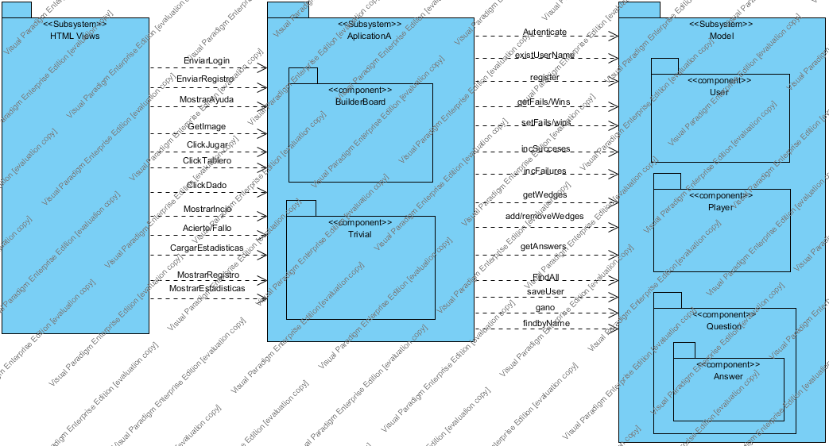

|  |  |
| --- | --- |
| Name | Value |
| Name | Diagrama de paquetes |
| Author | Trivial1a |
| Create Date Time | 06-may-2015 23:14:38 |
| Last Modified | 07-may-2015 23:02:18 |
| Teamwork Create Date Time | 0 |

## Summary

|  |  |
| --- | --- |
| Name | Description |
| Image15.png HTML Views | Las vistas realizan peticiones al controlador, ya que será el que las conecte con el modelo. El usuario interactuará a través de las vistas en los navegadores web. |
| Image15.png AplicationA | Aplication contiene la lógica del juego y es el controlador, es decir, se encarga de conectar las vistas con el modelo. Contendrá la lógica propia del juego y lo correspondiente a las imágenes y actualización de las mismas en la partida. |
| Image15.png Model | Esto es el modelo de datos que contiene los datos relacionados a la aplicación. Aquí se encontrarán usuarios registrados o logueados, los jugadores activos en una partida y las preguntas con sus respuestas. |
| Image15.png User | Aquí se almacenan los usuarios de la aplicación, tanto registrados como logueados. |
| Image15.png BuilderBoard | Lleva la parte de imágenes de la aplicación. |
| Image15.png Player | Durante una partida, los jugadores son almacenados aquí. De esta manera, la aplicación usará esto antes que la clase User para los jugadores que están en activo en una partida. |
| Image15.png Trivial | Aquí se encuentra la lógica correspondiente al juego. |
| Image15.png Question | Son las preguntas almacenadas con su respuesta. De aquí saldrás las que se usen durante la partida. |
| Image15.png Answer | Son las respuestas de las preguntas del juego. |

## Details

### Image16.png HTML Views

|  |  |
| --- | --- |
| Name | Value |
| Description | Las vistas realizan peticiones al controlador, ya que será el que las conecte con el modelo. El usuario interactuará a través de las vistas en los navegadores web. |
| Abstract | false |
| Leaf | false |
| Root | false |
| Stereotypes | Subsystem |
| Quality Score | Fair |
| Quality Reason | |  |  | | --- | --- | | Problem | Suggestion | | Name does not contain glossary terms | Define name as term in glossary | |
| Visibility | public |
| Project Management | |  |  | | --- | --- | | Name | Value | | Author | Trivial1a | | Create Date Time | 06-may-2015 23:16:29 | | Last Modified | 07-may-2015 22:51:07 | |

#### Relationships

|  |  |
| --- | --- |
| MostrarIncio : Dependency | |
| To | Image15.png AplicationA |
| Visibility | Unspecified |
| Quality Score | Fair |
| Quality Reason | |  |  | | --- | --- | | Problem | Suggestion | | Name does not contain glossary terms | Define name as term in glossary | |
| Project Management | |  |  | | --- | --- | | Name | Value | | Author | Trivial1a | | Create Date Time | 06-may-2015 23:33:59 | | Last Modified | 07-may-2015 17:51:39 | |

|  |  |
| --- | --- |
| EnviarLogin : Dependency | |
| To | Image15.png AplicationA |
| Visibility | Unspecified |
| Quality Score | Fair |
| Quality Reason | |  |  | | --- | --- | | Problem | Suggestion | | Name does not contain glossary terms | Define name as term in glossary | |
| Project Management | |  |  | | --- | --- | | Name | Value | | Author | Trivial1a | | Create Date Time | 06-may-2015 23:34:32 | | Last Modified | 07-may-2015 17:51:39 | |

|  |  |
| --- | --- |
| MostrarRegistro : Dependency | |
| To | Image15.png AplicationA |
| Visibility | Unspecified |
| Quality Score | Fair |
| Quality Reason | |  |  | | --- | --- | | Problem | Suggestion | | Name does not contain glossary terms | Define name as term in glossary | |
| Project Management | |  |  | | --- | --- | | Name | Value | | Author | Trivial1a | | Create Date Time | 06-may-2015 23:35:07 | | Last Modified | 07-may-2015 17:51:39 | |

|  |  |
| --- | --- |
| EnviarRegistro : Dependency | |
| To | Image15.png AplicationA |
| Description | Envia el registro de un usuario al controlador. |
| Visibility | Unspecified |
| Quality Score | Fair |
| Quality Reason | |  |  | | --- | --- | | Problem | Suggestion | | Name does not contain glossary terms | Define name as term in glossary | |
| Project Management | |  |  | | --- | --- | | Name | Value | | Author | Trivial1a | | Create Date Time | 06-may-2015 23:35:26 | | Last Modified | 07-may-2015 22:55:07 | |

|  |  |
| --- | --- |
| MostrarEstadisticas : Dependency | |
| To | Image15.png AplicationA |
| Description | Muestra las estadísticas del usuario. |
| Visibility | Unspecified |
| Quality Score | Fair |
| Quality Reason | |  |  | | --- | --- | | Problem | Suggestion | | Name does not contain glossary terms | Define name as term in glossary | |
| Project Management | |  |  | | --- | --- | | Name | Value | | Author | Trivial1a | | Create Date Time | 06-may-2015 23:35:53 | | Last Modified | 07-may-2015 22:57:18 | |

|  |  |
| --- | --- |
| MostrarAyuda : Dependency | |
| To | Image15.png AplicationA |
| Visibility | Unspecified |
| Quality Score | Fair |
| Quality Reason | |  |  | | --- | --- | | Problem | Suggestion | | Name does not contain glossary terms | Define name as term in glossary | |
| Project Management | |  |  | | --- | --- | | Name | Value | | Author | Trivial1a | | Create Date Time | 06-may-2015 23:36:50 | | Last Modified | 07-may-2015 17:51:39 | |

|  |  |
| --- | --- |
| ClickDado : Dependency | |
| To | Image15.png AplicationA |
| Description | Hace que saques un número para poder mover la ficha. |
| Visibility | Unspecified |
| Quality Score | Fair |
| Quality Reason | |  |  | | --- | --- | | Problem | Suggestion | | Name does not contain glossary terms | Define name as term in glossary | |
| Project Management | |  |  | | --- | --- | | Name | Value | | Author | Trivial1a | | Create Date Time | 06-may-2015 23:37:04 | | Last Modified | 07-may-2015 22:57:18 | |

|  |  |
| --- | --- |
| GetImage : Dependency | |
| To | Image15.png AplicationA |
| Visibility | Unspecified |
| Quality Score | Fair |
| Quality Reason | |  |  | | --- | --- | | Problem | Suggestion | | Name does not contain glossary terms | Define name as term in glossary | |
| Project Management | |  |  | | --- | --- | | Name | Value | | Author | Trivial1a | | Create Date Time | 06-may-2015 23:37:17 | | Last Modified | 07-may-2015 17:51:39 | |

|  |  |
| --- | --- |
| ClickTablero : Dependency | |
| To | Image15.png AplicationA |
| Visibility | Unspecified |
| Quality Score | Fair |
| Quality Reason | |  |  | | --- | --- | | Problem | Suggestion | | Name does not contain glossary terms | Define name as term in glossary | |
| Project Management | |  |  | | --- | --- | | Name | Value | | Author | Trivial1a | | Create Date Time | 06-may-2015 23:37:35 | | Last Modified | 07-may-2015 17:51:39 | |

|  |  |
| --- | --- |
| ClickJugar : Dependency | |
| To | Image15.png AplicationA |
| Visibility | Unspecified |
| Quality Score | Fair |
| Quality Reason | |  |  | | --- | --- | | Problem | Suggestion | | Name does not contain glossary terms | Define name as term in glossary | |
| Project Management | |  |  | | --- | --- | | Name | Value | | Author | Trivial1a | | Create Date Time | 06-may-2015 23:37:50 | | Last Modified | 07-may-2015 17:51:39 | |

|  |  |
| --- | --- |
| Acierto/Fallo : Dependency | |
| To | Image15.png AplicationA |
| Visibility | Unspecified |
| Project Management | |  |  | | --- | --- | | Name | Value | | Author | Trivial1a | | Create Date Time | 07-may-2015 22:50:40 | | Last Modified | 07-may-2015 22:52:18 | |

|  |  |
| --- | --- |
| CargarEstadisticas : Dependency | |
| To | Image15.png AplicationA |
| Description | Carga las estadísticas del usuario. |
| Visibility | Unspecified |
| Project Management | |  |  | | --- | --- | | Name | Value | | Author | Trivial1a | | Create Date Time | 07-may-2015 22:50:53 | | Last Modified | 07-may-2015 22:57:18 | |

### Image16.png AplicationA

|  |  |
| --- | --- |
| Name | Value |
| Description | Aplication contiene la lógica del juego y es el controlador, es decir, se encarga de conectar las vistas con el modelo. Contendrá la lógica propia del juego y lo correspondiente a las imágenes y actualización de las mismas en la partida. |
| Abstract | false |
| Leaf | false |
| Root | false |
| Stereotypes | Subsystem |
| Quality Score | Fair |
| Quality Reason | |  |  | | --- | --- | | Problem | Suggestion | | Name does not contain glossary terms | Define name as term in glossary | |
| Visibility | public |
| Project Management | |  |  | | --- | --- | | Name | Value | | Author | Trivial1a | | Create Date Time | 06-may-2015 23:19:42 | | Last Modified | 07-may-2015 22:53:19 | |

#### Children

|  |  |
| --- | --- |
| Name | Description |
| Image15.png BuilderBoard | Lleva la parte de imágenes de la aplicación. |
| Image15.png Trivial | Aquí se encuentra la lógica correspondiente al juego. |

#### Relationships

|  |  |
| --- | --- |
| Autenticate : Dependency | |
| To | Image15.png Model |
| Description | Autentifica al usuario. |
| Visibility | Unspecified |
| Quality Score | Fair |
| Quality Reason | |  |  | | --- | --- | | Problem | Suggestion | | Name does not contain glossary terms | Define name as term in glossary | |
| Project Management | |  |  | | --- | --- | | Name | Value | | Author | Trivial1a | | Create Date Time | 06-may-2015 23:38:39 | | Last Modified | 07-may-2015 22:57:18 | |

|  |  |
| --- | --- |
| existUserName : Dependency | |
| To | Image15.png Model |
| Visibility | Unspecified |
| Quality Score | Fair |
| Quality Reason | |  |  | | --- | --- | | Problem | Suggestion | | Name does not contain glossary terms | Define name as term in glossary | |
| Project Management | |  |  | | --- | --- | | Name | Value | | Author | Trivial1a | | Create Date Time | 06-may-2015 23:38:52 | | Last Modified | 07-may-2015 17:51:39 | |

|  |  |
| --- | --- |
| register : Dependency | |
| To | Image15.png Model |
| Description | Registra al usuario en el modelo. |
| Visibility | Unspecified |
| Quality Score | Fair |
| Quality Reason | |  |  | | --- | --- | | Problem | Suggestion | | Name does not contain glossary terms | Define name as term in glossary | |
| Project Management | |  |  | | --- | --- | | Name | Value | | Author | Trivial1a | | Create Date Time | 06-may-2015 23:39:19 | | Last Modified | 07-may-2015 22:57:18 | |

|  |  |
| --- | --- |
| getFails/Wins : Dependency | |
| To | Image15.png Model |
| Visibility | Unspecified |
| Quality Score | Fair |
| Quality Reason | |  |  | | --- | --- | | Problem | Suggestion | | Name does not contain glossary terms | Define name as term in glossary | |
| Project Management | |  |  | | --- | --- | | Name | Value | | Author | Trivial1a | | Create Date Time | 06-may-2015 23:40:07 | | Last Modified | 07-may-2015 17:51:39 | |

|  |  |
| --- | --- |
| setFails/wins : Dependency | |
| To | Image15.png Model |
| Visibility | Unspecified |
| Quality Score | Fair |
| Quality Reason | |  |  | | --- | --- | | Problem | Suggestion | | Name does not contain glossary terms | Define name as term in glossary | |
| Project Management | |  |  | | --- | --- | | Name | Value | | Author | Trivial1a | | Create Date Time | 06-may-2015 23:40:37 | | Last Modified | 07-may-2015 17:51:39 | |

|  |  |
| --- | --- |
| incSucceses : Dependency | |
| To | Image15.png Model |
| Visibility | Unspecified |
| Quality Score | Fair |
| Quality Reason | |  |  | | --- | --- | | Problem | Suggestion | | Name does not contain glossary terms | Define name as term in glossary | |
| Project Management | |  |  | | --- | --- | | Name | Value | | Author | Trivial1a | | Create Date Time | 06-may-2015 23:41:31 | | Last Modified | 07-may-2015 17:51:39 | |

|  |  |
| --- | --- |
| incFailures : Dependency | |
| To | Image15.png Model |
| Visibility | Unspecified |
| Quality Score | Fair |
| Quality Reason | |  |  | | --- | --- | | Problem | Suggestion | | Name does not contain glossary terms | Define name as term in glossary | |
| Project Management | |  |  | | --- | --- | | Name | Value | | Author | Trivial1a | | Create Date Time | 06-may-2015 23:42:05 | | Last Modified | 07-may-2015 17:51:39 | |

|  |  |
| --- | --- |
| getWedges : Dependency | |
| To | Image15.png Model |
| Visibility | Unspecified |
| Quality Score | Fair |
| Quality Reason | |  |  | | --- | --- | | Problem | Suggestion | | Name does not contain glossary terms | Define name as term in glossary | |
| Project Management | |  |  | | --- | --- | | Name | Value | | Author | Trivial1a | | Create Date Time | 06-may-2015 23:42:24 | | Last Modified | 07-may-2015 17:51:39 | |

|  |  |
| --- | --- |
| add/removeWedges : Dependency | |
| To | Image15.png Model |
| Visibility | Unspecified |
| Quality Score | Fair |
| Quality Reason | |  |  | | --- | --- | | Problem | Suggestion | | Name does not contain glossary terms | Define name as term in glossary | |
| Project Management | |  |  | | --- | --- | | Name | Value | | Author | Trivial1a | | Create Date Time | 06-may-2015 23:42:40 | | Last Modified | 07-may-2015 17:51:39 | |

|  |  |
| --- | --- |
| getAnswers : Dependency | |
| To | Image15.png Model |
| Visibility | Unspecified |
| Quality Score | Fair |
| Quality Reason | |  |  | | --- | --- | | Problem | Suggestion | | Name does not contain glossary terms | Define name as term in glossary | |
| Project Management | |  |  | | --- | --- | | Name | Value | | Author | Trivial1a | | Create Date Time | 06-may-2015 23:44:29 | | Last Modified | 07-may-2015 17:51:39 | |

|  |  |
| --- | --- |
| FindAll : Dependency | |
| To | Image15.png Model |
| Visibility | Unspecified |
| Quality Score | Fair |
| Quality Reason | |  |  | | --- | --- | | Problem | Suggestion | | Name does not contain glossary terms | Define name as term in glossary | |
| Project Management | |  |  | | --- | --- | | Name | Value | | Author | Trivial1a | | Create Date Time | 06-may-2015 23:44:43 | | Last Modified | 07-may-2015 17:51:39 | |

|  |  |
| --- | --- |
| gano : Dependency | |
| To | Image15.png Model |
| Description | Dice si el jugador gano la partida. |
| Visibility | Unspecified |
| Project Management | |  |  | | --- | --- | | Name | Value | | Author | Trivial1a | | Create Date Time | 07-may-2015 22:52:37 | | Last Modified | 07-may-2015 22:57:18 | |

|  |  |
| --- | --- |
| saveUser : Dependency | |
| To | Image15.png Model |
| Description | Guarda al usuario en el modelo. |
| Visibility | Unspecified |
| Project Management | |  |  | | --- | --- | | Name | Value | | Author | Trivial1a | | Create Date Time | 07-may-2015 22:52:45 | | Last Modified | 07-may-2015 22:57:18 | |

|  |  |
| --- | --- |
| findbyName : Dependency | |
| To | Image15.png Model |
| Visibility | Unspecified |
| Project Management | |  |  | | --- | --- | | Name | Value | | Author | Trivial1a | | Create Date Time | 07-may-2015 22:53:07 | | Last Modified | 07-may-2015 22:53:19 | |
| MostrarIncio : Dependency | |
| From | Image15.png HTML Views |
| Visibility | Unspecified |
| Quality Score | Fair |
| Quality Reason | |  |  | | --- | --- | | Problem | Suggestion | | Name does not contain glossary terms | Define name as term in glossary | |
| Project Management | |  |  | | --- | --- | | Name | Value | | Author | Trivial1a | | Create Date Time | 06-may-2015 23:33:59 | | Last Modified | 07-may-2015 17:51:39 | |

|  |  |
| --- | --- |
| EnviarLogin : Dependency | |
| From | Image15.png HTML Views |
| Visibility | Unspecified |
| Quality Score | Fair |
| Quality Reason | |  |  | | --- | --- | | Problem | Suggestion | | Name does not contain glossary terms | Define name as term in glossary | |
| Project Management | |  |  | | --- | --- | | Name | Value | | Author | Trivial1a | | Create Date Time | 06-may-2015 23:34:32 | | Last Modified | 07-may-2015 17:51:39 | |

|  |  |
| --- | --- |
| MostrarRegistro : Dependency | |
| From | Image15.png HTML Views |
| Visibility | Unspecified |
| Quality Score | Fair |
| Quality Reason | |  |  | | --- | --- | | Problem | Suggestion | | Name does not contain glossary terms | Define name as term in glossary | |
| Project Management | |  |  | | --- | --- | | Name | Value | | Author | Trivial1a | | Create Date Time | 06-may-2015 23:35:07 | | Last Modified | 07-may-2015 17:51:39 | |

|  |  |
| --- | --- |
| EnviarRegistro : Dependency | |
| From | Image15.png HTML Views |
| Description | Envia el registro de un usuario al controlador. |
| Visibility | Unspecified |
| Quality Score | Fair |
| Quality Reason | |  |  | | --- | --- | | Problem | Suggestion | | Name does not contain glossary terms | Define name as term in glossary | |
| Project Management | |  |  | | --- | --- | | Name | Value | | Author | Trivial1a | | Create Date Time | 06-may-2015 23:35:26 | | Last Modified | 07-may-2015 22:55:07 | |

|  |  |
| --- | --- |
| MostrarEstadisticas : Dependency | |
| From | Image15.png HTML Views |
| Description | Muestra las estadísticas del usuario. |
| Visibility | Unspecified |
| Quality Score | Fair |
| Quality Reason | |  |  | | --- | --- | | Problem | Suggestion | | Name does not contain glossary terms | Define name as term in glossary | |
| Project Management | |  |  | | --- | --- | | Name | Value | | Author | Trivial1a | | Create Date Time | 06-may-2015 23:35:53 | | Last Modified | 07-may-2015 22:57:18 | |

|  |  |
| --- | --- |
| MostrarAyuda : Dependency | |
| From | Image15.png HTML Views |
| Visibility | Unspecified |
| Quality Score | Fair |
| Quality Reason | |  |  | | --- | --- | | Problem | Suggestion | | Name does not contain glossary terms | Define name as term in glossary | |
| Project Management | |  |  | | --- | --- | | Name | Value | | Author | Trivial1a | | Create Date Time | 06-may-2015 23:36:50 | | Last Modified | 07-may-2015 17:51:39 | |

|  |  |
| --- | --- |
| ClickDado : Dependency | |
| From | Image15.png HTML Views |
| Description | Hace que saques un número para poder mover la ficha. |
| Visibility | Unspecified |
| Quality Score | Fair |
| Quality Reason | |  |  | | --- | --- | | Problem | Suggestion | | Name does not contain glossary terms | Define name as term in glossary | |
| Project Management | |  |  | | --- | --- | | Name | Value | | Author | Trivial1a | | Create Date Time | 06-may-2015 23:37:04 | | Last Modified | 07-may-2015 22:57:18 | |

|  |  |
| --- | --- |
| GetImage : Dependency | |
| From | Image15.png HTML Views |
| Visibility | Unspecified |
| Quality Score | Fair |
| Quality Reason | |  |  | | --- | --- | | Problem | Suggestion | | Name does not contain glossary terms | Define name as term in glossary | |
| Project Management | |  |  | | --- | --- | | Name | Value | | Author | Trivial1a | | Create Date Time | 06-may-2015 23:37:17 | | Last Modified | 07-may-2015 17:51:39 | |

|  |  |
| --- | --- |
| ClickTablero : Dependency | |
| From | Image15.png HTML Views |
| Visibility | Unspecified |
| Quality Score | Fair |
| Quality Reason | |  |  | | --- | --- | | Problem | Suggestion | | Name does not contain glossary terms | Define name as term in glossary | |
| Project Management | |  |  | | --- | --- | | Name | Value | | Author | Trivial1a | | Create Date Time | 06-may-2015 23:37:35 | | Last Modified | 07-may-2015 17:51:39 | |

|  |  |
| --- | --- |
| ClickJugar : Dependency | |
| From | Image15.png HTML Views |
| Visibility | Unspecified |
| Quality Score | Fair |
| Quality Reason | |  |  | | --- | --- | | Problem | Suggestion | | Name does not contain glossary terms | Define name as term in glossary | |
| Project Management | |  |  | | --- | --- | | Name | Value | | Author | Trivial1a | | Create Date Time | 06-may-2015 23:37:50 | | Last Modified | 07-may-2015 17:51:39 | |

|  |  |
| --- | --- |
| Acierto/Fallo : Dependency | |
| From | Image15.png HTML Views |
| Visibility | Unspecified |
| Project Management | |  |  | | --- | --- | | Name | Value | | Author | Trivial1a | | Create Date Time | 07-may-2015 22:50:40 | | Last Modified | 07-may-2015 22:52:18 | |

|  |  |
| --- | --- |
| CargarEstadisticas : Dependency | |
| From | Image15.png HTML Views |
| Description | Carga las estadísticas del usuario. |
| Visibility | Unspecified |
| Project Management | |  |  | | --- | --- | | Name | Value | | Author | Trivial1a | | Create Date Time | 07-may-2015 22:50:53 | | Last Modified | 07-may-2015 22:57:18 | |

### Image16.png Model

|  |  |
| --- | --- |
| Name | Value |
| Description | Esto es el modelo de datos que contiene los datos relacionados a la aplicación. Aquí se encontrarán usuarios registrados o logueados, los jugadores activos en una partida y las preguntas con sus respuestas. |
| Abstract | false |
| Leaf | false |
| Root | false |
| Stereotypes | Subsystem |
| Quality Score | Fair |
| Quality Reason | |  |  | | --- | --- | | Problem | Suggestion | | Name does not contain glossary terms | Define name as term in glossary | |
| Visibility | public |
| Project Management | |  |  | | --- | --- | | Name | Value | | Author | Trivial1a | | Create Date Time | 06-may-2015 23:31:36 | | Last Modified | 07-may-2015 22:53:19 | |

#### Children

|  |  |
| --- | --- |
| Name | Description |
| Image15.png User | Aquí se almacenan los usuarios de la aplicación, tanto registrados como logueados. |
| Image15.png Player | Durante una partida, los jugadores son almacenados aquí. De esta manera, la aplicación usará esto antes que la clase User para los jugadores que están en activo en una partida. |
| Image15.png Question | Son las preguntas almacenadas con su respuesta. De aquí saldrás las que se usen durante la partida. |

#### Relationships

|  |  |
| --- | --- |
| Autenticate : Dependency | |
| From | Image15.png AplicationA |
| Description | Autentifica al usuario. |
| Visibility | Unspecified |
| Quality Score | Fair |
| Quality Reason | |  |  | | --- | --- | | Problem | Suggestion | | Name does not contain glossary terms | Define name as term in glossary | |
| Project Management | |  |  | | --- | --- | | Name | Value | | Author | Trivial1a | | Create Date Time | 06-may-2015 23:38:39 | | Last Modified | 07-may-2015 22:57:18 | |

|  |  |
| --- | --- |
| existUserName : Dependency | |
| From | Image15.png AplicationA |
| Visibility | Unspecified |
| Quality Score | Fair |
| Quality Reason | |  |  | | --- | --- | | Problem | Suggestion | | Name does not contain glossary terms | Define name as term in glossary | |
| Project Management | |  |  | | --- | --- | | Name | Value | | Author | Trivial1a | | Create Date Time | 06-may-2015 23:38:52 | | Last Modified | 07-may-2015 17:51:39 | |

|  |  |
| --- | --- |
| register : Dependency | |
| From | Image15.png AplicationA |
| Description | Registra al usuario en el modelo. |
| Visibility | Unspecified |
| Quality Score | Fair |
| Quality Reason | |  |  | | --- | --- | | Problem | Suggestion | | Name does not contain glossary terms | Define name as term in glossary | |
| Project Management | |  |  | | --- | --- | | Name | Value | | Author | Trivial1a | | Create Date Time | 06-may-2015 23:39:19 | | Last Modified | 07-may-2015 22:57:18 | |

|  |  |
| --- | --- |
| getFails/Wins : Dependency | |
| From | Image15.png AplicationA |
| Visibility | Unspecified |
| Quality Score | Fair |
| Quality Reason | |  |  | | --- | --- | | Problem | Suggestion | | Name does not contain glossary terms | Define name as term in glossary | |
| Project Management | |  |  | | --- | --- | | Name | Value | | Author | Trivial1a | | Create Date Time | 06-may-2015 23:40:07 | | Last Modified | 07-may-2015 17:51:39 | |

|  |  |
| --- | --- |
| setFails/wins : Dependency | |
| From | Image15.png AplicationA |
| Visibility | Unspecified |
| Quality Score | Fair |
| Quality Reason | |  |  | | --- | --- | | Problem | Suggestion | | Name does not contain glossary terms | Define name as term in glossary | |
| Project Management | |  |  | | --- | --- | | Name | Value | | Author | Trivial1a | | Create Date Time | 06-may-2015 23:40:37 | | Last Modified | 07-may-2015 17:51:39 | |

|  |  |
| --- | --- |
| incSucceses : Dependency | |
| From | Image15.png AplicationA |
| Visibility | Unspecified |
| Quality Score | Fair |
| Quality Reason | |  |  | | --- | --- | | Problem | Suggestion | | Name does not contain glossary terms | Define name as term in glossary | |
| Project Management | |  |  | | --- | --- | | Name | Value | | Author | Trivial1a | | Create Date Time | 06-may-2015 23:41:31 | | Last Modified | 07-may-2015 17:51:39 | |

|  |  |
| --- | --- |
| incFailures : Dependency | |
| From | Image15.png AplicationA |
| Visibility | Unspecified |
| Quality Score | Fair |
| Quality Reason | |  |  | | --- | --- | | Problem | Suggestion | | Name does not contain glossary terms | Define name as term in glossary | |
| Project Management | |  |  | | --- | --- | | Name | Value | | Author | Trivial1a | | Create Date Time | 06-may-2015 23:42:05 | | Last Modified | 07-may-2015 17:51:39 | |

|  |  |
| --- | --- |
| getWedges : Dependency | |
| From | Image15.png AplicationA |
| Visibility | Unspecified |
| Quality Score | Fair |
| Quality Reason | |  |  | | --- | --- | | Problem | Suggestion | | Name does not contain glossary terms | Define name as term in glossary | |
| Project Management | |  |  | | --- | --- | | Name | Value | | Author | Trivial1a | | Create Date Time | 06-may-2015 23:42:24 | | Last Modified | 07-may-2015 17:51:39 | |

|  |  |
| --- | --- |
| add/removeWedges : Dependency | |
| From | Image15.png AplicationA |
| Visibility | Unspecified |
| Quality Score | Fair |
| Quality Reason | |  |  | | --- | --- | | Problem | Suggestion | | Name does not contain glossary terms | Define name as term in glossary | |
| Project Management | |  |  | | --- | --- | | Name | Value | | Author | Trivial1a | | Create Date Time | 06-may-2015 23:42:40 | | Last Modified | 07-may-2015 17:51:39 | |

|  |  |
| --- | --- |
| getAnswers : Dependency | |
| From | Image15.png AplicationA |
| Visibility | Unspecified |
| Quality Score | Fair |
| Quality Reason | |  |  | | --- | --- | | Problem | Suggestion | | Name does not contain glossary terms | Define name as term in glossary | |
| Project Management | |  |  | | --- | --- | | Name | Value | | Author | Trivial1a | | Create Date Time | 06-may-2015 23:44:29 | | Last Modified | 07-may-2015 17:51:39 | |

|  |  |
| --- | --- |
| FindAll : Dependency | |
| From | Image15.png AplicationA |
| Visibility | Unspecified |
| Quality Score | Fair |
| Quality Reason | |  |  | | --- | --- | | Problem | Suggestion | | Name does not contain glossary terms | Define name as term in glossary | |
| Project Management | |  |  | | --- | --- | | Name | Value | | Author | Trivial1a | | Create Date Time | 06-may-2015 23:44:43 | | Last Modified | 07-may-2015 17:51:39 | |

|  |  |
| --- | --- |
| gano : Dependency | |
| From | Image15.png AplicationA |
| Description | Dice si el jugador gano la partida. |
| Visibility | Unspecified |
| Project Management | |  |  | | --- | --- | | Name | Value | | Author | Trivial1a | | Create Date Time | 07-may-2015 22:52:37 | | Last Modified | 07-may-2015 22:57:18 | |

|  |  |
| --- | --- |
| saveUser : Dependency | |
| From | Image15.png AplicationA |
| Description | Guarda al usuario en el modelo. |
| Visibility | Unspecified |
| Project Management | |  |  | | --- | --- | | Name | Value | | Author | Trivial1a | | Create Date Time | 07-may-2015 22:52:45 | | Last Modified | 07-may-2015 22:57:18 | |

|  |  |
| --- | --- |
| findbyName : Dependency | |
| From | Image15.png AplicationA |
| Visibility | Unspecified |
| Project Management | |  |  | | --- | --- | | Name | Value | | Author | Trivial1a | | Create Date Time | 07-may-2015 22:53:07 | | Last Modified | 07-may-2015 22:53:19 | |

### Image16.png User

|  |  |
| --- | --- |
| Name | Value |
| Description | Aquí se almacenan los usuarios de la aplicación, tanto registrados como logueados. |
| Abstract | false |
| Leaf | false |
| Root | false |
| Stereotypes | component |
| Quality Score | Ignore |
| Visibility | public |
| Project Management | |  |  | | --- | --- | | Name | Value | | Author | Trivial1a | | Create Date Time | 06-may-2015 23:32:18 | | Last Modified | 07-may-2015 22:43:15 | |

### Image16.png BuilderBoard

|  |  |
| --- | --- |
| Name | Value |
| Description | Lleva la parte de imágenes de la aplicación. |
| Abstract | false |
| Leaf | false |
| Root | false |
| Stereotypes | component |
| Quality Score | Very Bad |
| Quality Reason | |  |  | | --- | --- | | Problem | Suggestion | | Name does not contain glossary terms | Define name as term in glossary | | Model element without any relationship | Connect model element with relationship | |
| Visibility | public |
| Project Management | |  |  | | --- | --- | | Name | Value | | Author | Trivial1a | | Create Date Time | 06-may-2015 23:20:57 | | Last Modified | 07-may-2015 22:43:15 | |

### Image16.png Player

|  |  |
| --- | --- |
| Name | Value |
| Description | Durante una partida, los jugadores son almacenados aquí. De esta manera, la aplicación usará esto antes que la clase User para los jugadores que están en activo en una partida. |
| Abstract | false |
| Leaf | false |
| Root | false |
| Stereotypes | component |
| Quality Score | Very Bad |
| Quality Reason | |  |  | | --- | --- | | Problem | Suggestion | | Name does not contain glossary terms | Define name as term in glossary | | Model element without any relationship | Connect model element with relationship | |
| Visibility | public |
| Project Management | |  |  | | --- | --- | | Name | Value | | Author | Trivial1a | | Create Date Time | 06-may-2015 23:32:46 | | Last Modified | 07-may-2015 22:43:15 | |

### Image16.png Trivial

|  |  |
| --- | --- |
| Name | Value |
| Description | Aquí se encuentra la lógica correspondiente al juego. |
| Abstract | false |
| Leaf | false |
| Root | false |
| Stereotypes | component |
| Quality Score | Very Bad |
| Quality Reason | |  |  | | --- | --- | | Problem | Suggestion | | Name does not contain glossary terms | Define name as term in glossary | | Model element without any relationship | Connect model element with relationship | |
| Visibility | public |
| Project Management | |  |  | | --- | --- | | Name | Value | | Author | Trivial1a | | Create Date Time | 06-may-2015 23:31:01 | | Last Modified | 07-may-2015 22:43:15 | |

### Image16.png Question

|  |  |
| --- | --- |
| Name | Value |
| Description | Son las preguntas almacenadas con su respuesta. De aquí saldrás las que se usen durante la partida. |
| Abstract | false |
| Leaf | false |
| Root | false |
| Stereotypes | component |
| Quality Score | Very Bad |
| Quality Reason | |  |  | | --- | --- | | Problem | Suggestion | | Name does not contain glossary terms | Define name as term in glossary | | Model element without any relationship | Connect model element with relationship | |
| Visibility | public |
| Project Management | |  |  | | --- | --- | | Name | Value | | Author | Trivial1a | | Create Date Time | 06-may-2015 23:33:11 | | Last Modified | 07-may-2015 22:51:07 | |

#### Children

|  |  |
| --- | --- |
| Name | Description |
| Image15.png Answer | Son las respuestas de las preguntas del juego. |

### Image16.png Answer

|  |  |
| --- | --- |
| Name | Value |
| Description | Son las respuestas de las preguntas del juego. |
| Abstract | false |
| Leaf | false |
| Root | false |
| Stereotypes | component |
| Quality Score | Very Bad |
| Quality Reason | |  |  | | --- | --- | | Problem | Suggestion | | Name does not contain glossary terms | Define name as term in glossary | | Model element without any relationship | Connect model element with relationship | |
| Visibility | public |
| Project Management | |  |  | | --- | --- | | Name | Value | | Author | Trivial1a | | Create Date Time | 06-may-2015 23:33:18 | | Last Modified | 07-may-2015 22:51:07 | |

# Anexo B: Diagrama BPMN

Diagrama de Procesos de Negocio

## Diagrama de Procesos de Negocio - Partida de Trivial

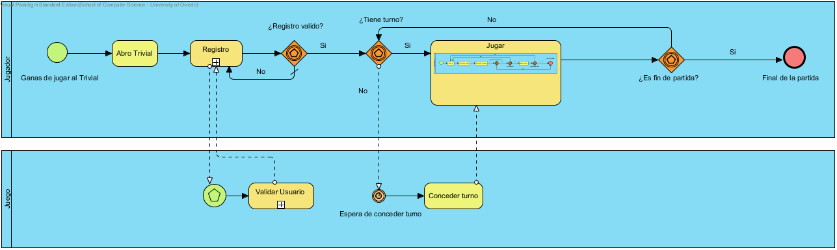

|  |  |
| --- | --- |
| Nombre | Valor |
| Nombre | Diagrama de Procesos de Negocio - Partida de Trivial |
| Autor | Trivial1a |
| Fecha de Creación | 23-abr-2015 15:46:46 |
| Última Modificación | 30-abr-2015 10:10:04 |
| Shape Presentation Option | 0 |
| Default Parent Model | Partida de trivial |
| Idioma | English |

## Resumen

|  |  |
| --- | --- |
| Nombre | Documentación |
| Image1.png Jugador | El usuario que se dispone a usar el juego. |
| Image1.png Juego | En nuestro caso este será el Trivial. |
| Image2.png Ganas de jugar al Trivial | La acción se va a desarrollar a partir de las ganas que al jugador le entran de jugar al Trivial. |
| Image3.png Abro Trivial | El jugador al tener ganas de jugar abre la plataforma donde jugará al trivial. |
| Image4.png Registro | El jugador después de entrar en la plataforma se dispone a registrarse para poder jugar. Este registro enviará los datos a la plataforma para que esta pueda validarlos. |
| Image4.png Validar Usuario | El proceso de validar a un usuario se omite ya que nos vamos a centrar en lo que es la partida del juego, pero si se tiene en cuenta como un subproceso de esta tarea. |
| Image5.png ¿Registro valido? | Si estos datos se validan correctamente, entonces se seguirá desarrollando la acción. Si no se volverá a pedir que el usuario se registre. |
| Image5.png ¿Tiene turno? | Se comprueba si el jugador activo tiene el turno o no. |
| Image6.png Espera de conceder turno | Espera el tiempo que tardaría la aplicación en concederle el turno al jugador. |
| Image3.png Conceder turno | Se concede el turno al jugador correspondiente. |
| Image4.png Jugar | Después de que el usuario se valide correctamente, podrá comenzar el juego. |
| Image5.png ¿Es fin de partida? | Comprueba si está acabada la partida. |
| Image7.png Final de la partida | Termina la partida. |

#### Documentación

El usuario que va a utilizar el juego.

## Detalles

### Image1.png Jugador

|  |  |
| --- | --- |
| Nombre | Valor |
| Identificación | BP02 |
| Quality Score | Fair |
| Quality Reason | |  |  | | --- | --- | | Problem | Suggestion | | Name does not contain glossary terms | Define name as term in glossary | |
| Black Box | false |
| Project Management | |  |  | | --- | --- | | Nombre | Valor | | Autor | Trivial1a | | Fecha de Creación | 23-abr-2015 15:48:00 | | Última Modificación | 30-abr-2015 10:03:21 | |

#### Hijos

|  |  |
| --- | --- |
| Nombre | Documentación |
| Image2.png Ganas de jugar al Trivial | La acción se va a desarrollar a partir de las ganas que al jugador le entran de jugar al Trivial. |
| Image3.png Abro Trivial | El jugador al tener ganas de jugar abre la plataforma donde jugará al trivial. |
| Image4.png Registro | El jugador después de entrar en la plataforma se dispone a registrarse para poder jugar. Este registro enviará los datos a la plataforma para que esta pueda validarlos. |
| Image5.png ¿Registro valido? | Si estos datos se validan correctamente, entonces se seguirá desarrollando la acción. Si no se volverá a pedir que el usuario se registre. |
| Image4.png Jugar | Después de que el usuario se valide correctamente, podrá comenzar el juego. |
| Image7.png Final de la partida | Termina la partida. |
| Image5.png ¿Tiene turno? | Se comprueba si el jugador activo tiene el turno o no. |
| Image5.png ¿Es fin de partida? | Comprueba si está acabada la partida. |

### Image1.png Juego

|  |  |
| --- | --- |
| Nombre | Valor |
| Documentación | En nuestro caso este será el Trivial. |
| Identificación | BP07 |
| Quality Score | Fair |
| Quality Reason | |  |  | | --- | --- | | Problem | Suggestion | | Name does not contain glossary terms | Define name as term in glossary | |
| Black Box | false |
| Project Management | |  |  | | --- | --- | | Nombre | Valor | | Autor | Trivial1a | | Fecha de Creación | 23-abr-2015 15:52:51 | | Última Modificación | 30-abr-2015 9:51:50 | |

#### Hijos

|  |  |
| --- | --- |
| Nombre | Documentación |
| Image8.png N/A |  |
| Image4.png Validar Usuario | El proceso de validar a un usuario se omite ya que nos vamos a centrar en lo que es la partida del juego, pero si se tiene en cuenta como un subproceso de esta tarea. |
| Image6.png Espera de conceder turno | Espera el tiempo que tardaría la aplicación en concederle el turno al jugador. |
| Image3.png Conceder turno | Se concede el turno al jugador correspondiente. |

### Image2.png Ganas de jugar al Trivial

|  |  |
| --- | --- |
| Nombre | Valor |
| Documentación | La acción se va a desarrollar a partir de las ganas que al jugador le entran de jugar al Trivial. |
| Identificación | BP02.BP01 |
| Quality Score | Fair |
| Quality Reason | |  |  | | --- | --- | | Problem | Suggestion | | Name does not contain glossary terms | Define name as term in glossary | |
| Project Management | |  |  | | --- | --- | | Nombre | Valor | | Autor | Trivial1a | | Fecha de Creación | 23-abr-2015 15:48:31 | | Última Modificación | 23-abr-2015 16:19:42 | |

#### Relationships

|  |  |
| --- | --- |
| Unnamed Secuencia de Flujo | |
| To | Image3.png Abro Trivial |
| Identificación | BP02.BP03 |
| Quality Score | Good |
| Condition Type | None |
| Immediate | Unspecified |
| Quantity | 1 |
| Timeout | 0 |
| Project Management | |  |  | | --- | --- | | Nombre | Valor | | Autor | Trivial1a | | Fecha de Creación | 23-abr-2015 15:49:51 | | Última Modificación | 23-abr-2015 15:57:50 | |

### Image3.png Abro Trivial

|  |  |
| --- | --- |
| Nombre | Valor |
| Documentación | El jugador al tener ganas de jugar abre la plataforma donde jugará al trivial. |
| Identificación | BP02.BP02 |
| Start Quantity | 1 |
| Completion Quantity | 1 |
| Suppress Join Failure | false |
| Enable Instance Compensation | false |
| Process Type | None |
| Estado | None |
| Quality Score | Fair |
| Quality Reason | |  |  | | --- | --- | | Problem | Suggestion | | Name does not contain glossary terms | Define name as term in glossary | |
| Compensation | false |
| Project Management | |  |  | | --- | --- | | Nombre | Valor | | Autor | Trivial1a | | Fecha de Creación | 23-abr-2015 15:49:30 | | Última Modificación | 23-abr-2015 16:19:42 | |

#### Relationships

|  |  |
| --- | --- |
| Unnamed Secuencia de Flujo | |
| To | Image4.png Registro |
| Identificación | BP02.BP08 |
| Quality Score | Good |
| Condition Type | None |
| Immediate | Unspecified |
| Quantity | 1 |
| Timeout | 0 |
| Project Management | |  |  | | --- | --- | | Nombre | Valor | | Autor | Trivial1a | | Fecha de Creación | 23-abr-2015 15:52:39 | | Última Modificación | 23-abr-2015 15:57:50 | |
| Unnamed Secuencia de Flujo | |
| From | Image2.png Ganas de jugar al Trivial |
| Identificación | BP02.BP03 |
| Quality Score | Good |
| Condition Type | None |
| Immediate | Unspecified |
| Quantity | 1 |
| Timeout | 0 |
| Project Management | |  |  | | --- | --- | | Nombre | Valor | | Autor | Trivial1a | | Fecha de Creación | 23-abr-2015 15:49:51 | | Última Modificación | 23-abr-2015 15:57:50 | |

### Image4.png Registro

|  |  |
| --- | --- |
| Nombre | Valor |
| Documentación | El jugador después de entrar en la plataforma se dispone a registrarse para poder jugar. Este registro enviará los datos a la plataforma para que esta pueda validarlos. |
| Identificación | BP02.BP07 |
| Start Quantity | 1 |
| Completion Quantity | 1 |
| Suppress Join Failure | false |
| Enable Instance Compensation | false |
| Process Type | None |
| Estado | None |
| Quality Score | Fair |
| Quality Reason | |  |  | | --- | --- | | Problem | Suggestion | | Name does not contain glossary terms | Define name as term in glossary | |
| Is Transaction | false |
| Compensation | false |
| Triggered By Event | false |
| Expanded Diagram Content | Same Diagram |
| Project Management | |  |  | | --- | --- | | Nombre | Valor | | Autor | Trivial1a | | Fecha de Creación | 23-abr-2015 15:52:08 | | Última Modificación | 23-abr-2015 16:19:42 | |

#### Relationships

|  |  |
| --- | --- |
| Unnamed Flujo de Mensajes | |
| To | Image8.png N/A |
| Identificación | BP02.BP10 |
| Quality Score | Good |
| Project Management | |  |  | | --- | --- | | Nombre | Valor | | Autor | Isabel | | Fecha de Creación | 23-abr-2015 15:55:38 | | Última Modificación | 23-abr-2015 16:19:42 | |

|  |  |
| --- | --- |
| Unnamed Secuencia de Flujo | |
| To | Image5.png ¿Registro valido? |
| Identificación | BP02.BP13 |
| Quality Score | Good |
| Condition Type | None |
| Immediate | Unspecified |
| Quantity | 1 |
| Timeout | 0 |
| Project Management | |  |  | | --- | --- | | Nombre | Valor | | Autor | Trivial1a | | Fecha de Creación | 23-abr-2015 16:00:24 | | Última Modificación | 23-abr-2015 16:19:42 | |
| Unnamed Secuencia de Flujo | |
| From | Image3.png Abro Trivial |
| Identificación | BP02.BP08 |
| Quality Score | Good |
| Condition Type | None |
| Immediate | Unspecified |
| Quantity | 1 |
| Timeout | 0 |
| Project Management | |  |  | | --- | --- | | Nombre | Valor | | Autor | Trivial1a | | Fecha de Creación | 23-abr-2015 15:52:39 | | Última Modificación | 23-abr-2015 15:57:50 | |

|  |  |
| --- | --- |
| Unnamed Flujo de Mensajes | |
| From | Image4.png Validar Usuario |
| Identificación | BP07.BP07 |
| Quality Score | Good |
| Project Management | |  |  | | --- | --- | | Nombre | Valor | | Autor | Trivial1a | | Fecha de Creación | 23-abr-2015 15:59:28 | | Última Modificación | 23-abr-2015 16:19:42 | |

|  |  |
| --- | --- |
| No : Secuencia de Flujo | |
| From | Image5.png ¿Registro valido? |
| Identificación | BP02.BP14 |
| Quality Score | Fair |
| Quality Reason | |  |  | | --- | --- | | Problem | Suggestion | | Name does not contain glossary terms | Define name as term in glossary | |
| Condition Type | Default |
| Immediate | Unspecified |
| Quantity | 1 |
| Timeout | 0 |
| Project Management | |  |  | | --- | --- | | Nombre | Valor | | Autor | Trivial1a | | Fecha de Creación | 23-abr-2015 16:00:39 | | Última Modificación | 23-abr-2015 16:40:44 | |

### Image8.png N/A

|  |  |
| --- | --- |
| Nombre | Valor |
| Identificación | BP07.BP01 |
| Quality Score | Good |
| Trigger | Image9.png Multiple |
| Project Management | |  |  | | --- | --- | | Nombre | Valor | | Autor | Trivial1a | | Fecha de Creación | 23-abr-2015 15:53:23 | | Última Modificación | 23-abr-2015 16:19:42 | |

#### Trigger

|  |  |
| --- | --- |
| Nombre | Valor |
| Type | Multiple Trigger |
| Nombre | Multiple |
| Trigger Type | Catching |
| Interrupting | true |
| Project Management | |  |  | | --- | --- | | Nombre | Valor | | Autor | Trivial1a | | Fecha de Creación | 23-abr-2015 15:53:23 | |

#### Relationships

|  |  |
| --- | --- |
| Unnamed Secuencia de Flujo | |
| To | Image4.png Validar Usuario |
| Identificación | BP07.BP06 |
| Quality Score | Good |
| Condition Type | None |
| Immediate | Unspecified |
| Quantity | 1 |
| Timeout | 0 |
| Project Management | |  |  | | --- | --- | | Nombre | Valor | | Autor | Trivial1a | | Fecha de Creación | 23-abr-2015 15:59:10 | | Última Modificación | 23-abr-2015 16:19:42 | |
| Unnamed Flujo de Mensajes | |
| From | Image4.png Registro |
| Identificación | BP02.BP10 |
| Quality Score | Good |
| Project Management | |  |  | | --- | --- | | Nombre | Valor | | Autor | Trivial1a | | Fecha de Creación | 23-abr-2015 15:55:38 | | Última Modificación | 23-abr-2015 16:19:42 | |

### Image4.png Validar Usuario

|  |  |
| --- | --- |
| Nombre | Valor |
| Documentación | El proceso de validar a un usuario se omite ya que nos vamos a centrar en lo que es la partida del juego, pero si se tiene en cuenta como un subproceso de esta tarea. |
| Identificación | BP07.BP05 |
| Start Quantity | 1 |
| Completion Quantity | 1 |
| Suppress Join Failure | false |
| Enable Instance Compensation | false |
| Process Type | None |
| Estado | None |
| Quality Score | Fair |
| Quality Reason | |  |  | | --- | --- | | Problem | Suggestion | | Name does not contain glossary terms | Define name as term in glossary | |
| Is Transaction | false |
| Compensation | false |
| Triggered By Event | false |
| Expanded Diagram Content | Same Diagram |
| Project Management | |  |  | | --- | --- | | Nombre | Valor | | Autor | Trivial1a | | Fecha de Creación | 23-abr-2015 15:58:52 | | Última Modificación | 23-abr-2015 16:19:42 | |

#### Relationships

|  |  |
| --- | --- |
| Unnamed Flujo de Mensajes | |
| To | Image4.png Registro |
| Identificación | BP07.BP07 |
| Quality Score | Good |
| Project Management | |  |  | | --- | --- | | Nombre | Valor | | Autor | Trivial1a | | Fecha de Creación | 23-abr-2015 15:59:28 | | Última Modificación | 23-abr-2015 16:19:42 | |
| Unnamed Secuencia de Flujo | |
| From | Image8.png N/A |
| Identificación | BP07.BP06 |
| Quality Score | Good |
| Condition Type | None |
| Immediate | Unspecified |
| Quantity | 1 |
| Timeout | 0 |
| Project Management | |  |  | | --- | --- | | Nombre | Valor | | Autor | Trivial1a | | Fecha de Creación | 23-abr-2015 15:59:10 | | Última Modificación | 23-abr-2015 16:19:42 | |

### Image5.png ¿Registro valido?

|  |  |
| --- | --- |
| Nombre | Valor |
| Documentación | Si estos datos se validan correctamente, entonces se seguirá desarrollando la acción. Si no se volverá a pedir que el usuario se registre. |
| Identificación | BP02.BP12 |
| Quality Score | Fair |
| Quality Reason | |  |  | | --- | --- | | Problem | Suggestion | | Name does not contain glossary terms | Define name as term in glossary | |
| Gateway Type | Image5.png XOR |
| Gateway Direction | Unspecified |
| Inject Inherent Logic | false |
| Project Management | |  |  | | --- | --- | | Nombre | Valor | | Autor | Trivial1a | | Fecha de Creación | 23-abr-2015 16:00:13 | | Última Modificación | 23-abr-2015 16:40:44 | |

#### Gateway Type

|  |  |
| --- | --- |
| Nombre | Valor |
| Type | Decisión Exclusiva/Combinación (O Exclusivo) basado en eventos |
| Nombre | XOR |
| Instantiate | false |
| Event Gateway Type | Exclusive |
| Project Management | |  |  | | --- | --- | | Nombre | Valor | | Autor | Trivial1a | | Fecha de Creación | 23-abr-2015 16:00:13 | |

#### Relationships

|  |  |
| --- | --- |
| No : Secuencia de Flujo | |
| To | Image4.png Registro |
| Identificación | BP02.BP14 |
| Quality Score | Fair |
| Quality Reason | |  |  | | --- | --- | | Problem | Suggestion | | Name does not contain glossary terms | Define name as term in glossary | |
| Condition Type | Default |
| Immediate | Unspecified |
| Quantity | 1 |
| Timeout | 0 |
| Project Management | |  |  | | --- | --- | | Nombre | Valor | | Autor | Trivial1a | | Fecha de Creación | 23-abr-2015 16:00:39 | | Última Modificación | 23-abr-2015 16:40:44 | |

|  |  |
| --- | --- |
| Si : Secuencia de Flujo | |
| To | Image5.png ¿Tiene turno? |
| Identificación | BP02.BP19 |
| Quality Score | Fair |
| Quality Reason | |  |  | | --- | --- | | Problem | Suggestion | | Name does not contain glossary terms | Define name as term in glossary | |
| Condition Type | Expression |
| Immediate | Unspecified |
| Quantity | 1 |
| Timeout | 0 |
| Project Management | |  |  | | --- | --- | | Nombre | Valor | | Autor | Trivial1a | | Fecha de Creación | 23-abr-2015 16:01:44 | | Última Modificación | 30-abr-2015 9:47:45 | |
| Unnamed Secuencia de Flujo | |
| From | Image4.png Registro |
| Identificación | BP02.BP13 |
| Quality Score | Good |
| Condition Type | None |
| Immediate | Unspecified |
| Quantity | 1 |
| Timeout | 0 |
| Project Management | |  |  | | --- | --- | | Nombre | Valor | | Autor | Trivial1a | | Fecha de Creación | 23-abr-2015 16:00:24 | | Última Modificación | 23-abr-2015 16:19:42 | |

### Image5.png ¿Tiene turno?

|  |  |
| --- | --- |
| Nombre | Valor |
| Documentación | Se comprueba si el jugador activo tiene el turno o no. |
| Identificación | BP02.BP22 |
| Quality Score | Fair |
| Quality Reason | |  |  | | --- | --- | | Problem | Suggestion | | Name does not contain glossary terms | Define name as term in glossary | |
| Gateway Type | Image5.png XOR |
| Gateway Direction | Unspecified |
| Inject Inherent Logic | false |
| Project Management | |  |  | | --- | --- | | Nombre | Valor | | Autor | Trivial1a | | Fecha de Creación | 30-abr-2015 9:45:05 | | Última Modificación | 30-abr-2015 10:03:21 | |

#### Gateway Type

|  |  |
| --- | --- |
| Nombre | Valor |
| Type | Decisión Exclusiva/Combinación (O Exclusivo) basado en eventos |
| Nombre | XOR |
| Instantiate | false |
| Event Gateway Type | Exclusive |
| Project Management | |  |  | | --- | --- | | Nombre | Valor | | Autor | Trivial1a | | Fecha de Creación | 30-abr-2015 9:45:05 | |

#### Relationships

|  |  |
| --- | --- |
| Si : Secuencia de Flujo | |
| To | Image4.png Jugar |
| Identificación | BP02.BP23 |
| Quality Score | Fair |
| Quality Reason | |  |  | | --- | --- | | Problem | Suggestion | | Name does not contain glossary terms | Define name as term in glossary | |
| Condition Type | None |
| Immediate | Unspecified |
| Quantity | 1 |
| Timeout | 0 |
| Project Management | |  |  | | --- | --- | | Nombre | Valor | | Autor | Trivial1a | | Fecha de Creación | 30-abr-2015 9:45:37 | | Última Modificación | 30-abr-2015 9:59:41 | |

|  |  |
| --- | --- |
| No : Flujo de Mensajes | |
| To | Image6.png Espera de conceder turno |
| Identificación | BP02.BP24 |
| Quality Score | Fair |
| Quality Reason | |  |  | | --- | --- | | Problem | Suggestion | | Name does not contain glossary terms | Define name as term in glossary | |
| Project Management | |  |  | | --- | --- | | Nombre | Valor | | Autor | Trivial1a | | Fecha de Creación | 30-abr-2015 9:46:27 | | Última Modificación | 30-abr-2015 9:59:41 | |
| Si : Secuencia de Flujo | |
| From | Image5.png ¿Registro valido? |
| Identificación | BP02.BP19 |
| Quality Score | Fair |
| Quality Reason | |  |  | | --- | --- | | Problem | Suggestion | | Name does not contain glossary terms | Define name as term in glossary | |
| Condition Type | Expression |
| Immediate | Unspecified |
| Quantity | 1 |
| Timeout | 0 |
| Project Management | |  |  | | --- | --- | | Nombre | Valor | | Autor | Trivial1a | | Fecha de Creación | 23-abr-2015 16:01:44 | | Última Modificación | 30-abr-2015 9:47:45 | |

|  |  |
| --- | --- |
| No : Secuencia de Flujo | |
| From | Image5.png ¿Es fin de partida? |
| Identificación | BP02.BP29 |
| Condition Type | None |
| Immediate | Unspecified |
| Quantity | 1 |
| Timeout | 0 |
| Project Management | |  |  | | --- | --- | | Nombre | Valor | | Autor | Trivial1a | | Fecha de Creación | 30-abr-2015 9:59:27 | | Última Modificación | 30-abr-2015 9:59:41 | |

### Image6.png Espera de conceder turno

|  |  |
| --- | --- |
| Nombre | Valor |
| Documentación | Espera el tiempo que tardaría la aplicación en concederle el turno al jugador. |
| Identificación | BP07.BP08 |
| Quality Score | Fair |
| Quality Reason | |  |  | | --- | --- | | Problem | Suggestion | | Name does not contain glossary terms | Define name as term in glossary | |
| Trigger | Image10.png Temporizador |
| Project Management | |  |  | | --- | --- | | Nombre | Valor | | Autor | Trivial1a | | Fecha de Creación | 30-abr-2015 9:46:14 | | Última Modificación | 30-abr-2015 9:59:41 | |

#### Trigger

|  |  |
| --- | --- |
| Nombre | Valor |
| Type | Timer Trigger |
| Nombre | Temporizador |
| Interrupting | true |
| Cancel Activity | false |
| Deadline Execution | Synchr |
| Project Management | |  |  | | --- | --- | | Nombre | Valor | | Autor | Trivial1a | | Fecha de Creación | 30-abr-2015 9:46:14 | |

#### Relationships

|  |  |
| --- | --- |
| Unnamed Secuencia de Flujo | |
| To | Image3.png Conceder turno |
| Identificación | BP07.BP10 |
| Quality Score | Good |
| Condition Type | None |
| Immediate | Unspecified |
| Quantity | 1 |
| Timeout | 0 |
| Project Management | |  |  | | --- | --- | | Nombre | Valor | | Autor | Trivial1a | | Fecha de Creación | 30-abr-2015 9:47:13 | | Última Modificación | 30-abr-2015 9:59:41 | |
| No : Flujo de Mensajes | |
| From | Image5.png ¿Tiene turno? |
| Identificación | BP02.BP24 |
| Quality Score | Fair |
| Quality Reason | |  |  | | --- | --- | | Problem | Suggestion | | Name does not contain glossary terms | Define name as term in glossary | |
| Project Management | |  |  | | --- | --- | | Nombre | Valor | | Autor | Trivial1a | | Fecha de Creación | 30-abr-2015 9:46:27 | | Última Modificación | 30-abr-2015 9:59:41 | |

### Image3.png Conceder turno

|  |  |
| --- | --- |
| Nombre | Valor |
| Documentación | Se concede el turno al jugador correspondiente. |
| Identificación | BP07.BP09 |
| Start Quantity | 1 |
| Completion Quantity | 1 |
| Suppress Join Failure | false |
| Enable Instance Compensation | false |
| Process Type | None |
| Estado | None |
| Quality Score | Fair |
| Quality Reason | |  |  | | --- | --- | | Problem | Suggestion | | Name does not contain glossary terms | Define name as term in glossary | |
| Compensation | false |
| Project Management | |  |  | | --- | --- | | Nombre | Valor | | Autor | Trivial1a | | Fecha de Creación | 30-abr-2015 9:46:54 | | Última Modificación | 30-abr-2015 10:03:21 | |

#### Relationships

|  |  |
| --- | --- |
| Unnamed Flujo de Mensajes | |
| To | Image4.png Jugar |
| Identificación | BP07.BP12 |
| Quality Score | Good |
| Project Management | |  |  | | --- | --- | | Nombre | Valor | | Autor | Trivial1a | | Fecha de Creación | 30-abr-2015 9:50:53 | | Última Modificación | 30-abr-2015 9:59:41 | |
| Unnamed Secuencia de Flujo | |
| From | Image6.png Espera de conceder turno |
| Identificación | BP07.BP10 |
| Quality Score | Good |
| Condition Type | None |
| Immediate | Unspecified |
| Quantity | 1 |
| Timeout | 0 |
| Project Management | |  |  | | --- | --- | | Nombre | Valor | | Autor | Trivial1a | | Fecha de Creación | 30-abr-2015 9:47:13 | | Última Modificación | 30-abr-2015 9:59:41 | |

### Image4.png Jugar

|  |  |
| --- | --- |
| Nombre | Valor |
| Documentación | Después de que el usuario se valide correctamente, podrá comenzar el juego. |
| Identificación | BP02.BP16 |
| Start Quantity | 1 |
| Completion Quantity | 1 |
| Suppress Join Failure | false |
| Enable Instance Compensation | false |
| Process Type | None |
| Estado | None |
| Quality Score | Fair |
| Quality Reason | |  |  | | --- | --- | | Problem | Suggestion | | Name does not contain glossary terms | Define name as term in glossary | |
| Is Transaction | false |
| Compensation | false |
| Triggered By Event | false |
| Sub-process Diagram | Image11.png Jugar |
| Expanded Diagram Content | Separate Diagram |
| Project Management | |  |  | | --- | --- | | Nombre | Valor | | Autor | Trivial1a | | Fecha de Creación | 23-abr-2015 16:01:09 | | Última Modificación | 30-abr-2015 9:59:41 | |

#### Relationships

|  |  |
| --- | --- |
| Unnamed Secuencia de Flujo | |
| To | Image5.png ¿Es fin de partida? |
| Identificación | BP02.BP21 |
| Quality Score | Good |
| Condition Type | None |
| Immediate | Unspecified |
| Quantity | 1 |
| Timeout | 0 |
| Project Management | |  |  | | --- | --- | | Nombre | Valor | | Autor | Trivial1a | | Fecha de Creación | 23-abr-2015 16:02:57 | | Última Modificación | 30-abr-2015 9:59:41 | |
| Si : Secuencia de Flujo | |
| From | Image5.png ¿Tiene turno? |
| Identificación | BP02.BP23 |
| Quality Score | Fair |
| Quality Reason | |  |  | | --- | --- | | Problem | Suggestion | | Name does not contain glossary terms | Define name as term in glossary | |
| Condition Type | None |
| Immediate | Unspecified |
| Quantity | 1 |
| Timeout | 0 |
| Project Management | |  |  | | --- | --- | | Nombre | Valor | | Autor | Trivial1a | | Fecha de Creación | 30-abr-2015 9:45:37 | | Última Modificación | 30-abr-2015 9:59:41 | |

|  |  |
| --- | --- |
| Unnamed Flujo de Mensajes | |
| From | Image3.png Conceder turno |
| Identificación | BP07.BP12 |
| Quality Score | Good |
| Project Management | |  |  | | --- | --- | | Nombre | Valor | | Autor | Trivial1a | | Fecha de Creación | 30-abr-2015 9:50:53 | | Última Modificación | 30-abr-2015 9:59:41 | |

#### Sub Diagrams

|  |  |
| --- | --- |
| Nombre | Documentación |
| Image11.png Jugar | Se corresponde con la realización de una jugada de la partida. |

### Image5.png ¿Es fin de partida?

|  |  |
| --- | --- |
| Nombre | Valor |
| Documentación | Comprueba si está acabada la partida. |
| Identificación | BP02.BP27 |
| Gateway Type | Image5.png XOR |
| Gateway Direction | Unspecified |
| Inject Inherent Logic | false |
| Project Management | |  |  | | --- | --- | | Nombre | Valor | | Autor | Trivial1a | | Fecha de Creación | 30-abr-2015 9:59:00 | | Última Modificación | 30-abr-2015 10:03:21 | |

#### Gateway Type

|  |  |
| --- | --- |
| Nombre | Valor |
| Type | Decisión Exclusiva/Combinación (O Exclusivo) basado en eventos |
| Nombre | XOR |
| Instantiate | false |
| Event Gateway Type | Exclusive |
| Project Management | |  |  | | --- | --- | | Nombre | Valor | | Autor | Trivial1a | | Fecha de Creación | 30-abr-2015 9:59:00 | |

#### Relationships

|  |  |
| --- | --- |
| Si : Secuencia de Flujo | |
| To | Image7.png Final de la partida |
| Identificación | BP02.BP28 |
| Condition Type | None |
| Immediate | Unspecified |
| Quantity | 1 |
| Timeout | 0 |
| Project Management | |  |  | | --- | --- | | Nombre | Valor | | Autor | Trivial1a | | Fecha de Creación | 30-abr-2015 9:59:20 | | Última Modificación | 30-abr-2015 9:59:41 | |

|  |  |
| --- | --- |
| No : Secuencia de Flujo | |
| To | Image5.png ¿Tiene turno? |
| Identificación | BP02.BP29 |
| Condition Type | None |
| Immediate | Unspecified |
| Quantity | 1 |
| Timeout | 0 |
| Project Management | |  |  | | --- | --- | | Nombre | Valor | | Autor | Trivial1a | | Fecha de Creación | 30-abr-2015 9:59:27 | | Última Modificación | 30-abr-2015 9:59:41 | |
| Unnamed Secuencia de Flujo | |
| From | Image4.png Jugar |
| Identificación | BP02.BP21 |
| Quality Score | Good |
| Condition Type | None |
| Immediate | Unspecified |
| Quantity | 1 |
| Timeout | 0 |
| Project Management | |  |  | | --- | --- | | Nombre | Valor | | Autor | Trivial1a | | Fecha de Creación | 23-abr-2015 16:02:57 | | Última Modificación | 30-abr-2015 9:59:41 | |

### Image7.png Final de la partida

|  |  |
| --- | --- |
| Nombre | Valor |
| Documentación | Termina la partida. |
| Identificación | BP02.BP20 |
| Quality Score | Fair |
| Quality Reason | |  |  | | --- | --- | | Problem | Suggestion | | Name does not contain glossary terms | Define name as term in glossary | |
| Project Management | |  |  | | --- | --- | | Nombre | Valor | | Autor | Trivial1a | | Fecha de Creación | 23-abr-2015 16:02:37 | | Última Modificación | 30-abr-2015 10:03:21 | |

#### Relationships

|  |  |
| --- | --- |
| Si : Secuencia de Flujo | |
| From | Image5.png ¿Es fin de partida? |
| Identificación | BP02.BP28 |
| Condition Type | None |
| Immediate | Unspecified |
| Quantity | 1 |
| Timeout | 0 |
| Project Management | |  |  | | --- | --- | | Nombre | Valor | | Autor | Trivial1a | | Fecha de Creación | 30-abr-2015 9:59:20 | | Última Modificación | 30-abr-2015 9:59:41 | |

Diagrama de Procesos de Negocio

## Jugar

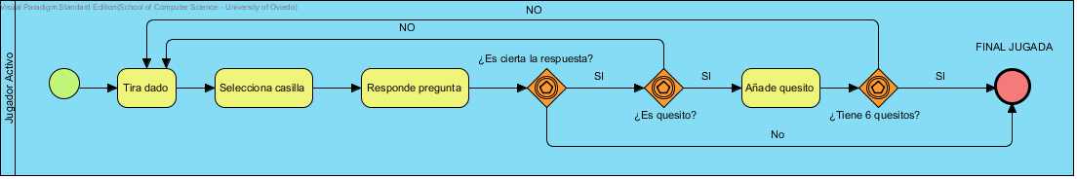

|  |  |
| --- | --- |
| Nombre | Valor |
| Nombre | Jugar |
| Autor | Trivial1a |
| Fecha de Creación | 23-abr-2015 16:32:44 |
| Última Modificación | 30-abr-2015 10:08:25 |
| Shape Presentation Option | 0 |
| Default Parent Model | Tarea Jugar |
| Bpmn Id | BP02.BP16. |
| Idioma | English |

## Resumen

|  |  |
| --- | --- |
| Nombre | Documentación |
| Image1.png Jugador Activo | Usuario al que le corresponde hacer una jugada. |
| Image2.png N/A | Comienza la jugada del jugador activo. |
| Image3.png Tira dado | El jugador principal tira el dado para saber a que casilla debe ir. |
| Image3.png Selecciona casilla | El jugador principal de las casillas disponibles dadas por el numero del dado y su posición actual, elige a la que desea ir. |
| Image3.png Responde pregunta | El jugador principal responde a una pregunta de la categoría que ha elegido mediante la elección de casilla. |
| Image5.png ¿Es cierta la respuesta? | Comprueba si la respuesta es correcta. |
| Image5.png ¿Es quesito? | Comprueba si la respuesta contestada está en una casilla de quesito. |
| Image3.png Añade quesito | Si la respuesta es correcta añade un quesito al jugador activo. |
| Image5.png ¿Tiene 6 quesitos? | Comprueba si el jugador a conseguido los 6 quesitos necesarios para ganar el juego. |
| Image7.png FINAL JUGADA | Termina la jugada actual del jugador activo. |

## Detalles

### Image1.png Jugador Activo

|  |  |
| --- | --- |
| Nombre | Valor |
| Identificación | BP02.BP16.BP01 |
| Quality Score | Fair |
| Quality Reason | |  |  | | --- | --- | | Problem | Suggestion | | Name does not contain glossary terms | Define name as term in glossary | |
| Black Box | false |
| Project Management | |  |  | | --- | --- | | Nombre | Valor | | Autor | Trivial1a | | Fecha de Creación | 23-abr-2015 16:33:10 | | Última Modificación | 30-abr-2015 9:59:41 | |

#### Hijos

|  |  |
| --- | --- |
| Nombre | Documentación |
| Image2.png N/A | Comienza la jugada del jugador activo. |
| Image3.png Tira dado | El jugador principal tira el dado para saber a que casilla debe ir. |
| Image3.png Selecciona casilla | El jugador principal de las casillas disponibles dadas por el numero del dado y su posición actual, elige a la que desea ir. |
| Image3.png Responde pregunta | El jugador principal responde a una pregunta de la categoría que ha elegido mediante la elección de casilla. |
| Image5.png ¿Es cierta la respuesta? | Comprueba si la respuesta es correcta. |
| Image5.png ¿Es quesito? | Comprueba si la respuesta contestada está en una casilla de quesito. |
| Image3.png Añade quesito | Si la respuesta es correcta añade un quesito al jugador activo. |
| Image5.png ¿Tiene 6 quesitos? | Comprueba si el jugador a conseguido los 6 quesitos necesarios para ganar el juego. |
| Image7.png FINAL JUGADA | Termina la jugada actual del jugador activo. |

### Image2.png N/A

|  |  |
| --- | --- |
| Nombre | Valor |
| Documentación | Comienza la jugada del jugador activo. |
| Identificación | BP02.BP16.BP01.BP01 |
| Quality Score | Good |
| Project Management | |  |  | | --- | --- | | Nombre | Valor | | Autor | Trivial1a | | Fecha de Creación | 23-abr-2015 16:39:35 | | Última Modificación | 30-abr-2015 10:08:13 | |

#### Relationships

|  |  |
| --- | --- |
| Unnamed Secuencia de Flujo | |
| To | Image3.png Tira dado |
| Identificación | BP02.BP16.BP01.BP03 |
| Quality Score | Good |
| Condition Type | None |
| Immediate | Unspecified |
| Quantity | 1 |
| Timeout | 0 |
| Project Management | |  |  | | --- | --- | | Nombre | Valor | | Autor | Trivial1a | | Fecha de Creación | 23-abr-2015 16:40:00 | | Última Modificación | 23-abr-2015 17:13:10 | |

### Image3.png Tira dado

|  |  |
| --- | --- |
| Nombre | Valor |
| Documentación | El jugador principal tira el dado para saber a que casilla debe ir. |
| Identificación | BP02.BP16.BP01.BP02 |
| Start Quantity | 1 |
| Completion Quantity | 1 |
| Suppress Join Failure | false |
| Enable Instance Compensation | false |
| Process Type | None |
| Estado | None |
| Quality Score | Fair |
| Quality Reason | |  |  | | --- | --- | | Problem | Suggestion | | Name does not contain glossary terms | Define name as term in glossary | |
| Compensation | false |
| Project Management | |  |  | | --- | --- | | Nombre | Valor | | Autor | Trivial1a | | Fecha de Creación | 23-abr-2015 16:39:43 | | Última Modificación | 30-abr-2015 9:47:45 | |

#### Relationships

|  |  |
| --- | --- |
| Unnamed Secuencia de Flujo | |
| To | Image3.png Selecciona casilla |
| Identificación | BP02.BP16.BP01.BP05 |
| Quality Score | Good |
| Condition Type | None |
| Immediate | Unspecified |
| Quantity | 1 |
| Timeout | 0 |
| Project Management | |  |  | | --- | --- | | Nombre | Valor | | Autor | Trivial1a | | Fecha de Creación | 23-abr-2015 16:40:03 | | Última Modificación | 23-abr-2015 17:13:10 | |
| Unnamed Secuencia de Flujo | |
| From | Image2.png N/A |
| Identificación | BP02.BP16.BP01.BP03 |
| Quality Score | Good |
| Condition Type | None |
| Immediate | Unspecified |
| Quantity | 1 |
| Timeout | 0 |
| Project Management | |  |  | | --- | --- | | Nombre | Valor | | Autor | Trivial1a | | Fecha de Creación | 23-abr-2015 16:40:00 | | Última Modificación | 23-abr-2015 17:13:10 | |

|  |  |
| --- | --- |
| NO : Secuencia de Flujo | |
| From | Image5.png ¿Es quesito? |
| Identificación | BP02.BP16.BP01.BP22 |
| Quality Score | Fair |
| Quality Reason | |  |  | | --- | --- | | Problem | Suggestion | | Name does not contain glossary terms | Define name as term in glossary | |
| Condition Type | None |
| Immediate | Unspecified |
| Quantity | 1 |
| Timeout | 0 |
| Project Management | |  |  | | --- | --- | | Nombre | Valor | | Autor | Trivial1a | | Fecha de Creación | 23-abr-2015 17:03:03 | | Última Modificación | 23-abr-2015 17:13:10 | |

|  |  |
| --- | --- |
| NO : Secuencia de Flujo | |
| From | Image5.png ¿Tiene 6 quesitos? |
| Identificación | BP02.BP16.BP01.BP23 |
| Quality Score | Fair |
| Quality Reason | |  |  | | --- | --- | | Problem | Suggestion | | Name does not contain glossary terms | Define name as term in glossary | |
| Condition Type | None |
| Immediate | Unspecified |
| Quantity | 1 |
| Timeout | 0 |
| Project Management | |  |  | | --- | --- | | Nombre | Valor | | Autor | Trivial1a | | Fecha de Creación | 23-abr-2015 17:03:47 | | Última Modificación | 23-abr-2015 17:13:10 | |

### Image3.png Selecciona casilla

|  |  |
| --- | --- |
| Nombre | Valor |
| Documentación | El jugador principal de las casillas disponibles dadas por el numero del dado y su posición actual, elige a la que desea ir. |
| Identificación | BP02.BP16.BP01.BP04 |
| Start Quantity | 1 |
| Completion Quantity | 1 |
| Suppress Join Failure | false |
| Enable Instance Compensation | false |
| Process Type | None |
| Estado | None |
| Quality Score | Fair |
| Quality Reason | |  |  | | --- | --- | | Problem | Suggestion | | Name does not contain glossary terms | Define name as term in glossary | |
| Compensation | false |
| Project Management | |  |  | | --- | --- | | Nombre | Valor | | Autor | Trivial1a | | Fecha de Creación | 23-abr-2015 16:40:03 | | Última Modificación | 23-abr-2015 17:13:10 | |

#### Relationships

|  |  |
| --- | --- |
| Unnamed Secuencia de Flujo | |
| To | Image3.png Responde pregunta |
| Identificación | BP02.BP16.BP01.BP07 |
| Quality Score | Good |
| Condition Type | None |
| Immediate | Unspecified |
| Quantity | 1 |
| Timeout | 0 |
| Project Management | |  |  | | --- | --- | | Nombre | Valor | | Autor | Trivial1a | | Fecha de Creación | 23-abr-2015 16:40:16 | | Última Modificación | 23-abr-2015 17:13:10 | |
| Unnamed Secuencia de Flujo | |
| From | Image3.png Tira dado |
| Identificación | BP02.BP16.BP01.BP05 |
| Quality Score | Good |
| Condition Type | None |
| Immediate | Unspecified |
| Quantity | 1 |
| Timeout | 0 |
| Project Management | |  |  | | --- | --- | | Nombre | Valor | | Autor | Trivial1a | | Fecha de Creación | 23-abr-2015 16:40:03 | | Última Modificación | 23-abr-2015 17:13:10 | |

### Image3.png Responde pregunta

|  |  |
| --- | --- |
| Nombre | Valor |
| Documentación | El jugador principal responde a una pregunta de la categoría que ha elegido mediante la elección de casilla. |
| Identificación | BP02.BP16.BP01.BP06 |
| Start Quantity | 1 |
| Completion Quantity | 1 |
| Suppress Join Failure | false |
| Enable Instance Compensation | false |
| Process Type | None |
| Estado | None |
| Quality Score | Fair |
| Quality Reason | |  |  | | --- | --- | | Problem | Suggestion | | Name does not contain glossary terms | Define name as term in glossary | |
| Compensation | false |
| Project Management | |  |  | | --- | --- | | Nombre | Valor | | Autor | Trivial1a | | Fecha de Creación | 23-abr-2015 16:40:16 | | Última Modificación | 23-abr-2015 17:13:10 | |

#### Relationships

|  |  |
| --- | --- |
| Unnamed Secuencia de Flujo | |
| To | Image5.png ¿Es cierta la respuesta? |
| Identificación | BP02.BP16.BP01.BP09 |
| Quality Score | Good |
| Condition Type | None |
| Immediate | Unspecified |
| Quantity | 1 |
| Timeout | 0 |
| Project Management | |  |  | | --- | --- | | Nombre | Valor | | Autor | Trivial1a | | Fecha de Creación | 23-abr-2015 16:40:26 | | Última Modificación | 23-abr-2015 17:13:10 | |
| Unnamed Secuencia de Flujo | |
| From | Image3.png Selecciona casilla |
| Identificación | BP02.BP16.BP01.BP07 |
| Quality Score | Good |
| Condition Type | None |
| Immediate | Unspecified |
| Quantity | 1 |
| Timeout | 0 |
| Project Management | |  |  | | --- | --- | | Nombre | Valor | | Autor | Trivial1a | | Fecha de Creación | 23-abr-2015 16:40:16 | | Última Modificación | 23-abr-2015 17:13:10 | |

### Image5.png ¿Es cierta la respuesta?

|  |  |
| --- | --- |
| Nombre | Valor |
| Documentación | Comprueba si la respuesta es correcta. |
| Identificación | BP02.BP16.BP01.BP08 |
| Quality Score | Fair |
| Quality Reason | |  |  | | --- | --- | | Problem | Suggestion | | Name does not contain glossary terms | Define name as term in glossary | |
| Gateway Type | Image5.png XOR |
| Gateway Direction | Unspecified |
| Inject Inherent Logic | false |
| Project Management | |  |  | | --- | --- | | Nombre | Valor | | Autor | Trivial1a | | Fecha de Creación | 23-abr-2015 16:40:26 | | Última Modificación | 30-abr-2015 10:08:13 | |

#### Gateway Type

|  |  |
| --- | --- |
| Nombre | Valor |
| Type | Decisión Exclusiva/Combinación (O Exclusivo) basado en eventos |
| Nombre | XOR |
| Instantiate | false |
| Event Gateway Type | Exclusive |
| Project Management | |  |  | | --- | --- | | Nombre | Valor | | Autor | Trivial1a | | Fecha de Creación | 23-abr-2015 16:40:43 | |

#### Relationships

|  |  |
| --- | --- |
| SI : Secuencia de Flujo | |
| To | Image5.png ¿Es quesito? |
| Identificación | BP02.BP16.BP01.BP13 |
| Quality Score | Fair |
| Quality Reason | |  |  | | --- | --- | | Problem | Suggestion | | Name does not contain glossary terms | Define name as term in glossary | |
| Condition Type | None |
| Immediate | Unspecified |
| Quantity | 1 |
| Timeout | 0 |
| Project Management | |  |  | | --- | --- | | Nombre | Valor | | Autor | Trivial1a | | Fecha de Creación | 23-abr-2015 16:59:19 | | Última Modificación | 23-abr-2015 17:13:10 | |

|  |  |
| --- | --- |
| No : Secuencia de Flujo | |
| To | Image7.png FINAL JUGADA |
| Identificación | BP02.BP16.BP01.BP25 |
| Quality Score | Fair |
| Quality Reason | |  |  | | --- | --- | | Problem | Suggestion | | Name does not contain glossary terms | Define name as term in glossary | |
| Condition Type | None |
| Immediate | Unspecified |
| Quantity | 1 |
| Timeout | 0 |
| Project Management | |  |  | | --- | --- | | Nombre | Valor | | Autor | Trivial1a | | Fecha de Creación | 30-abr-2015 9:57:37 | | Última Modificación | 30-abr-2015 9:59:41 | |
| Unnamed Secuencia de Flujo | |
| From | Image3.png Responde pregunta |
| Identificación | BP02.BP16.BP01.BP09 |
| Quality Score | Good |
| Condition Type | None |
| Immediate | Unspecified |
| Quantity | 1 |
| Timeout | 0 |
| Project Management | |  |  | | --- | --- | | Nombre | Valor | | Autor | Trivial1a | | Fecha de Creación | 23-abr-2015 16:40:26 | | Última Modificación | 23-abr-2015 17:13:10 | |

### Image5.png ¿Es quesito?

|  |  |
| --- | --- |
| Nombre | Valor |
| Documentación | Comprueba si la respuesta contestada está en una casilla de quesito. |
| Identificación | BP02.BP16.BP01.BP12 |
| Quality Score | Fair |
| Quality Reason | |  |  | | --- | --- | | Problem | Suggestion | | Name does not contain glossary terms | Define name as term in glossary | |
| Gateway Type | Image5.png XOR |
| Gateway Direction | Unspecified |
| Inject Inherent Logic | false |
| Project Management | |  |  | | --- | --- | | Nombre | Valor | | Autor | Trivial1a | | Fecha de Creación | 23-abr-2015 16:59:19 | | Última Modificación | 30-abr-2015 10:08:13 | |

#### Gateway Type

|  |  |
| --- | --- |
| Nombre | Valor |
| Type | Decisión Exclusiva/Combinación (O Exclusivo) basado en eventos |
| Nombre | XOR |
| Instantiate | false |
| Event Gateway Type | Exclusive |
| Project Management | |  |  | | --- | --- | | Nombre | Valor | | Autor | Trivial1a | | Fecha de Creación | 23-abr-2015 16:59:22 | |

#### Relationships

|  |  |
| --- | --- |
| SI : Secuencia de Flujo | |
| To | Image3.png Añade quesito |
| Identificación | BP02.BP16.BP01.BP15 |
| Quality Score | Fair |
| Quality Reason | |  |  | | --- | --- | | Problem | Suggestion | | Name does not contain glossary terms | Define name as term in glossary | |
| Condition Type | None |
| Immediate | Unspecified |
| Quantity | 1 |
| Timeout | 0 |
| Project Management | |  |  | | --- | --- | | Nombre | Valor | | Autor | Trivial1a | | Fecha de Creación | 23-abr-2015 17:00:36 | | Última Modificación | 23-abr-2015 17:13:10 | |

|  |  |
| --- | --- |
| NO : Secuencia de Flujo | |
| To | Image3.png Tira dado |
| Identificación | BP02.BP16.BP01.BP22 |
| Quality Score | Fair |
| Quality Reason | |  |  | | --- | --- | | Problem | Suggestion | | Name does not contain glossary terms | Define name as term in glossary | |
| Condition Type | None |
| Immediate | Unspecified |
| Quantity | 1 |
| Timeout | 0 |
| Project Management | |  |  | | --- | --- | | Nombre | Valor | | Autor | Trivial1a | | Fecha de Creación | 23-abr-2015 17:03:03 | | Última Modificación | 23-abr-2015 17:13:10 | |
| SI : Secuencia de Flujo | |
| From | Image5.png ¿Es cierta la respuesta? |
| Identificación | BP02.BP16.BP01.BP13 |
| Quality Score | Fair |
| Quality Reason | |  |  | | --- | --- | | Problem | Suggestion | | Name does not contain glossary terms | Define name as term in glossary | |
| Condition Type | None |
| Immediate | Unspecified |
| Quantity | 1 |
| Timeout | 0 |
| Project Management | |  |  | | --- | --- | | Nombre | Valor | | Autor | Trivial1a | | Fecha de Creación | 23-abr-2015 16:59:19 | | Última Modificación | 23-abr-2015 17:13:10 | |

### Image3.png Añade quesito

|  |  |
| --- | --- |
| Nombre | Valor |
| Documentación | Si la respuesta es correcta añade un quesito al jugador activo. |
| Identificación | BP02.BP16.BP01.BP14 |
| Start Quantity | 1 |
| Completion Quantity | 1 |
| Suppress Join Failure | false |
| Enable Instance Compensation | false |
| Process Type | None |
| Estado | None |
| Quality Score | Fair |
| Quality Reason | |  |  | | --- | --- | | Problem | Suggestion | | Name does not contain glossary terms | Define name as term in glossary | |
| Compensation | false |
| Project Management | |  |  | | --- | --- | | Nombre | Valor | | Autor | Trivial1a | | Fecha de Creación | 23-abr-2015 17:00:36 | | Última Modificación | 30-abr-2015 10:08:13 | |

#### Relationships

|  |  |
| --- | --- |
| Unnamed Secuencia de Flujo | |
| To | Image5.png ¿Tiene 6 quesitos? |
| Identificación | BP02.BP16.BP01.BP17 |
| Quality Score | Good |
| Condition Type | None |
| Immediate | Unspecified |
| Quantity | 1 |
| Timeout | 0 |
| Project Management | |  |  | | --- | --- | | Nombre | Valor | | Autor | Trivial1a | | Fecha de Creación | 23-abr-2015 17:01:31 | | Última Modificación | 23-abr-2015 17:13:10 | |
| SI : Secuencia de Flujo | |
| From | Image5.png ¿Es quesito? |
| Identificación | BP02.BP16.BP01.BP15 |
| Quality Score | Fair |
| Quality Reason | |  |  | | --- | --- | | Problem | Suggestion | | Name does not contain glossary terms | Define name as term in glossary | |
| Condition Type | None |
| Immediate | Unspecified |
| Quantity | 1 |
| Timeout | 0 |
| Project Management | |  |  | | --- | --- | | Nombre | Valor | | Autor | Trivial1a | | Fecha de Creación | 23-abr-2015 17:00:36 | | Última Modificación | 23-abr-2015 17:13:10 | |

### Image5.png ¿Tiene 6 quesitos?

|  |  |
| --- | --- |
| Nombre | Valor |
| Documentación | Comprueba si el jugador a conseguido los 6 quesitos necesarios para ganar el juego. |
| Identificación | BP02.BP16.BP01.BP16 |
| Quality Score | Fair |
| Quality Reason | |  |  | | --- | --- | | Problem | Suggestion | | Name does not contain glossary terms | Define name as term in glossary | |
| Gateway Type | Image5.png XOR |
| Gateway Direction | Unspecified |
| Inject Inherent Logic | false |
| Project Management | |  |  | | --- | --- | | Nombre | Valor | | Autor | Trivial1a | | Fecha de Creación | 23-abr-2015 17:01:31 | | Última Modificación | 30-abr-2015 10:08:13 | |

#### Gateway Type

|  |  |
| --- | --- |
| Nombre | Valor |
| Type | Decisión Exclusiva/Combinación (O Exclusivo) basado en eventos |
| Nombre | XOR |
| Instantiate | false |
| Event Gateway Type | Exclusive |
| Project Management | |  |  | | --- | --- | | Nombre | Valor | | Autor | Trivial1a | | Fecha de Creación | 23-abr-2015 17:01:34 | |

#### Relationships

|  |  |
| --- | --- |
| SI : Secuencia de Flujo | |
| To | Image7.png FINAL JUGADA |
| Identificación | BP02.BP16.BP01.BP21 |
| Quality Score | Fair |
| Quality Reason | |  |  | | --- | --- | | Problem | Suggestion | | Name does not contain glossary terms | Define name as term in glossary | |
| Condition Type | None |
| Immediate | Unspecified |
| Quantity | 1 |
| Timeout | 0 |
| Project Management | |  |  | | --- | --- | | Nombre | Valor | | Autor | Trivial1a | | Fecha de Creación | 23-abr-2015 17:02:37 | | Última Modificación | 23-abr-2015 17:13:10 | |

|  |  |
| --- | --- |
| NO : Secuencia de Flujo | |
| To | Image3.png Tira dado |
| Identificación | BP02.BP16.BP01.BP23 |
| Quality Score | Fair |
| Quality Reason | |  |  | | --- | --- | | Problem | Suggestion | | Name does not contain glossary terms | Define name as term in glossary | |
| Condition Type | None |
| Immediate | Unspecified |
| Quantity | 1 |
| Timeout | 0 |
| Project Management | |  |  | | --- | --- | | Nombre | Valor | | Autor | Trivial1a | | Fecha de Creación | 23-abr-2015 17:03:47 | | Última Modificación | 23-abr-2015 17:13:10 | |
| Unnamed Secuencia de Flujo | |
| From | Image3.png Añade quesito |
| Identificación | BP02.BP16.BP01.BP17 |
| Quality Score | Good |
| Condition Type | None |
| Immediate | Unspecified |
| Quantity | 1 |
| Timeout | 0 |
| Project Management | |  |  | | --- | --- | | Nombre | Valor | | Autor | Trivial1a | | Fecha de Creación | 23-abr-2015 17:01:31 | | Última Modificación | 23-abr-2015 17:13:10 | |

### Image7.png FINAL JUGADA

|  |  |
| --- | --- |
| Nombre | Valor |
| Documentación | Termina la jugada actual del jugador activo. |
| Identificación | BP02.BP16.BP01.BP20 |
| Quality Score | Fair |
| Quality Reason | |  |  | | --- | --- | | Problem | Suggestion | | Name does not contain glossary terms | Define name as term in glossary | |
| Project Management | |  |  | | --- | --- | | Nombre | Valor | | Autor | Trivial1a | | Fecha de Creación | 23-abr-2015 17:02:20 | | Última Modificación | 30-abr-2015 10:08:13 | |

#### Relationships

|  |  |
| --- | --- |
| SI : Secuencia de Flujo | |
| From | Image5.png ¿Tiene 6 quesitos? |
| Identificación | BP02.BP16.BP01.BP21 |
| Quality Score | Fair |
| Quality Reason | |  |  | | --- | --- | | Problem | Suggestion | | Name does not contain glossary terms | Define name as term in glossary | |
| Condition Type | None |
| Immediate | Unspecified |
| Quantity | 1 |
| Timeout | 0 |
| Project Management | |  |  | | --- | --- | | Nombre | Valor | | Autor | Trivial1a | | Fecha de Creación | 23-abr-2015 17:02:37 | | Última Modificación | 23-abr-2015 17:13:10 | |

|  |  |
| --- | --- |
| No : Secuencia de Flujo | |
| From | Image5.png ¿Es cierta la respuesta? |
| Identificación | BP02.BP16.BP01.BP25 |
| Quality Score | Fair |
| Quality Reason | |  |  | | --- | --- | | Problem | Suggestion | | Name does not contain glossary terms | Define name as term in glossary | |
| Condition Type | None |
| Immediate | Unspecified |
| Quantity | 1 |
| Timeout | 0 |
| Project Management | |  |  | | --- | --- | | Nombre | Valor | | Autor | Trivial1a | | Fecha de Creación | 30-abr-2015 9:57:37 | | Última Modificación | 30-abr-2015 9:59:41 | |

# Anexo C: Manual de sistema

## Instalación y configuración de play

Lo primero que haremos será descargar el framework play versión 2.2.6 :

<https://www.playframework.com/download>

Lo guardaremos en una carpeta de cual sepamos que no lo vamos a mover.

Ahora procederemos a configurarlo:

Vamos a las variables del entorno del sistema y modificamos el path añadiendo la dirección de la carpeta play anteriormente descargada (Propiedades del sistema-Opciones Avanzadas-Variables del entorno…).

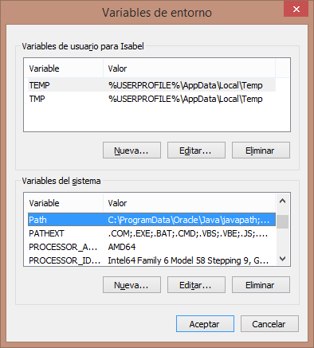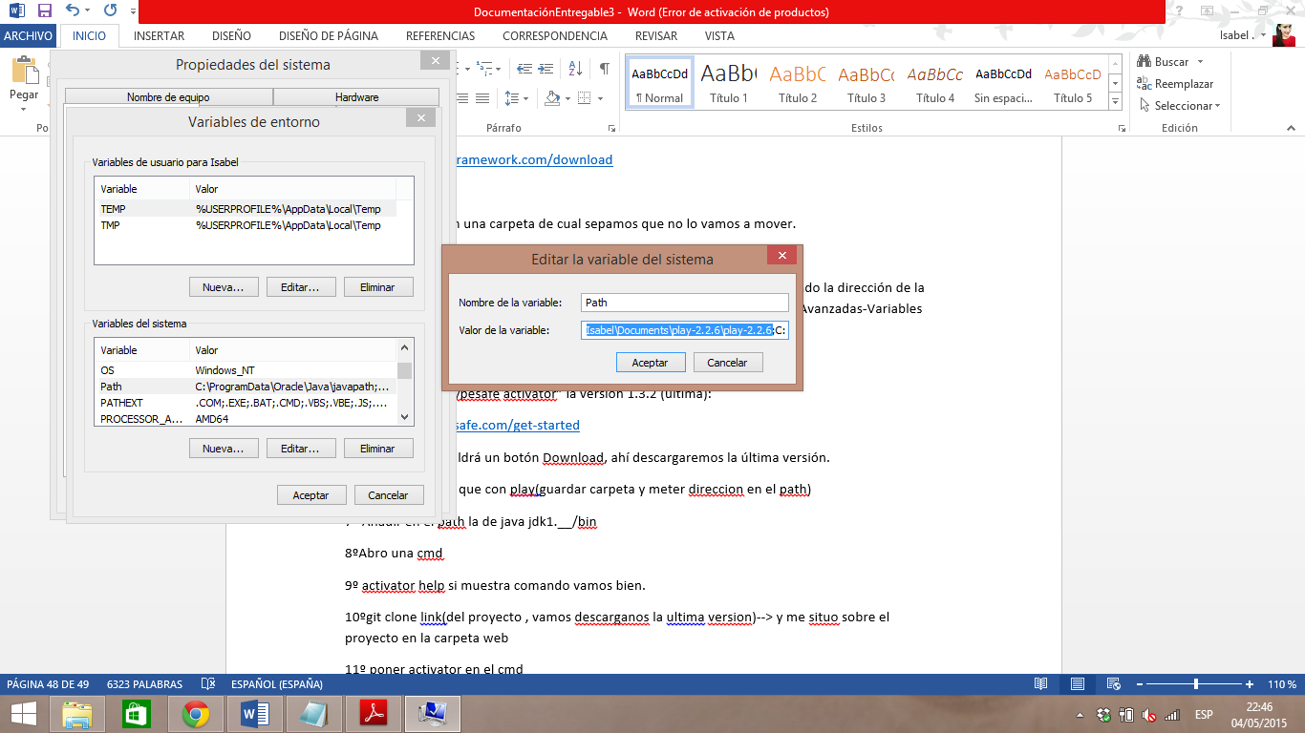

Descargamos el “typesafe activator” la versión 1.3.2 (ultima):

<https://www.typesafe.com/get-started>

En la página nos saldrá un botón Download, ahí descargaremos la última versión.

Ahora haremos lo mismo que con la carpeta play, modificaremos la variable path de Windows y añadiremos la carpeta del activator.

Añadiremos también si no lo tenemos la carpeta bin del jdk de java.

## Ejecución del proyecto

Abrimos una interfaz de comandos y escribimos “activator help”, si nos salen las opciones disponibles es que lo hemos configurado bien anteriormente.

Nos situamos en la carpeta “web” del proyecto.

Vamos a la interfaz de comandos y nos posicionamos en la carpeta “web” de nuestro proyecto y escribimos “activator”, se nos pondrán a instalar paquetes.

Una vez instalados todos nos saldrá algo así **[Trivial1a]~** en nuestro caso con nuestro nombre del proyecto.

Hacemos en la interfaz de comandos “clean” y después “compile”.

Ahora escribimos en la interfaz de comandos “eclipse” y después vamos a eclipse e importamos el proyecto (Import Project🡪Existing projects into workspace)

Para finalizar escribimos en la interfaz de comandos “run” y abriremos una ventana del explorador y escribiremos la dirección localhost:9000 y debería mostrarse el proyecto.

# Anexo D: Manual de usuario

El Trivial1a es un juego de preguntas online en el que el usuario tendrá que ir acertando las preguntas de las categorías que se le propongan y conseguir los quesitos o premios de cada una de las diferentes categorías para poder ganar la partida.

## Ventana de Login

El usuario tendrá una pantalla para poder loguearse o registrarse en el caso de ser la primera vez que juega. Pulsando el botón Entrar, con los campos de usuario y password completos, el usuario accederá al juego, en caso de estar ya registrado. Si se pulsa el botón Regístrame, el usuario accederá a una pantalla que le permitirá registrarse para poder jugar.

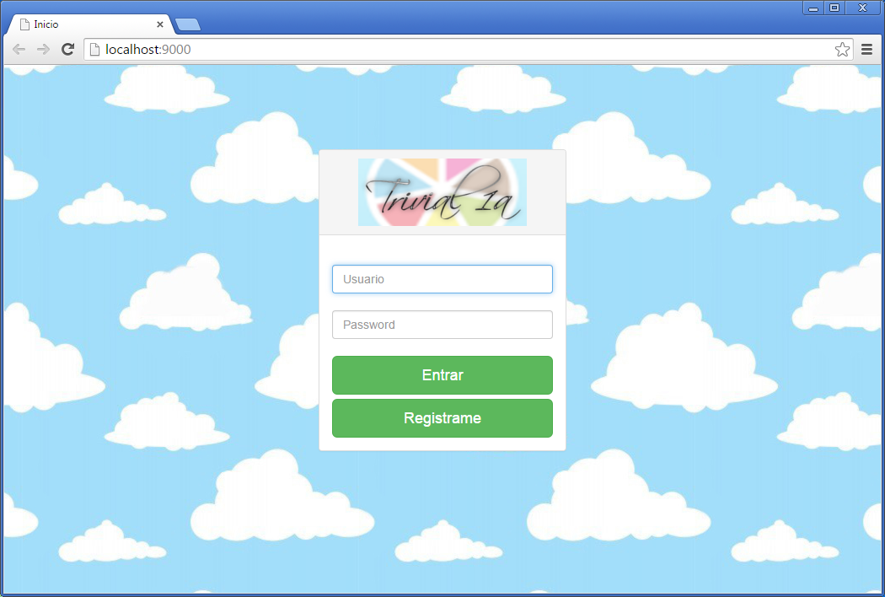

## Ventana de registro

Dentro de la pantalla de registro al pulsar el botón Regístrame entraremos en esta pantalla. Tendremos que rellenar los campos, repitiendo el mismo password en “Password” y “Password de nuevo” ya que sino no dejará que se realice el registro. En caso de pulsar Atrás, volveremos a la pantalla anterior.

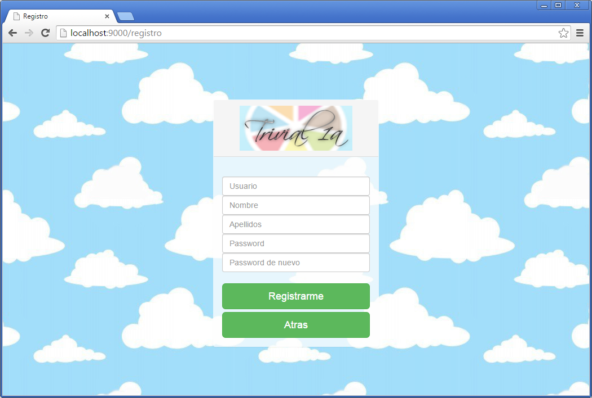

## Ventana de menú principal

En la siguiente pantalla, una vez registrados y logueados, tenemos las opciones de Jugar y Estadísticas. Con la opción Jugar entraremos al juego y comenzaremos una partida nueva. Y en la opción de Estadísticas podremos ver nuestras estadísticas dentro del juego. En cambio, pulsando Atrás volveremos a la pantalla de logueo.

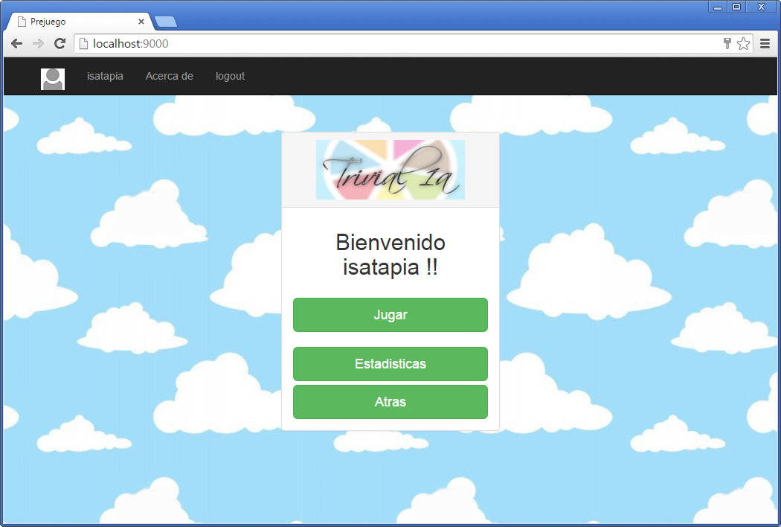

Como podemos apreciar en la barra de arriba tenemos opciones:

* El logout que nos cierra la sesión.

## Ventana de estadísticas

Aquí podremos ver las estadísticas de nuestro usuario dentro del juego, las que se dividen por las categorías de las preguntas.

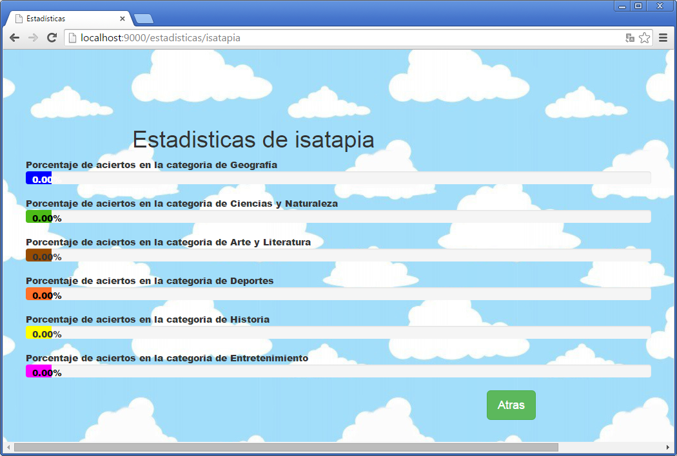

## Ventana del juego

Al darle a Jugar, nos saldrá esta pantalla en la que le daremos a Lanzar para sacar un número que nos permitirá movernos por el tablero, eligiendo casilla, que dependiendo del color será de una categoría determinada. Las cruces señalaran las posiciones hacia las que el usuario se podrá mover, eligiendo una de ellas.

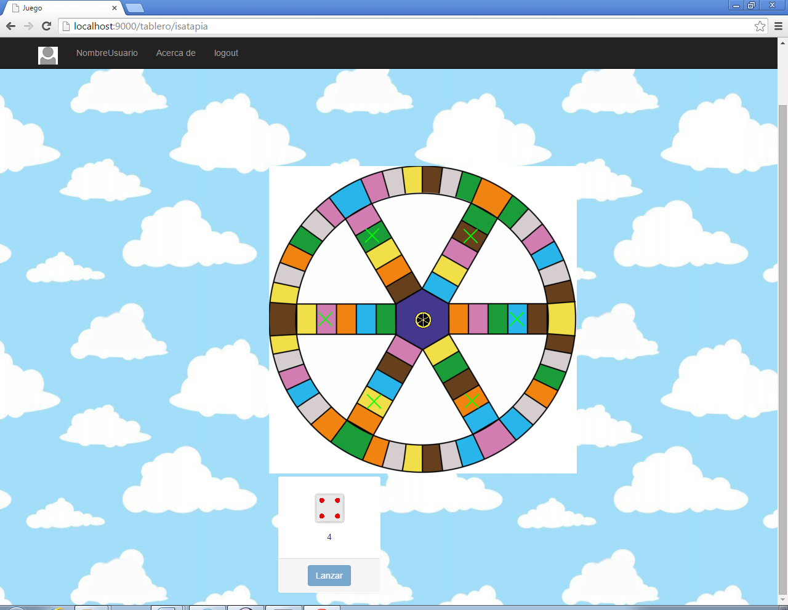

Al pulsar en la casilla determinada, nos aparecerá la pregunta correspondiente de esa determinada categoría. Teniendo que elegir entre una de las respuestas.

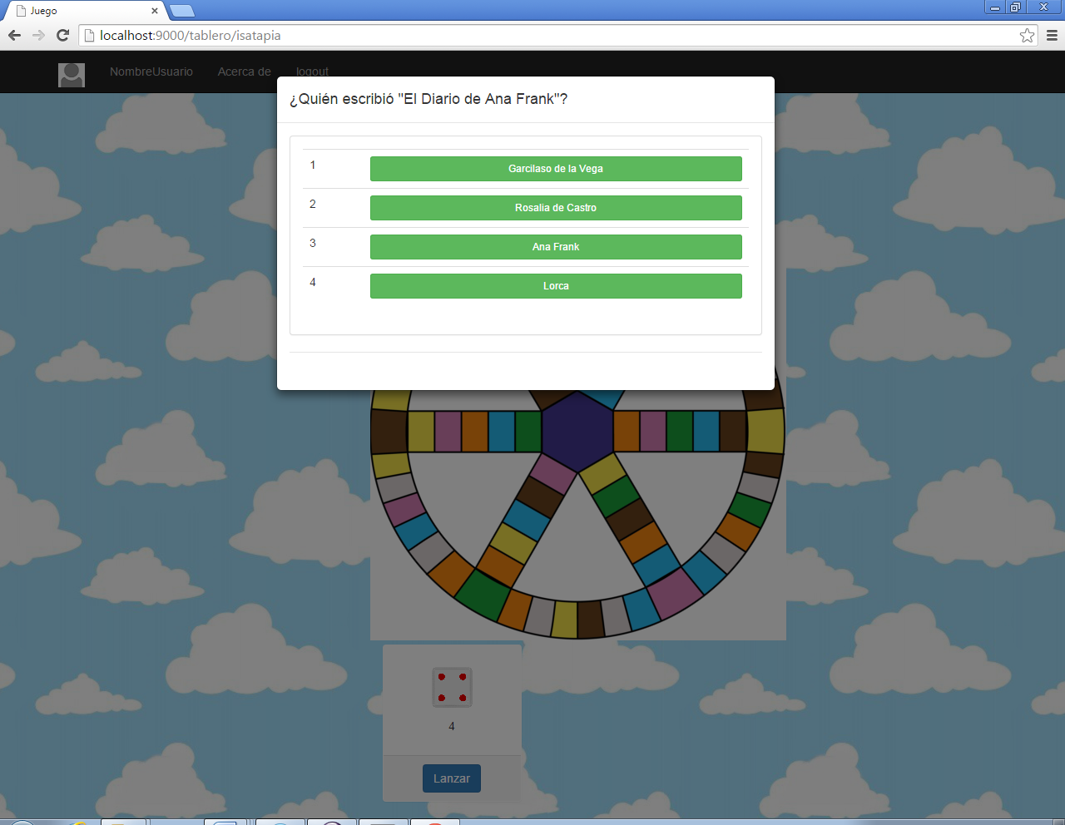

Al acertar la pregunta aparecerá un aviso en el que nos dirá si hemos acertado la pregunta, permitiéndonos continuar con nuestro turno.

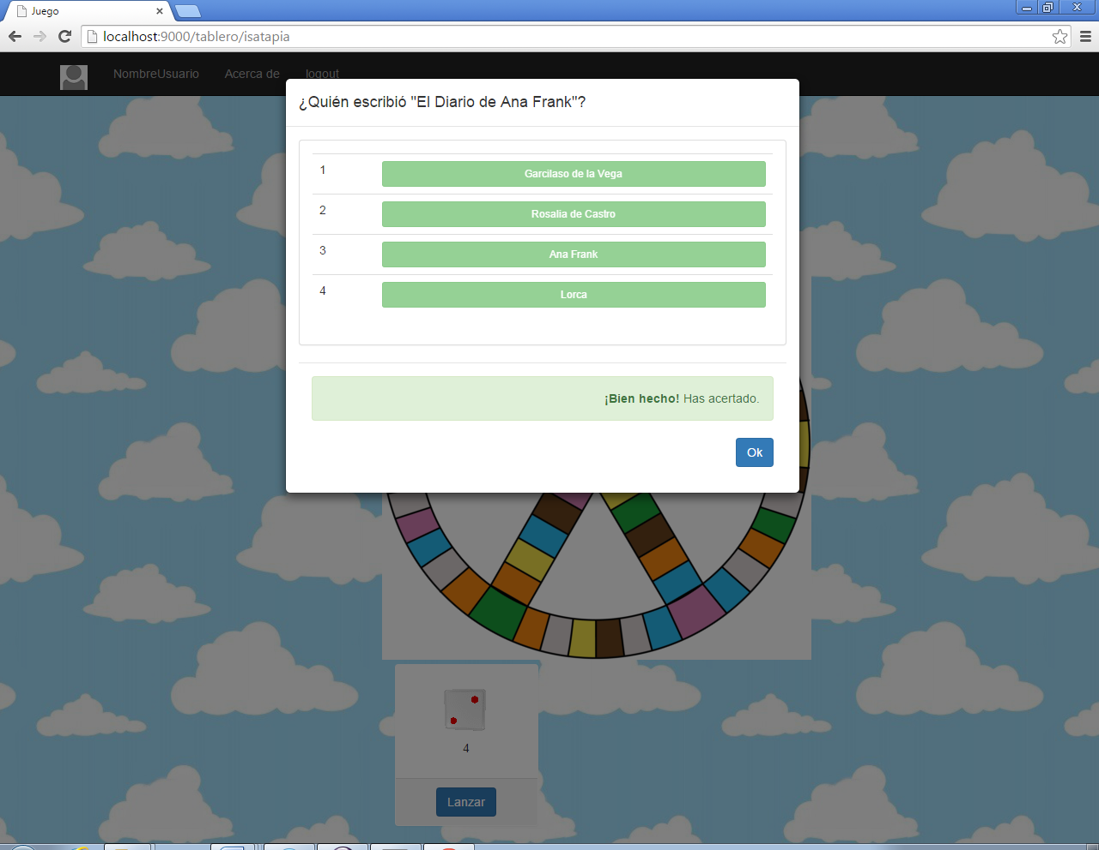

Al fallar, también nos lo indicará pero al ser de un solo jugador, el usuario podrá continuar con la partida.

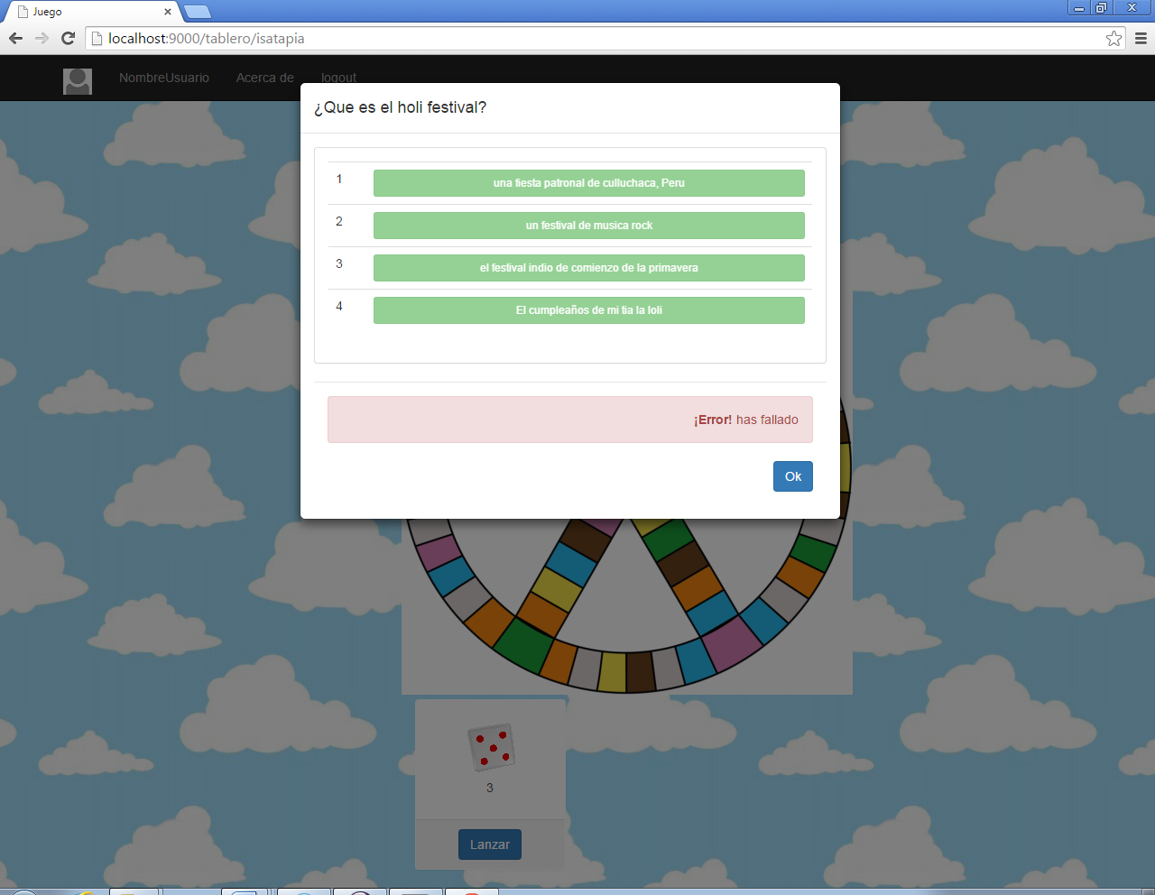

Cuando consigamos todos los quesitos finalizará el juego y se nos mostrará un mensaje como el siguiente:

